Warwickshire Historic Towns Project
(English Heritage Project Number: 5922)

Brinklow Historic Character Assessment

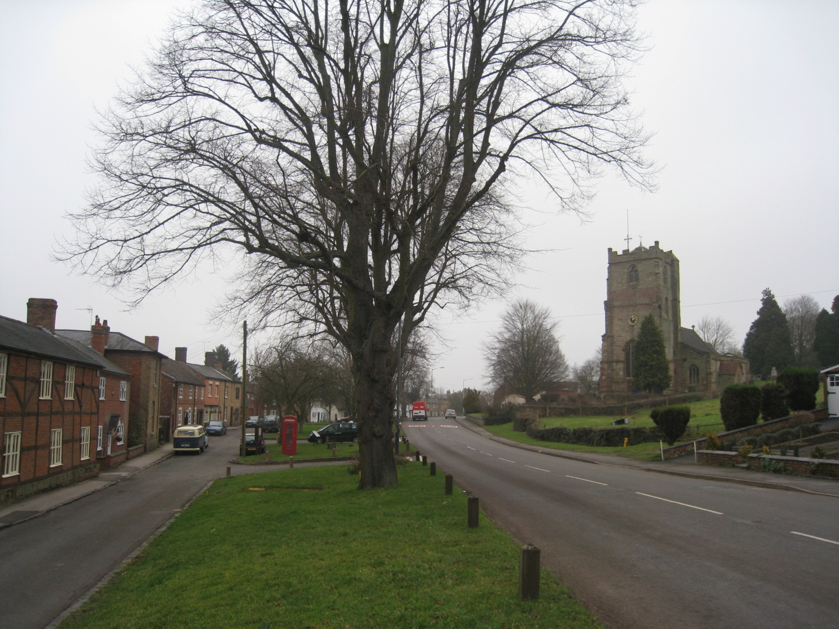

Benjamin Morton
Warwickshire Historic Environment Record
Warwickshire County Council
August 2014

Brinklow Historic Character Assessment
Warwickshire Historic Towns Project (English Heritage Project No: 5922)
Part of the National Programme of Extensive Urban Surveys (EUS)

Author: Benjamin Morton
Project Manager: Ben Wallace

Warwickshire Historic Environment Record
Archaeological Information and Advice
Warwickshire County Council, Barrack Street, Warwick, CV34 4TH

(Postal address) Warwickshire County Council,
PO Box 43, Shire Hall, Warwick, CV34 4SX

Maps and photographs
Unless otherwise marked, all maps are oriented north at the top of the page and are copyright Warwickshire County Council. Where used Ordnance Survey data is Crown Copyright, All Rights Reserved and have been reproduced under licence no. 100019520.
All photographs, unless otherwise stated, have been taken by the author and are copyright Warwickshire County Council.
Front cover image: The Crescent, Brinklow looking towards the Church

Acknowledgements
The author would like to thank the following people who have helped produce the Warwickshire Historic Towns Project: the members of the project steering group, for their advice and encouragement; Giles Carey, Assistant Historic Environment Record Officer, for his work on the project webpage; John Robinson, Assistant Historic Environment Record Officer, for his contribution to the characterisation work and advice; Bryn Gethin, Archaeology Warwickshire Project Officer, for his contribution to the town reports, and for his friendly encouragement and advice; Jonathan Parkhouse, former Country Archaeologist, for his support in the early days of the project, and for editing the reports; Ben Wallace, Historic Environment Record Manager, who managed the project; Zhenya Dewfield, whose personal support during the first two years of the project was invaluable.
Lastly, special thanks must go to Anne Morton, for her time spent editing the reports, and for her additional help and support over the years.
I am forever grateful.

Table of Contents
Abbreviations 1
Periods 1
1. Introduction 2
1.1. Purpose of this study 2
1.2. Scope 3
1.3. Methodology 4
2. Summary 5
3. The Setting 7
4. A Settlement Through Time 8
4.1. Place name 8
4.2. The Prehistoric and Roman Periods 8
4.3. The Anglo-Saxon Period 8
4.4. The Norman Village 9
4.5. A Medieval Borough 10
4.6. Late Medieval Decline 11
4.7. The Early Modern Village 12
4.8. The Industrial and Modern Town 12
5. Historic Character 14
5.1. Overview 14
5.2. The Historic Village Plan 17
5.3. Significance of the Village Plan 20
6. Historic Town Character Areas 22
6.1. The Crescent HTCA 24
6.2. Lutterworth Road HTCA 29
6.3. Broad Street HTCA 32
6.4. Coventry Road and Rugby Road HTCA 35
6.5. Green Lane and Heath Lane HTCA 38
7. Bibliography 41
Appendix 1: Brinklow Historic Archive Report 44

Abbreviations
BCA – Birmingham City Archives
HER – Historic Environment Record
HTC – Historic Town Component
HTCA – Historic Town Character Area
LB – Nationally Listed Building
EWA - Warwickshire HER Event number
MWA – Warwickshire HER Monument number
SAM – Scheduled Ancient Monument
SBT – Shakespeare Birthplace Trust
SWA – Warwickshire HER Source number
TNA – The National Archives
VCH – Victoria County History
WCRO – Warwickshire County Record Office

Periods
Prehistoric (Pre 43 AD)
Roman (43 AD to the fourth century)
Sub-Roman (fifth century)
Early Anglo-Saxon (fifth to seventh century)
Middle Anglo-Saxon (eighth to ninth century)
Late Anglo-Saxon (tenth century to 1086)
High Medieval (1086 to 1350)
Late Medieval (1350 to 1540)
Early Modern (1540 to 1750)
Early Industrial (1750 to 1850)
Industrial (1850 to 1918)
Inter-War (1918 to 1945)
Late Industrial (1945 to 1979)
Post Industrial (1979 to Present)

Brinklow Historic Character Assessment
- Introduction
  - Purpose of this study
The Brinklow Historic Character Assessment has been completed as part of the Warwickshire Historic Towns Project. The project intends to increase and synthesise the knowledge and understanding of the historic environment and historic character of twenty towns in Warwickshire.
The project forms part of the national programme of Extensive Urban Surveys initiated and supported by English Heritage. The programme is already well underway with a number of English counties having been completed or undergoing study.
This report is best read in conjunction with the Warwickshire Historic Towns Project Report and the Rugby Borough Strategic Report. These reports and the GIS data and database records generated from the project can be obtained from the Warwickshire HER.

  - Scope
The geographical extent of this study has been based on the maximum extent of the modern built up area of Brinklow. The study covers all periods of Brinklow’s history from the prehistoric period until the present day.
Geographical extent of the Brinklow Historic Character Assessment

  - Methodology
The project examines the following aspects of Brinklow: its context, historical development and finally its historic character. Each of these factors is then used to disaggregate the townscape into a number of distinct character areas.
A major part of this study has been the characterisation of the townscape. The purpose of historic characterisation is to interpret and understand the inherited character of all places, and the evidence for change and continuity in the present environment. It is based on the need to understand and help professionals and communities to manage the present environment as a product of past change and the raw material for future change. It functions at an area-scale, above that of individual sites and features (protected or not). It differs from research and survey, as undertaken in the historic environment sector, by its promotion of broad and generalised approaches to understanding the historic environment.
A detailed assessment of the historic character of Brinklow has therefore been undertaken that has attempted to bridge the gap between characterisation studies and more detailed research and survey. This has been accomplished by mapping and defining a number of Historic Town Components (HTCs) with broad character type classifications (such as settlement, industrial, recreational etc.) and sub character types that provide more detail. This characterisation has formed the evidence base upon which Historic Town Character Areas (HTCAs) have been created.
Each area within a town has been examined in terms of its historic character, present function and period of origin. Where an area displays a morphological, functional and chronological coherence it has been treated as one HTC. This approach uses a variety of sources and approaches to understand the historic character of an area to significantly aid understanding of variations in function, historic character, architectural style and period of origin.
The historical and archaeological research conducted for this report uses techniques developed in archaeology, historical geography, history and architectural history in an attempt to provide a holistic understanding of the historical development and historic character of Brinklow.

- Summary
Brinklow is a large attractive village with a population of around 1000 people (2001 Census), located about 7 miles to the east of Coventry and 5 miles north-west of Rugby, situated on the end of a spur overlooking the Smite Brook. Today the village contains several shops and pubs and a primary school. However, its most noteworthy features are the prominent earthwork remains of Brinklow Castle, the wide expanse of The Crescent, the parish church and its numerous historic buildings.
There is little direct evidence for prehistoric activity in the Brinklow area. However, the low element in the place name suggests that there may have been a round barrow, probably of Bronze Age date, which may have lain in the vicinity of the castle. The Fosse Way, a major Roman road, passes through the village. Historically the road probably continued in a straight line to the east of the modern village; however, it was probably diverted to its present course after the building of the castle in the late eleventh century.
There is some evidence for Anglo-Saxon activity in Brinklow. In the 19th century a glass bead was found next to a decorated urn on ‘glebe land’ within the parish, hinting at a Saxon cremation burial. Brinklow was not mentioned in the Domesday Book of 1086 and probably formed part of the larger parish of Smite. Brinklow’s absence suggests that it was a relatively small settlement at the time of the Norman Conquest. Despite this, soon after the Norman Conquest, a motte and bailey castle was built at Brinklow in part to control traffic along the Fosse Way. The building of the castle may also have involved the wholesale reorganisation of settlement in the locality, with the establishment of a village just outside the castle. The series of long plots which front The Crescent almost certainly date from this period.
In 1218 Nicholas de Stuteville was confirmed in possession of the manor and in right to hold a weekly market and an annual fair. It is likely that any existing settlement at Brinklow was remodelled under seigniorial influence with new urban plots laid out. Along the towns streets long plots with narrow frontages were either newly laid out or created out of existing plots. The Crescent served as the market place and its broad profile still echoes its former function. The effects of medieval town planning are still visible in the settlement morphology of Brinklow and consequently this is a unique and highly significant townscape documenting the history of Brinklow and more generally the founding and evolution of medieval small towns that is a highly important part of the village’s historic character.
A number of Warwickshire towns exhibit the same type of plan as Brinklow, but in many cases in a more fragmentary form, as continued development down the centuries has often removed boundaries, created new streets and lanes and lead to new buildings being constructed behind the main street frontage. This happened because these settlements continuing as successful towns into the modern period - Brinklow did not. The market had probably become defunct at some point in the late medieval period and by the sixteenth century Brinklow had reverted back to being a rural settlement.
Whilst the underlying pattern of streets and plots laid down in the medieval period still largely structures the layout of the village’s streets, buildings and open spaces; its buildings provide a visual backdrop to its streets. Brinklow has surviving buildings dating from the medieval period onwards. As expected they line the village’s historic streets and provide a visual narrative of its history. However, they also play a vital role in shaping Brinklow’s historic character and in reinforcing local distinctiveness.

- The Setting
Brinklow lies within the Feldon, a belt of clay land in the south and east of Warwickshire. This area is a landscape of villages, which have been occupied since at least the medieval period, and isolated farmsteads, typically dating from between the sixteenth and nineteenth centuries when the open fields were enclosed. The parish of Brinklow was enclosed in 1741 (VCH: 1951), and the extensive tracts of ridge and furrow that survive across the parish are an important reminder of the former open fields.
The underlying geology of the area is Wolston Sand and Gravel over Wolston Clay (British Geological Survey: 1994).
Location and Setting of Brinklow
- A Settlement Through Time
  - Place name
The place name ‘Brinklow’ dates from the Anglo-Saxon period and incorporates the personal name ‘Brynca’, and ‘hlaw’ (low), meaning hill or barrow. An alternative interpretation has been offered for the ‘brink’ element which may be Old English for ‘slope, hill’ (Mawer and Stenton, 1936: 98).
  - The Prehistoric and Roman Periods
The Old English ‘low’ element in the place name suggests the presence of a round barrow, probably Bronze Age, which may have lain in the vicinity of the castle, possible under the motte. Apart from this, direct archaeological evidence for prehistoric activity is limited to a single flint flake of Mesolithic to Bronze Age date found 400m south east of Brinklow.
The Fosse Way, a major Roman road that linked Exeter (Isca Dumnoniorum) to Lincoln (Lindum Colonia), runs north-south through the parish. There is a lack of Roman settlement on the Fosse Way between the known Roman settlements at Princethorpe (see MWA 3106, 4888) and High Cross (see MWA 3678) which suggests that Brinklow may have been the site of such a Roman settlement (Lilley, 1994: 52).
Archaeological evidence for this is slight. In the nineteenth century some Roman relics were found (Wilson, 1872), and in 1932 the local schoolmaster discovered a few Roman coins, including one of Valens, A.D. 364-78 (Chatwin, 1936: 152). In recent times, a residual sherd of Romano-British pottery was recovered during the observation of ground works across the churchyard of St. John the Baptist church (Coutts, 2004).
  - The Anglo-Saxon Period
Typically, as for many villages in Warwickshire, evidence for settlement in the Anglo-Saxon period is slight, however, in the nineteenth century a glass bead was found next to a decorated urn on ‘glebe land’ within the parish, hinting at a Saxon cremation burial (Bloxham, 1840-50: 58-9). The reuse of earlier prehistoric monuments in the early Anglo-Saxon period, such as the prehistoric barrow (implied by Brinklow’s place name as stated earlier), is well attested in the archaeological record, and it would not be surprising if the barrow formed a focus for ritual activity at this time (Williams, 1998: 90-108 and Semple, 1998).
In the mid to late Saxon period Brinklow became the meeting point for the Brinklow Hundred. The prehistoric burial mound likely forming the focus for the hundred meeting point. The hundred of Brinklow persisted until the twelfth century when it was amalgamated with Stoneleigh and Marton Hundreds to form Knightlow Hundred (Hooke, 1985: 98)
  - The Norman Village
Soon after the Norman Conquest, a motte and bailey castle was built at Brinklow in part to control traffic along the Fosse Way.
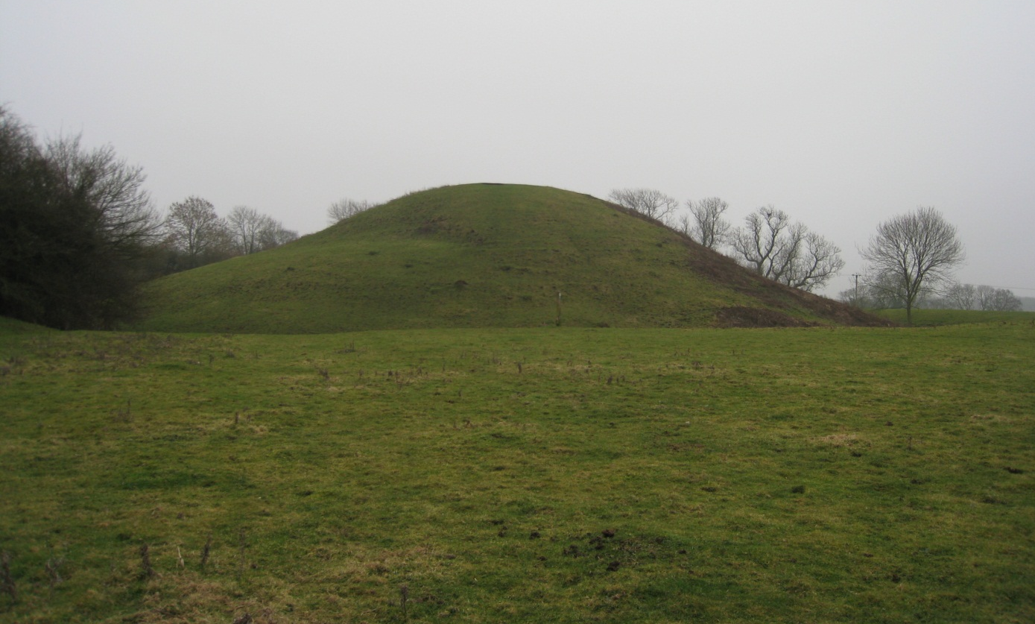
Brinklow Castle (‘The Tump’)
Despite the presence of the castle, Brinklow is not mentioned in Domesday at which time the area formed part of the parish of Smite (VCH, 1951: 45). The building of the castle may also have involved the wholesale reorganisation of settlement in the locality, with the establishment of a village just outside the castle. The series of typically medieval long plots which front The Crescent almost certainly date from this period, for the manner in which the street curves round the castle bailey indicates that this part of the settlement post-dates the construction of the castle, while recovery of twelfth century pottery, suggests it dates from before the establishment of the borough in the early thirteenth century (Coutts and Gethin, 1999).

  - A Medieval Borough
The twelfth and thirteenth centuries saw a flurry of new town foundations across England. Typically, the establishment of a new town was preceded by the acquisition of a market charter (Slater and Jarvis, 1982). In 1218, Nicholas de Stuteville was granted the right to hold a weekly market on Mondays, and an annual fair on St. Margaret’s day, at Brinklow (VCH 1951). The settlement’s position on both the Fosse Way and the Coventry to Rugby road meant that it was well situated to benefit from passing trade. In addition, the castle functioned as an administrative centre for the local area and would have brought people to Brinklow. This was a good site to establish a town, so it is possible that a customary market may have been in operation at Brinklow in the years preceding the charter. Certainly this is known to have been the case elsewhere (Slater and Jarvis, 1982), and such activity could have been accommodated in the broad profile of the village street.
Either way, the establishment of a market at Brinklow was part of a strategy to develop a borough on the site. In common with other medieval town plantations, soon after the market charter was granted burgage plots were marked out and offered to prospective tenants. The borough was certainly in existence by 1227 when a grant mentions two burgages (SBT, DR 10/43).
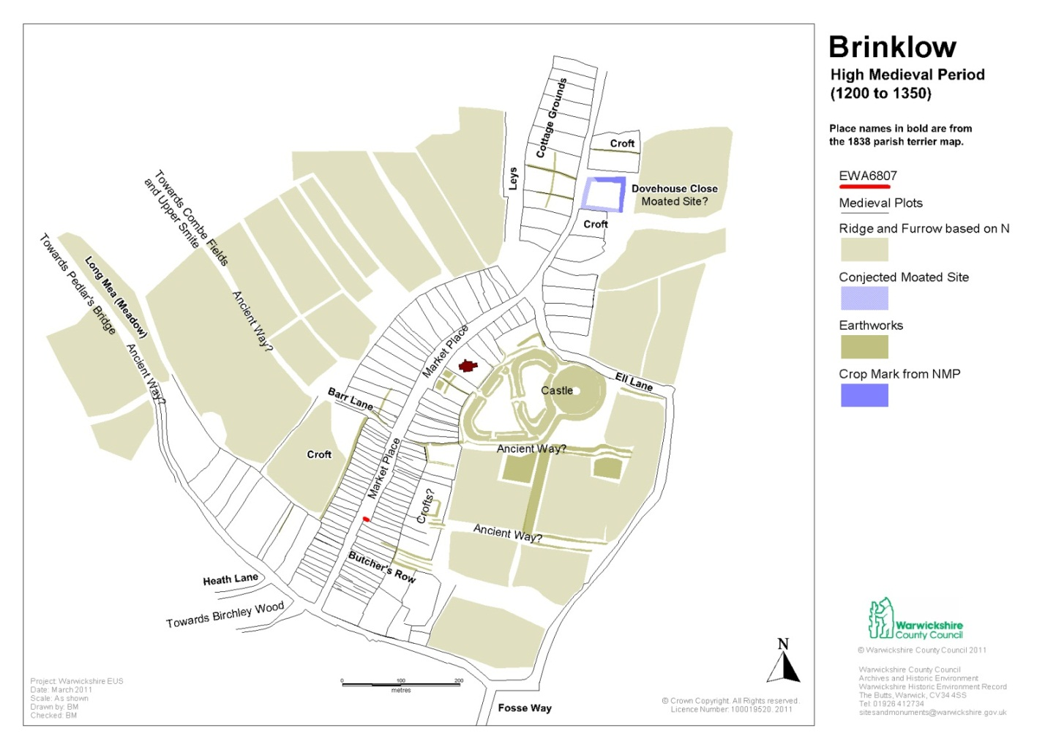

Indicative Plan of Brinklow in the High Medieval Period
The earliest surviving building in the village is the church of St. John the Baptist (MWA 3655). The chronological relationship between the castle and the church is unclear. However, the earliest fabric in the church dates from the 13th century and the church may have originated as a castle chapel (Chatwin, 1928: 134). The proximity of the church to the castle demonstrates the broader association between secular power and the church.
Brinklow was never a large town for, although it was recorded as a borough in 1306, it was only valuated at £26.83 in the Lay Subsidy of 1334 (Glasscock, 1975). Compared with other towns such as Coventry (£750), Henley in Arden (£41.83), Rugby (£37.50) and Warwick (£84.67), this places Brinklow at the lower end of the urban hierarchy in the area (Letters, 2004). Despite this, the Poll Tax assessment of 1379 shows the presence of a community of artisans, and lists, amongst its eighty inhabitants, a turner and a badge or corn dealer. Surnames (which were becoming hereditary at the time but still give some indication of occupation) include mason, weaver, smith, tailor, cook and fisher (Dyer and Lilley, 2012: 89).
  - Late Medieval Decline
By the late medieval period the Black Death, and possibly a number of factors, including Brinklow’s proximity to Coventry (one of the largest centres in England at this period), caused the town to enter a period of decline from which it never fully recovered. The last mention of burgage tenure in Brinklow was in 1473 (SBT, DR 10/106), and by this time the market had in all probability died out. Despite this decline, the parish church was substantially rebuilt towards the end of the fifteenth century, and surviving buildings in the village (such as the jettied timber-framed house at 31-37 The Crescent), show the continuing prosperity of at least some of the community’s inhabitants. By the sixteenth century, however, Brinklow had reverted back to being a rural settlement.
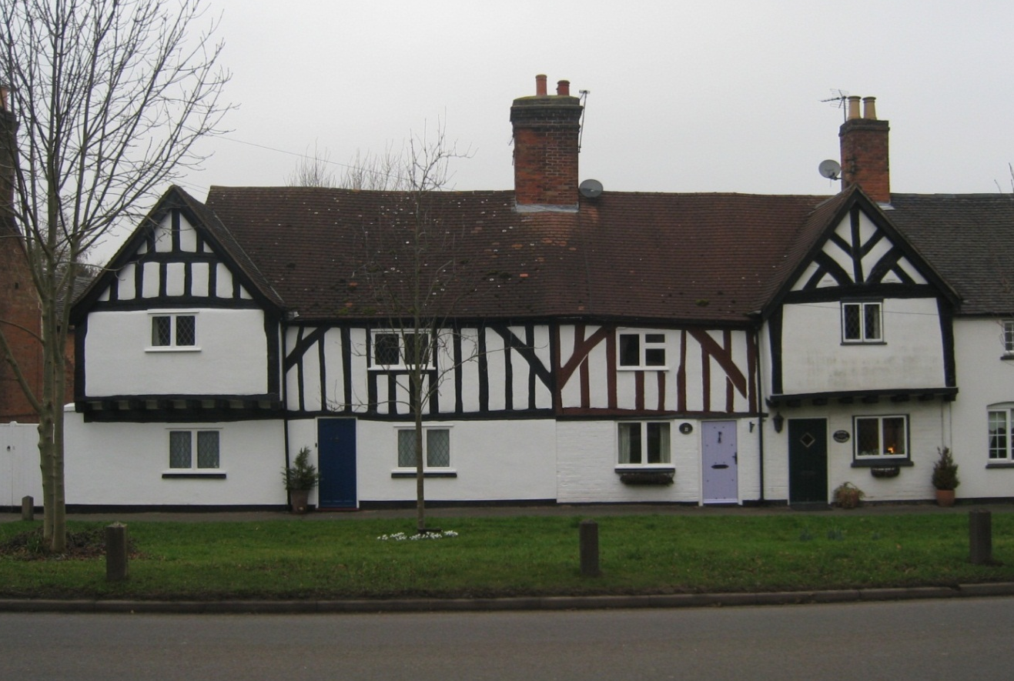
31-37 The Crescent, Brinklow
  - The Early Modern Village
The village continued to take advantage of its position along the Fosse Way, and the settlement accumulated a large number of alehouses (VCH, 1951: 42). In 1741 the Brinklow Enclosure Act, relating to 1,700 acres, was passed (ibid).
  - The Industrial and Modern Town
Brinklow remained little affected by the changes taking place across the country as a result of the industrial revolution, the exception being the building of the Oxford Canal through the village in the late eighteenth century (MWA 3661). The canal followed the 90 metre contour curving round the back of the buildings that lined Broad Street on its western side. In a move to speed up journey times the canal was straightened in 1831, bypassing Brinklow, although the Brinklow Arm was kept open for commercial use. In 1866 Brinklow railway station was opened along the Rugby to Nuneaton line, half a mile north of the village.
Since the Second World War there has been a relatively large amount of new housing built to the south of the village. The vast majority of this new building was directed away from the village's historic street frontages, although some redevelopment did take place behind street frontages at Hall Grove and Barr Lane
Map showing Brinklow and it’s setting in the early 20th Century (OS 1:2500 map, 1903)
- Historic Character
  - Overview
There are few modern buildings along Brinklow’s historic streets and the castle mound is a prominent feature of the settlement’s character. Most buildings date from the medieval period up to the mid-nineteenth century, before the period when changes in transport, and the introduction of manufactured building materials and new aesthetic fashions, led to a standardisation in building styles.
The built environment reflects past changes in styles and materials. In particular, a large number of buildings built (or rebuilt) between the eighteenth and mid-nineteenth centuries reflect Georgian influences to varying degrees. There are a few late nineteenth and early twentieth century buildings reflecting the popularity of revivalist styles at that time.
The village plan still reflects Brinklow's medieval past. The broad profile of the Crescent still echoes its former role as a market place, while the pattern of historic plots is largely the result of medieval settlement planning.

Map showing HTCs by Type

Map showing HTCs by Period
  - The Historic Village Plan
The pre-borough landscape
Development of the medieval town of Brinklow was strongly influenced by existing environmental factors such as topography, drainage, vegetation, land ownership and agricultural systems.
Consequently, detailed analysis of Brinklow's historic plan, and its relationship to the surrounding area, has the potential to tell us much about the landscape before the establishment of the town in the thirteenth century.
The early Norman village of Brinklow, established soon after the castle was built, developed within a landscape comprising extensive areas of uncultivated land and woodland. Meadows would have lain along the Smite Brook to the north west of the village-
Twelfth century records mention woodland at Burdlege or Burhleia, a reference presumably to Birchley wood, south of Brinklow, which is also likely to have included the area later known as Brinklow heath.
The 1838 Parish Terrier Map shows field names such as ‘Ridding’ and ‘Birchley’, which suggest that this woodland extended toward the Fosse Way. To the east of the village, within the parish of Easenhall, is a cluster of place names that refer to woodland. The area is still relatively heavily wooded with a number of spinneys and a larger area of woodland known as 'All Oaks Wood'.
Furthermore, the absence of medieval ridge and furrow in this area suggests the woodland is of ancient origin, and did not regenerate on abandoned fields since the medieval period.
From the surviving pattern of ridge and furrow around the village it is clear that there were a series of uncultivated routes, or ‘leys’, running roughly east-west through the open field system. In the parish enclosure award of 1742 (WCRO CR 2893/8,9; WCRO QS 9/12).these routes were called ‘ancient ways’, one such route went from ‘Sitch Gutter’ to ‘Pedlars Bridge’, where it crossed the Smite Brook by the bridge which was first mentioned in 1443. These uncultivated routes then were clearly established in medieval times, and before the enclosure of the parish's open fields in 1744.They may have been the means by which livestock was moved through the medieval open field system, either to meadows along the Smite Brook and/or the wooded area in Easenhall, or to graze and fertilise fallow parts of the open fields. Various models have been proposed for the origins of open fields in England. Within open fields in parts of Cambridgeshire, Susan Oosthuizen (2005) demonstrated the existence of long furlongs which often crossed several parishes, and were used as 'commons' along their entire length. She suggested that these long furlongs were laid out sometime during the prehistoric period. This may have also been the case at Brinklow, so the series of east-west routes could have been in place long before the establishment of-the medieval open field system.
Significantly, some of these routes pass through the settlement, along the boundaries of the town plan units as defined by Lilley (1994). Consequently, the impression gained is that the settlements growth, reflected in its plan units, took place within an earlier framework of these east-west routes.
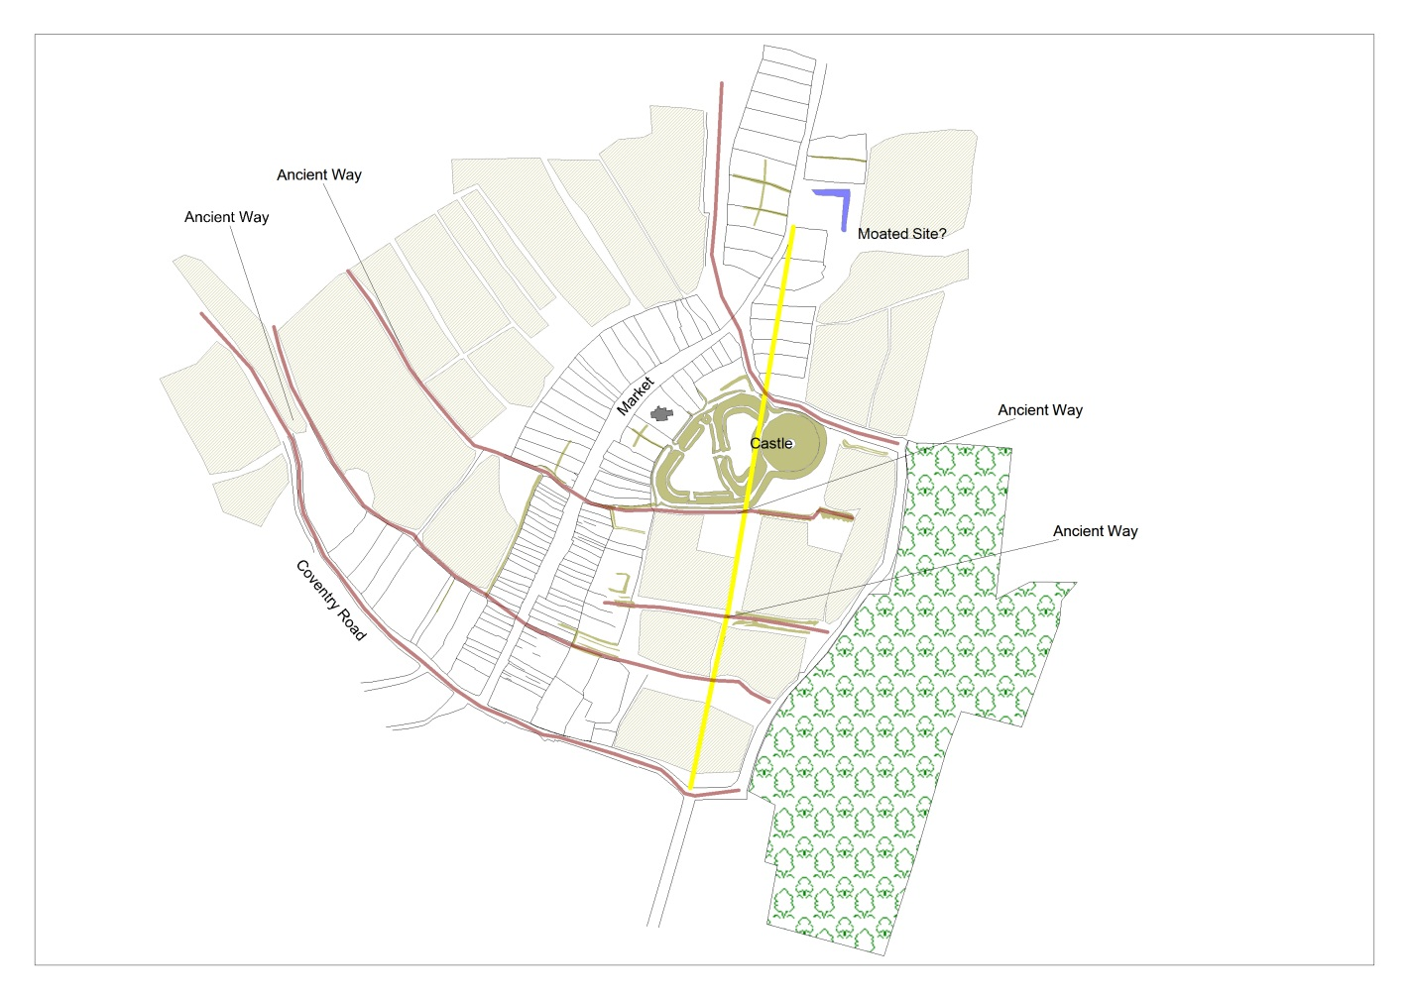
Indicative plan showing the possible pre-medieval routeways through Brinklow
The pre-borough settlement
According to Lilley (1994) the series of long plots fronting The Crescent formed the focus of settlement in the eleventh and twelfth centuries (area 1 in map below). As Lilley stated (1994: 58), the manner in which this part of the village curves around the castle bailey indicates that the settlement plan post-dates the construction of the castle. The recovery of substantial quantities of twelfth century pottery from this area is further proof of the existence of a settlement before the establishment of the borough in the thirteenth century (Coutts and Gethin, 1999).
The medieval borough
Soon after the market grant, plots were laid out along Broad Street. These were regular shallow burgage plots; whose morphological coherence implies that they were part of a deliberate urban extension (area 2 and 3 in map below). According to Lilley this street represented one distinct phase of development. However, analysis of plot dimensions in Broad Street and The Crescent, as depicted on the Ordinance Survey Second Edition, shows a significant difference in the average width of plots between the two streets. The early success of the town would possibly have led to the sub-division of burgage plots in an attempt to maximise rental income.
This urban extension may have included the development of a second market place. The 1838 terrier map shows clearly that Upper Broad Street was significantly wider than Lower Broad Street, with a ‘dog-leg’ at the junction between the two.
The presence of two listed seventeenth century houses (numbers 46 and 50 Broad Street) along the same alignment demonstrates that the frontage dates back to at least the seventeenth century Archaeological work on the eastern side of Broad Street uncovered a ditch, presumably a boundary, with pottery dated between the thirteenth and fourteenth centuries, indicating that the street frontage was on this alignment from the earliest years of the borough.
Despite the formalisation of urban status at this time, it appears that consideration was given to rural activities by the maintenance of an existing route for the movement of livestock through the new extension of the borough. The lozenge-shaped Barr Lane linked the High Street to the open fields beyond. Opposite this is a further lane similarly linked the High Street to fields immediately behind it. The two lanes would have facilitated the movement of stock - through the town to the surrounding fields.
Continued expansion of the population saw a corresponding expansion of the town along the Rugby and Coventry roads (areas 4-7 in map below). The recent find of a timber cruck in the Bull's Head public house on Coventry Road testifies to the presence of habitation at least from the late medieval period (Vernacular Architecture Group, 2003). One incentive for developing this area may have been to benefit from passing trade moving between Coventry and Rugby.
Settlement along Lutterworth Road
According to Lilley (1994) the medieval town did not extend north along the Lutterworth road beyond Ell Lane, this appears to be a later development of the settlement (area 8 in map below).
  - Significance of the Village Plan
A number of the Warwickshire’s towns with origins in the medieval period still exhibit the same characteristic plan features as Brinklow, but often in a more fragmentary form. Down the centuries, continued urban development in these centres often removed boundaries, created new streets, and developed areas behind the main street frontage. Brinklow’s failure to remain an urban centre meant that it largely escaped these changes associated with the pressures of urban expansion.
Consequently Brinklow’s village plan is a unique and highly significant resource illustrating the history of village, and the founding processes and evolution of a medieval small borough.

Map showing plan units and development sequence for Brinklow (OS 1903 basemap)

- Historic Town Character Areas
Using the information from this historic assessment and associated historic characterisation, Brinklow has been divided into five historic town character areas (HTCAs):
For each HTCA a statement has been written which is intended to provide a localised summary of heritage interest and character of each area. In defining each area the overall historic character of the townscape is taken into account.
Brinklow Historic Town Character Areas (HTCAs)

  - The Crescent HTCA
Sense of Place
The medieval settlement plan still underpins the area’s historic character. The broad profile of The Crescent, which now serves as a village green, is a reflection of its past function as the town’s market place. The near–continuous, present-day street frontage on the western side of The Crescent is a product of the narrow width of the medieval plots. Buildings dating from the fifteenth to the twentieth century are aligned along this street frontage. The streetscape, therefore, reflects past changes in architectural fashion and building materials.
History
Evidence for pre-medieval activity within the area is slight. However, a residual sherd of Romano-British pottery was recovered during the observation of groundworks across the churchyard of St. John the Baptist Church (MWA9863), and in 1932 a single Roman coin and medieval pottery were uncovered close to the castle (MWA6010).
Soon after the Norman Conquest (1066) Brinklow Castle was constructed, perhaps in part to control the Fosse Way. It is likely that a village was laid out soon after the building of the castle and The Crescent formed the focus of this settlement. After the establishment of the borough in the early thirteenth century, The Crescent served as the market place.
Despite the loss of Brinklow’s urban status in the fifteenth century, the continuing success of the village is demonstrated by the large number of fine buildings, dating from the fifteenth to nineteenth centuries, which still survive.
Settlement Morphology
The character of the road and street network in the area is largely the result of medieval settlement planning; the area’s pattern of plots were laid out soon after the building of the castle. The broad profile of The Crescent reflects its original role as a medieval village green, and later as the medieval town’s market place. The narrowing of The Crescent at both ends was to restrict access to and from the market place.
The large gardens running behind the street frontage has often resulted in infill development. Here during the early industrial period (1750 to 1850) mainly industrial development took place behind properties lining The Crescent. These developments were likely continuing a tradition dating back to the medieval period where industrial and agricultural activity took place behind the house fronting the street.
Recent development, on large gardens behind the street frontage, has been less sympathetic to the inherited settlement plan, with new housing at Hall Grove obliterating the earlier pattern of plots.
Built Character
The townscape is characterised by a number of highly distinctive buildings dating from the late medieval period to the present.
In general, vernacular houses along the western side of The Crescent share a number of common characteristics. Roofs tend to be gabled at either end; earlier houses have a steeper pitch to the roof than later (mainly nineteenth century) examples. The overwhelming majority are terraced and mainly two storey facing side on to the street frontage.
Changes in vernacular domestic designs, reflecting changing aspirations and identities, are clear from later alterations to vernacular dwellings in the area. This is evident in the differences between number 7 The Crescent, with a steeper pitched roof, and the shallow pitches on numbers 11, 13 and 15.
No’s 7-15 The Crescent, Brinklow
The eastern side of The Crescent displays considerably less unity in building types and styles. 72 Broad Street is an important example of how the form and style of a house can change over time. The early origins of this building are attested by the exposed box timber-framing on the northern gable wall. At some point the timber frame was concealed by a brick façade, which may have covered over or replaced the wattle and daub infill. The brickwork shows no recognisable bond: this and the irregular shape of the bricks also suggest an early date for the building.
At a later date the building was heightened in brick, Flemish bonded, giving the roof a much shallower pitch. It is likely that this took place during the nineteenth century.

72 Broad Street, Brinklow

This character area also contains a number of important buildings that reflect the more recent changes to the village. A fine example of late nineteenth century Gothic Revival architecture can found at The Revel School, The Crescent. The building has a number of features typical of gothic styling including pointed window arches and front door frame, a steep conspicuous roof, and a faintly ecclesiastical look.

The Revel School, The Crescent, Brinklow

A distinctive late nineteenth century Queen Anne style can be seen at 44 The Crescent, where the vernacular influence is clear with the tall chimneys, bay windows, and the use of red brick. The first floor is rendered white to contrast against the red brick ground floor.
47 The Crescent, formerly a farmhouse, is largely mid-nineteenth century Italianate in style. The brick Romanesque arch around the front door, and the roof with overhanging eaves, are typical of the Italianate -style; while the hipped roof and straight headed window surrounds are features often associated with Georgian buildings. This building represents an important example of the cross-over between Georgian and later Italianate styles.
5 The Crescent has elements of Georgian styling, with tall windows and a shallow pitch to the roof.

  - Lutterworth Road HTCA
Sense of place
The character of Lutterworth Road is largely the product of the area’s medieval settlement plan, the presence of historic farmsteads, the former course of the Oxford Canal, and the construction of suburban villas in the late nineteenth and early twentieth centuries.
History
There is no direct evidence for pre-medieval activity within the area, but it probably formed part of a planned settlement laid out soon after the building of the castle. The area was probably occupied throughout the whole of the medieval period; however, the intensity of settlement is likely to have contracted from the mid-fourteenth century onwards. Evidence for a significant degree of settlement shrinkage comes from the lack of early buildings dating from before the eighteenth century. By the time the 1838 Terrier Map of the parish was produced, a series of what appear to be vacant plots line Lutterworth road.
The fortunes of the area do not seem to have changed greatly when the Oxford Canal was built in the late eighteenth century. The straightening of the canal in 1831, with its consequent by-passing of Brinklow, would have dealt a significant blow to any commercial aspirations the residents might have had for the area. This would have been further compounded by the railways largely by-passing the town in the mid nineteenth century. Despite this, by the mid to late nineteenth century two large farmsteads with associated labourers’ cottages had developed here.
A major change to the area’s character started in the late nineteenth century with the construction of a fine example of a Gothic Revival suburban house. This process of gentrification has continued into the present with the construction of a number of bespoke houses and bungalows, although residential development only began in the nineteen twenties.
The cemetery along Lutterworth Road was created in the late nineteenth century.
Settlement Morphology
It is likely that Lutterworth Road formed part of the planned medieval settlement. The pattern of early settlement still influences many of the area’s plots and paddocks.
The building of the Oxford Canal in the late eighteenth century had a major impact upon the area’s townscape grain. When the original part of the canal which skirted round Brinklow fell out of use, it allowed the creation of distinctively curved plots along its former course. The wharf that developed at the end of the Oxford Canal Brinklow Arm is still visible and is an important contributor to the area’s character.
The layout of housing in Lutterworth Road is characteristic of inter-war linear growth, but the earlier field boundaries have partly influenced growth in the area. For example, when the cemetery was laid out it adapted an existing paddock marked as a ‘croft’ on the 1838 Parish Terrier Map.
Built Character
The area has a few examples of vernacular architecture dating from the Early Industrial (1750 to 1850) period, and possibly earlier. The most significant is the farmstead complex at 6 Lutterworth Road. The Parish Terrier map of 1838 shows a developed farmstead, and it is likely that this site had already been occupied for a significant period. Nearby are houses dating from the Early Industrial (1750 to 1850) period, and may have housed agricultural labourers possibly working at the farmstead at 6 Lutterworth Road.
6 Lutterworth Road, Brinklow

A key characteristic of the area is the diversity of architectural types exhibited in a small number of buildings reflecting the piecemeal nature of development. Important examples of late nineteenth and early twentieth century architecture can be seen at 13 Lutterworth Road, a fine example of late Victorian gothic architecture that has altered little since it was built.
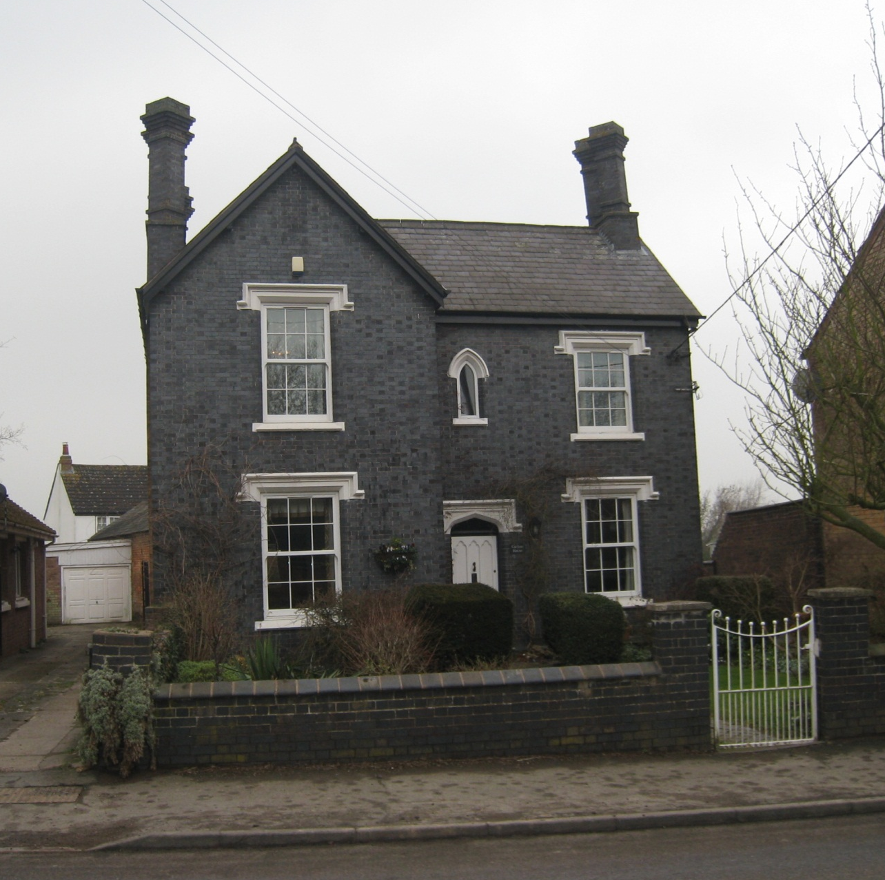
13 Lutterworth Road, Brinklow

71 and 69 Lutterworth Road show elements of the arts and crafts style.

  - Broad Street HTCA
Sense of place
The overall composition of the streetscape still reflects the medieval pattern of narrow burgage plots along Broad Street.
Broad Street contains a number of highly distinctive buildings from many periods. Each incorporates different building materials to produce a distinct character.
History
Evidence for pre-medieval activity within the area is slight. It is likely that Broad Street was a speculative development laid out after the granting of a market charter in 1218. The planned urban character of this extension is suggested by the narrow plots that display a morphological coherence and are similar to other known medieval burgage plots in Warwickshire. That this area was laid out early on is supported by the twelfth to thirteenth century medieval pottery recovered from a ditch fill at 28 – 30 Broad Street.
Although the area lacks examples of high status timber-framed housing such as is found in The Crescent HTCA, a number of important sixteenth and seventeenth century timber-framed houses survive, testifying to the area’s continuing occupation during the early modern period.
Settlement Morphology
Broad Street’s settlement plan is heavily influenced by that of the medieval period, with burgage plots lying along both sides of the road.
Built Character
Broad Street’s built heritage is characterised by a number of highly distinctive buildings dating from the late medieval period to the present. In general, however, timber-framed buildings in the area are smaller than those found along The Crescent. This may reflect either a difference in survival rate of buildings or an historical difference in status between the two areas. The presence of the parish church and the castle may have attracted high status habitation.
Broad Street has a number of fine, mainly pre-nineteenth century, vernacular houses. Many of them exhibit a number of common characteristics. Houses tend to have gabled roofs; earlier houses have a steeper roof pitch than later (mainly nineteenth century) dwellings. Many are terraced and mainly two storey, facing side on to the street frontage.
Houses 13, 15 and 17 Broad Street demonstrate the changes to vernacular forms between the seventeenth and eighteenth centuries. Houses 13 and 15 date from the 17th century and are timber-framed with later brick infill between the timbers. The roofs are thatched and of a steep pitch. Above the ground floor is an attic. 17 Broad Street is of brick construction which has been rendered. It has a slate roof and the pitch is much shallower than that at 13 and 15. The house has two full height storeys. These differences demonstrate the extent to which vernacular forms could change over a comparatively short period of time.
Generally, the characteristics observed in 13, 15 and 17 can be seen in other vernacular buildings in the area.
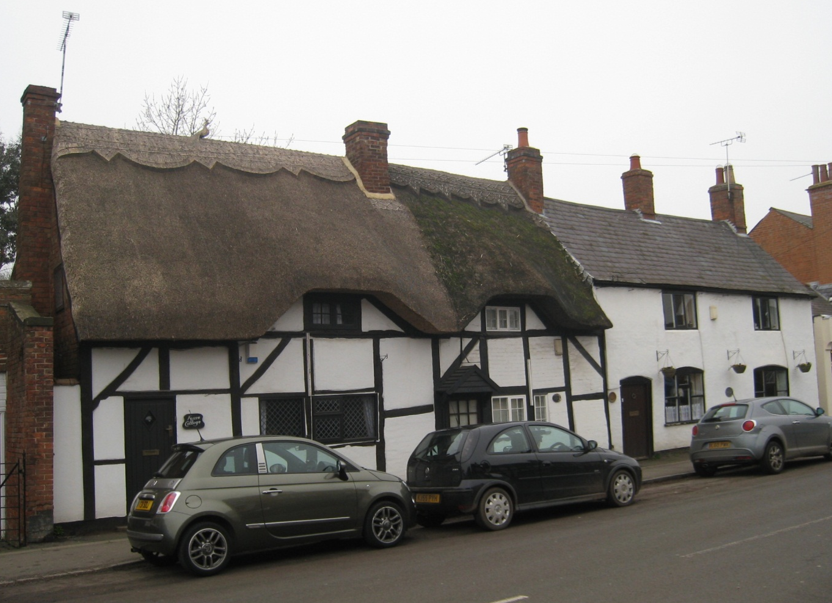
13-17 Broad Street, Brinklow

This character area has a number of buildings conforming to architectural styles from the Georgian period onwards. One of the earliest examples is 11 Broad Street, a three storey building that dominates the southern end of Broad Street.
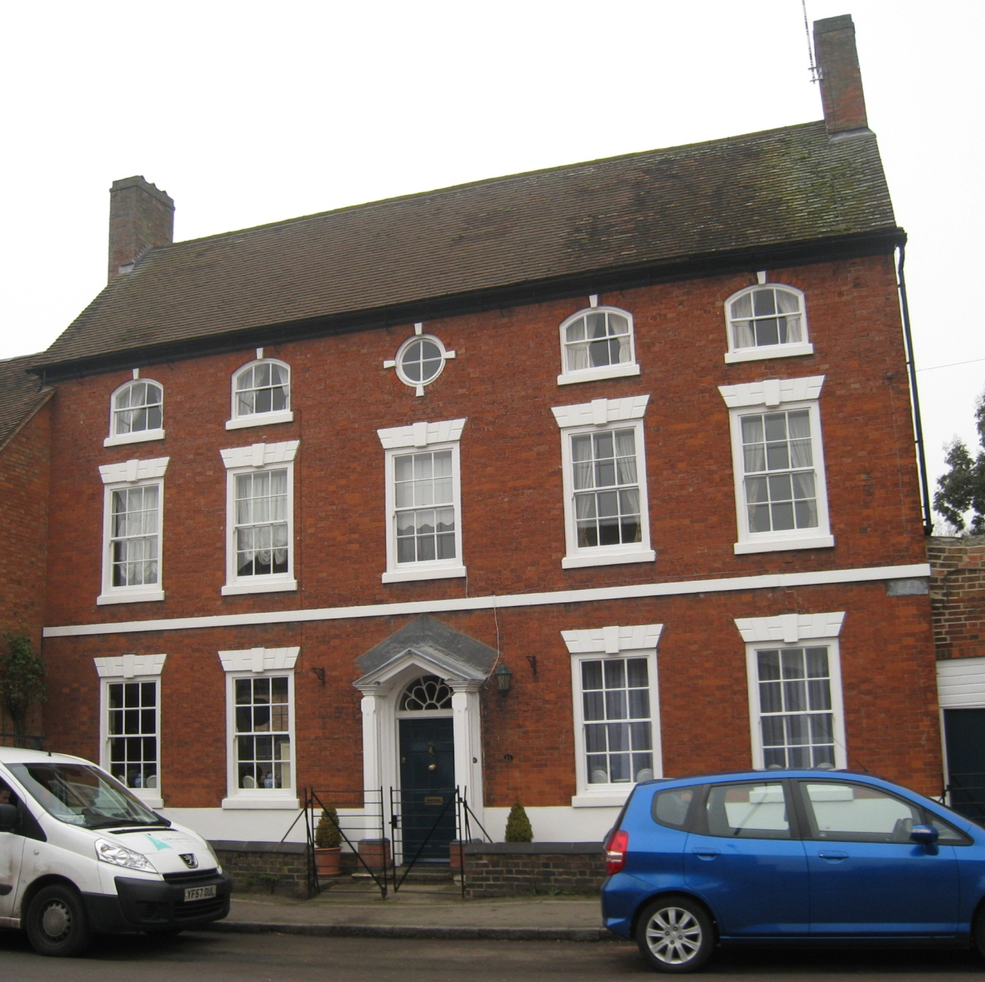
11 Broad Street, Brinklow

Opposite this house is Brinklow United Reformed Church. The chapel probably dates from the mid-nineteenth century and is heavily Georgian in style.

  - Coventry Road and Rugby Road HTCA
Sense of Place
On the periphery of the town, this area’s character is strongly rural. It is influenced largely by the continued presence of a working farm, and historic dwellings set in large plots with mature planting.
History
It is likely that settlement first developed here in the medieval period, during the demographic expansion of the twelfth to thirteenth centuries. The peripheral location may have made any settlement here particularly prone to contraction or abandonment in the late medieval period.
In the early modern period settlement was most probably very limited and agricultural in nature. The surviving timber frame in the western gable end wall of West Farm House indicates that it may date from this period.
Between the late eighteenth to nineteenth centuries West Farm and Home Farm continued to expand, testified by a number of surviving agricultural buildings. At about the same time the area also had a smithy that probably served West Farm and Home Farm, and cottages for agricultural labourers.
Settlement Morphology
Coventry and Rugby road area’s settlement plan is heavily influenced by that of the medieval period, with burgage plots lying along both sides of the road.
The presence of curved plot boundaries along the Coventry Road suggests that they were laid out over ridge and furrow.
The fragmented pattern of agricultural paddocks and low density settlement made this area particularly susceptible to twentieth century piecemeal infill development. This has resulted in grandiose modern (post-1990) detached dwellings that alter the area’s historic character
Built Character
The area has a few important examples of vernacular architecture. In particular, the farmhouse at 5 Rugby Road is a significant example of a timber-framed seventeenth century farmhouse that was later clad in brick.
5 Rugby Road, Brinklow
The Bull’s Head Public House, shown on the Parish Terrier map of 1838, is one and a half storeys high with external brick walling. Dating this building is difficult -but it may belong to the early modern period (1540 to 1750).
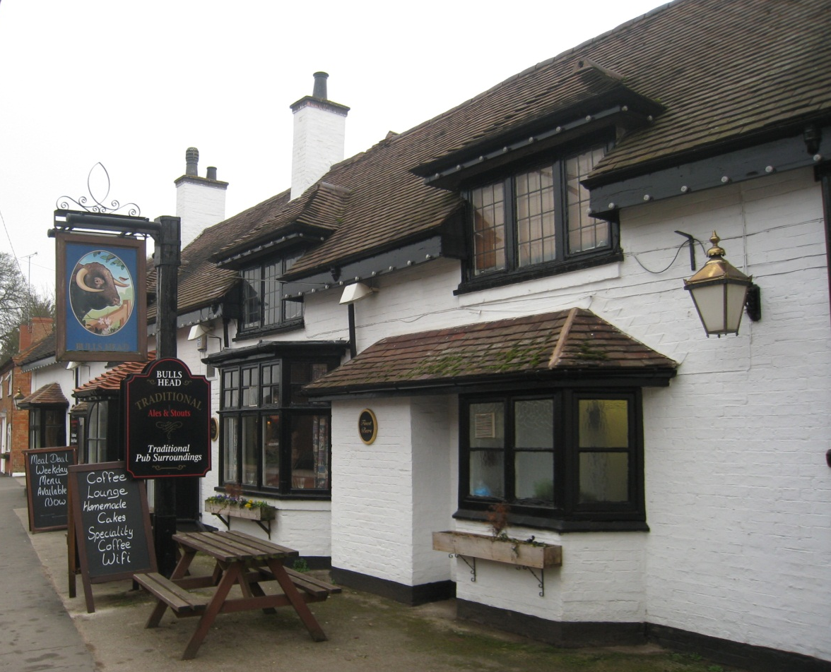
The Bull’s Head, Coventry Road, Brinklow
There is a particularly interesting example of the stylising of an earlier historic building at a later period. The house at 27 Coventry Road dates from the early 17th century and is of timber-framed construction with later brick infill and cladding, a form and construction very similar to 5 Rugby Road. However, at some point in the late nineteenth or twentieth century, features were added such as a bay window on the ground floor, and an imitation jettied gable section above. The later styling reflects a deliberate ‘rustification’ of the house, and is typical of the vernacular revival movement of the early to mid-twentieth century.
27 Coventry Road, Brinklow

Each vernacular house is an aggregation of different architectural styles acquired over the ages. Relatively modern houses tend to conform to one of a range of styles, each borrowing from a specific historical period. This historically wide-ranging but individually homogenous architectural style can be classified as modern eclectic.

  - Green Lane and Heath Lane HTCA
Sense of Place
This area is largely the result of post-war growth, with a high degree of uniformity of house design and plot layouts over large areas. Despite this, clear phases of development can be seen from differences in housing styles.
History
The area’s earlier history is largely unknown, although historic maps show a series of paddocks running along Coventry Road which may be the remnants of a medieval settlement. This suggestion is partly supported by the fact that their length is similar to plots on the other side of the road.
The Ordinance Survey second edition shows an area of allotment gardens. During the inter-war period (1918 to -1939), housing developed along part of Coventry Road.
However, the area remained largely undeveloped until the second half of the twentieth century. Between 1955 and 1970 a number of houses were built.
Settlement Morphology
The street layout is typical of many housing developments built between 1960 to 1980 with the frequent use of long crescents and multi-headed cul-de-sacs.
The townscape is largely the result of inter-war linear growth along a main road, a type of urban growth particularly common during this period, before the introduction of stringent planning controls were introduced to restrict urban sprawl.
Cul-de-sac at Heath Lane/Green Lane
Built Character
The area’s only example of a vernacular building, shown on the 1838 Parish Terrier map, is 4 Coventry Road, a cottage with an M-shaped shallow pitched roof, and brick walling
Of particular interest are 1 Heath Lane, a small Georgian styled farmstead and an important reminder of the area’s once-agricultural character, and The Fire Station, Heath Lane, an example of post-war neo-Georgian municipal architecture.
1 Heath Lane, Brinklow

Buildings in the area are typical of those found on post-war social housing developments.
The area has a number of houses that have features associated with neo-Georgian styling. Later post-war development has displayed less uniformity in terms of architectural styles.

- Bibliography
Aston, M. and Bond, J. (1987) The Landscape of Towns, Sutton, Gloucester
Barker, W. A. (1986) ‘Warwickshire Markets’, Warwickshire History
Beresford, M. W. (1967) New Towns in the Middle Ages: town plantation in England, Wales and Gascony, Lutterworth, London.
Beresford, M. W. and Finberg, H. P. R. (1973) ‘English medieval boroughs: a handlist’, David and Charles, Newton Abbot.
British Geological Survey (1994)
Bloxham, M. H. (1840-1850) Fragmentaria Sepulchralia: A Glimpse of Sepulchral and Early Monumental Remains of Great Britain (Oxford: Oxford University Press).
Camden, Wm, 1607, Britannia hypertext critical edition by Dana F. Sutton (2004)
Chatwin, P. B., 1928, Transactions of the Birmingham and Warwickshire Archaeological Society Vol. 53
Chatwin, P. B., 1936, Transactions of the Birmingham and Warwickshire Archaeological Society Vol. 60
Chatwin, P.B., 1947-8, 'Castles in Warwickshire' Transactions of the Birmingham and Warwickshire Archaeological Society Vol. 67
Conzen, M. R. G. (1960) Alnwick, Northumberland: a study in town-plan analysis (Publication No. 27), Institute of British Geographers, London.
Coutts, C. (2004) Archaeological Observation at St John’s Church, Brinklow, Warwickshire. Warwickshire Museum Field Services.
Coutts, C. and Gethin, B. (1999) Archaeological Observation at Hill Farm, 29 The Crescent, Brinklow, Warwickshire, Warwickshire Museum Field Services.
Creighton, O. (2002) Castles and Landscapes: Power, Community and Fortification in Medieval England. Equinox, London,
Dyer, A. (1976/7) ‘Warwickshire Towns under the Tudors and Stuarts’, Warwickshire History
Dyer, C. and Lilley, K. (2012) 'Town and Countryside: Relationships and Resemblances' in Medieval Rural Settlement: Britain and Ireland, AD 800-1600, ed. by N, Christie and P. Stamper, Windgather Press, Oxford.
Dugdale, W, Historian, (1605 – 1686): His Life, His Writings and His County (ed. C, Dyer and C, Richardson) The Boydell Press, Woodbridge (2009).
Glasscock, R. E, (1975) The Lay Subsidy of 1334, Oxford University Press: British Academy.
Hooke, D. (1985) The Anglo-Saxon landscape: The Kingdom of the Hwicce, Manchester University Press, Manchester
Hoskins, W. G. (1955) The Making of the English Landscape, London.
Jones, S. (ed.) (2003) Georgian Coleshill: by The Georgian Group of Coleshill Civic Society, Coleshill Civic Society, Coleshill’.
King D. J. C. (1983) ‘Castellarium anglicanum: an index and bibliography of the castles in England, Wales and the Islands’. Volume II: Norfolk-Yorkshire and the islands,
Letters, S. (2004) Online Gazetteer of Markets and Fairs in England Wales to 1516 (http://www.history.ac.uk/cmh/gaz/gazweb2.html): Warwickshire (Centre for Metropolitan History, Institute of Historical Research): last updated date 16 March, 2007, accessed: August 2014
Lilley, K. D. (2000) 'Mapping the medieval city: plan analysis and urban history' in Urban History, Vol. 27
Lilley, K. (1994) ‘A Warwickshire medieval borough: Brinklow and the contribution of town-plan analysis’, in Transactions of the Birmingham and Warwickshire Archaeological Society 98,
Morris, J Phillimore, Chichester (1976), Domesday Book: Warwickshire including Birmingham, History from the Sources.
Mawer, A. and Stenton, F. M. (1936) The Place-Names of Warwickshire, Cambridge University Press, Cambridge
Oosthuizen, S. (2005) ‘New Light on the Origins of Open-field Farming?’ In Medieval Archaeology Vol. 49.
Report of the Committee for 1933’, in Transactions of the Birmingham and Warwickshire Archaeological Society 57.
Schofield, J. and Vince, A. (1994) Medieval Towns, Leicester University Press, Leicester.
Semple, S. J. (1998) ‘A fear of the past: the place of the prehistoric burial mound in the ideology of middle and later Anglo-Saxon England.’ World Archaeology
Slater, T. R. (2008) ‘In the Hands of an Alien Priory: Creating a Medieval Town’ in Atherstone a Pleasantly Placed Town (ed.) N. Alcock, and M. Hughes (Phillimore & Co, Chichester)
Slater, T. R. (1987) ‘Ideal and Reality in English Episcopal Medieval Town Planning’, Transactions of the Institute of British Geographers New Series xxii,
Slater T. R. and Jarvis P. J. (1982) Field and Forest, An Historical Geography of Warwickshire and Worcestershire (Geo Books, Norwich)
Sweet, R. (1999) The English Town 1680-1840: Government, Society and Culture, Longman, London
Toulmin-Smith, Lucy (ed) (1910), The itinerary of John Leland in or about the years 1535-1543 (Bell and Sons; London)
VCH (1951) The Victoria County History of Warwickshire Vol. VI, Knightlow Hundred, London
Vernacular Architecture Group (2003), Cruck database http://archaeologydataservice.ac.uk/archives/view/vag_cruck/ Last updated 2011, accessed August 2014
Wager, S. J. (1998) Woods, Wolds and Groves: the woodland of medieval Warwickshire, BAR British Series 269, Archaeopress
Williams, H. (1998) ‘Monuments and the past in early Anglo-Saxon England.’ World Archaeology 30
Williams, H. (2006) Death and Memory in Early Medieval Britain: Cambridge Studies in Archaeology, Cambridge University Press, Cambridge.
Wilson, J. M. (1872-72) Imperial Gazetteer of England and Wales
Appendix 1: Brinklow Historic Archive Report
The report below was produced by the Warwickshire County Record Office as a summary of the archive material relating to Brinklow available at the Record Office.
HISTORICAL INTRODUCTION

Background and Administrative History
Brinklow is a parish situated seven miles east of Coventry and five mile north-west of Rugby. It was anciently a chapelry in the parish of Smite, but became a separate parish in the early middle ages. It is in the hundred of Knightow, and in 1836 became part of Rugby Poor Law Union, from which Rugby Sanitary District was formed in 1872. In 1894 it became part of Rugby Rural District Council, and in 1974 part of Rugby Borough Council. It was in the diocese of Lichfield and Coventry until 1836, then in the diocese of Worcester until 1918, and since then in the diocese of Coventry. The village of Brinklow is situated on the Fosse Way, which at this point is diverted around the presumed prehistoric burial mound that forms the motte of the 11th century castle.

Manorial History
Brinklow does not appear separately in the Domesday Book, probably because it was part of the parish of Smite. The overlordship was held by the earls of Leicester, and later by the earls and dukes of Lancaster: they continued to hold courts for Brinklow until 1821, although the court leet and view of frankpledge was leased to Sir Fulwar Skipwith in 1685, and the manor was leased to Sir Thomas Skipwith in 1789 and granted to Sir Thomas George Skipwith in 1854. By 1866 it appears to have been held by the Gregorys of Stivichale.

The principal tenancy, from early in the 12th century, was held of the earls of Leicester by the Mowbrays, who in early in the 13th century granted their rights in the manor to the Stutevilles. The subsequent history of this tenancy is rather confused, but it seems to have been leased to the Segraves before 1240. The tenancy passed to the Wakes of Liddel in the mid 13th century by the marriage of Joan Stuteville to Hugh Wake, and was leased to the Whittlebury family in the late 13th century. It was held by William de Thorp by 1341. He then granted it (with the permission of the Earl of Lancaster) to the abbey of Combe in 1344.

In 1539 the manor of Brinklow (i.e. the tenancy granted by William de Thorp in 1344 to the Abbot of Combe) was granted for life to Mary, Duchess of Richmond and Somerset. She died in 1557, and the following year the manor was granted to Robert Lane and Anthony Throckmorton, who that same year obtained licence to grant the manor to William Dawes, his heirs and assigns, to be held in chief. In 1588 William Dawes granted lands in Brinklow and all his manorial rights to Arthur Gregory, and the Gregorys held the tenancy of the manor thereafter.

Markets and Fairs
A grant of a weekly market (on Mondays) and an annual fair was made by King John and confirmed in 1218. King Henry granted a weekly market on Tuesdays to Stephen de Segrave in 1240. The weekly market is mentioned in manorial documents as late as 1832, but seems to have died out long before then; it is not mentioned by Dugdale.

Burgages
A grant of 1227 mentions two burgages (SBT DR 10/43). The last mention of a burgage in the deeds in the Gregory archives is a deed of 1473 (DR 10/106).

Landed Estates
The major medieval landowners are mentioned in the manorial history given above. There are few surviving accumulations of records for these families, or for the Abbey of Combe, apart from records in the archives of the families mentioned below.

The post-medieval situation of Brinklow was not dominated by a single estate. The major family with a substantial landed interest in Brinklow were the Gregory-Hoods of Stivichall. Other major landowners include the Cravens of Combe Abbey and the Leighs of Stoneleigh.

PRIMARY SOURCES (archival) | Reference
Antiquarians’ papers | Nothing noted
Building plans
Rugby RDC building control plans, 1902-1948 Rugby RDC building control plans, 1948-1974 | WCRO CR 2888  WCRO CR 3573
Businesses (see also Industries)
Trades | Nothing noted
Cemetery Records
Brinklow Burial Board, 1884-1987 | WCRO CR 629A, CR 2893, CR 2961, CR 3152
Census Returns | On microfilm at WCRO
1841 census of Brinklow | TNA HO 107/1136
1851 census of Brinklow | TNA HO 107/2069
1861 census of Brinklow | TNA RG 9/2210
1871 census of Brinklow | TNA RG 10/3183
1881 census of Brinklow | TNA RG 11/3076
1891 census of Brinklow | TNA RG 12/2456
1901 census of Brinklow | TNA RG 13/2914
1911 census of Brinklow | TNA RG 14/18595,  TNA RG 78/1112
Charities (see also Parish)
Hancox’s Bread Charity, 1747-1869 | WCRO CR 624
Communications
Turnpikes | Nothing noted
Canals
Oxford Canal: company records, late 18th to 20th centuries | WCRO CR 1590; British Waterways Archives at Gloucester
Oxford Canal: plan of intended improvements, 1828, 1829 | WCRO QS 111/60, 63
Oxford Canal: plans of intended improvements, 1829 | WCRO CR 1365
Railways | Nothing noted
Courts
Quarter Sessions  Minutes & order books, 1625-1973 | WCRO QS (1625-1699 printed in Warwick County Record Series)
Hundred Court
Knightlow Hundred Court, 1694-1720 | WCRO HR 52
Magistrates Court
Kirby Division, minutes etc., 1865-1907 | CR 321
Rugby Division, minutes etc., 1899-1978 | WRCO QS 116/8, CR 1617, CR 2694, CR 2694
Diocese | Lichfield and Coventry
Bishops registers | Lichfield Record Office
Church Courts | Lichfield Record Office
Visitation records | Lichfield Record Office
Documents of title (see also Landed Estates)
Craven of Combe Abbey; Brinklow deeds, 1714-1876 | WCRO CR 8/52, 53; WCRO CR 2582/1-10
Craven of Combe Abbey; Warwickshire deeds, 13th c.-19th c. | BLO
Gregory-Hood of Stivichall; Brinklow deeds, 12th c.-1817 | SBT DR 10/38-185a
Leigh of Stoneleigh deeds, 1694-1820 | SBT DR 18
Skipwith estate deeds, 1610-1784 | WCRO CR 829/43-53
Skipwith estate deeds, 1351-1854 | BCA Keen purchase [MS 3307]
Skipwith: Abstract of the title of Charles Ramsden to the Newbold Hall estate, 1861 (1770-1857). | WCRO CR 2942/1/1
Ward-Boughton Leigh deeds, c. 1300-1534 | WCRO 162/45-49
Collection of deeds etc., 1574-1716 | BCA 338308
Deeds of Mrs Bird’s estate, c.1669-1841 | WCRO CR 188/13
Deeds of Mr Robert’s estate, 1510-1??? | WCRO CR 410
Deeds of former Police House, 1797-1831 | WCRO CR 703
Misc. deeds, 1648-1790 | WCRO D 19/155-165
Deeds relating to a close of land at Brinklow, 1766-1856 | WCRO CR 3291/707
Deeds relating to close of land at Brinklow, 1793-1813 | WCRO CR 3291/711
Deeds for Jayes House, Brinklow, 1741-1837 | WCRO CR3291/712
Deeds for farm in Brinklow, 1733-1841 | WCRO CR0210/1-13
Deeds for Holy Trinity, Coventry, estate, 1311-1875 | WCRO DR 429, DR 564
Inclosure
Award (no plan), 1741-2 (with typed copy) | WCRO CR 2893/8,9; WCRO QS 9/12
Interpretation of Award (with plan) | WCRO Z 894 (sm)
Industries | Nothing noted
Landed Estates
Craven of Combe Abbey | WCRO CR 8; WCRO CR 2582
Gregory-Hood of Stivichall | SBT DR 10
Leigh of Stoneleigh | SBT DR 18
Local Government
County Council | WCRO
District Council | WCRO CR 1523; CR 2174;  CR 2656; CR 2897
Parish Council (see also Parish)  Minutes, etc. 1927-1987 | CR 2961; CR 2893
Manorial (see also Landed Estates)
Views of Frankpledge, 1441-4, 1465,1471, 1473, 1478, 1486, 1497-8, 1557-9, 1564-1568 [Duchy of Lancaster] | SBT DR 10/2235-40, 2243-4, 2245, 2246-7, 2251-2254, 2257-59, 2260-63
[Views of Frankpledge?], 1543-4, 1553-5, 1561-3, 1587-8, 1744-1752, 1785-1821 [Duchy of Lancaster] | TNA DL 30/81/114-115, 1119, 1125, 1152-6
Little Court, 1475-1477 [Combe abbey?] | SBT DR 10/2241-2
Court Baron, 1504, 1550, 1590-1, 1593, 1596, 1667-81, 1690, 1774, 1795, 1817, 1822-3, 1825, 1829, 1832, 1841 [Gregory-Hood] | SBT DR 10/2248, 2249, 2268-70, 2274-5, 2276, 2292-97, 2299-300, 2309, 2311, 2314, 2315-6, 2317, 2318, 2319, 2320
Rental [Duchy of Lancs.], 1450s | SBT DR 10/2237
Rentals & Chief Rentals, 1589-1802 | SBT DR 10/2266-2312
Compotus of the Bailiff of the Hundred of Knightlow and of the leets of Stoneleigh and Brinklow in the same hundred | BL Stow Ch. 645
Compotus, 1589-1593 | SBT DR 10/2272
Maps & surveys (see also Landed Estates & Secondary sources)
Craven of Combe Abbey, 1775-8 [estate only] | WCRO CR 8/184
Craven of Combe Abbey, 1823 [estate only] | WCRO D 34
Gregory-Hood of Stivichall, 1788 [estate only] | SBT DR 10/1431-5
Holy Trinity, Coventry, 1766 [estate only] | DR 929/1,2
Leigh of Stoneleigh, 1767 [estate only] | SBT DR 18; WCRO Z 149(L)
Terrier and map of 1837 [whole parish] | WCRO CR 2893/10, MB1838
Trinity College, Cambridge, 1793 [titheable lands only] | WCRO CR 2026/24
Non-Conformist Churches
Congregational Church  Registers of baptisms, minute books, church accounts, etc., 19th to 20th centuries. | WCRO CR 3763
Parish (Parish Council: see Local Government) | WCRO DR 150, DR 366, DR 577, DR 648, DR 865, DR 1137, DR 1229, DR 1239, DR 1315
Registers  Baptisms, 1558-1928  Marriages, 1574-1633, 1748-2005  Burials, 1558-1978 | On microfilm at WCRO
Glebe Terriers, 1676-1836 | WCRO DR 72A
Churchwardens  Account book, 1829-1898  Church restoration papers, 1861-1862 | WCRO DR 150/7  WCRO DR 150/8, DR 366/64
Vestry/PCC  Vestry minute book, 1819-1884  PCC minute books, 1929-1996 | WCRO DR 150/11  WCRO DR 366/72-4, DR 648/8, DR 865/1, DR 1229/1
Constables  Account book, 1821-1841 | WCRO DR 150/12
Overseers of the Poor  Accounts, 1766-1774, 1831-1851  Settlement papers, 1692-1850  Apprenticeship indentures, 1824-1827 | WCRO DR 150/13-16  WCRO DR 366/93-101  WCRO DR 366/106/1-2
Overseers of the Highways  Account book, 1821-1860 | WCRO DR 150/17
Charities (see also Charities)
Charities (various), 19th c. & 20th c.
Rating and Valuation records
Parish  Rating lists, 1800, 1819, 1821, 1833  Valuation lists, 1904-1921  Rate books, 1851-67, 1890-1923 | WCRO DR 366/85-89  WCRO CR 629  WCRO CR 629, CR 725
Poor Law Union  Valuation lists, 1909-1921 | WCRO CR 2174/173
District/Borough Council  Rugby RDC Valuation list part II, 1929  Rugby RDC rate books, 1936-1941, 1945-6, 1950-1, 1955-6, 1960-1, 1965-6 | WCRO CR 2174/139  WCRO CR 1523/194-229
District Valuer  Domesday Book, c. 1910  Field Books  Maps | WCRO CR 1978/2/23  TNA IR 58/60663-5  TNA IR 129/2/150
Societies
Pig Club, c. 1885-1968 | WCRO CR 2894
Schools & Education
Brinklow CE School, logbooks, 1871-1996, admission registers, 1911-1994 | WCRO CR 3417
Brinklow handicraft centre logbook, 1912-1940 | WCRO CR 1689
Building grant plan of Brinklow National School, nd [mid 19th c.] | WCRO CR0962/8
Taxation
Hearth tax returns, 1662-1674 | WCRO QS 11, Z 336(L)
Land Tax returns, 1775-1831 | WCRO QS 77/45/1-56
Poll Tax returns, 1379 | TNA E179/192/24; printed in The Poll Taxes of 1377, 1379 and 1381, part 2, Lincolnshire-Westmoreland, pub. By the British Academy (OUP 2001)
Subsidies
1327 | TNA E179/192; printed in Transactions of the Midland Record Society, 1901.
1332 | TNA E179/192/5; printed in Publications of the Dugdale Society, vol. VI (OUP 1926)
1524 | TNA E179/192/120,129; copy at WCRO MI 250
Tithe
Tithe Apportionment | None
Tithe valuations and papers concerning disputes, 1742-1770 | WCRO DR 366/37, 38
Tithe and rent ledgers for Brinklow and neighbouring parishes, 1854-1901 | WCRO CR 4112
Utilities | Nothing noted
Visual material
Prints and Views | WCRO PV collections
Photographs | WCRO PH collections
Wills & inventories | Lichfield Record Office (pre 1836)

SECONDARY SOURCES
Directories
County Directories
Universal British Directory 1792 - Warwickshire* | WCRO (microfiche Mf 25)
Pigot 1821-2 - Warwickshire* | WCRO (microfiche Mf 33)
Pigot 1828-9 - Warwickshire* | WCRO
West 1830 - Warwickshire* | WCRO, Kenilworth, Nuneaton, Rugby & Stratford
Pigot 1835 - Warwickshire* | WCRO, Nuneaton
Pigot 1842 - Warwickshire* | WCRO, Nuneaton
Post Office 1845 - Warwickshire | Nuneaton
White 1850 - Warwickshire | WCRO, Atherstone, Coleshill , Nuneaton & Stratford libraries
Slater 1851– Warwickshire* | WCRO, Nuneaton
Post Office 1854 - Warwickshire | WCRO
Kelly’s 1860 - Warwickshire | WCRO
Kelly’s 1863 - Warwickshire | WCRO, Rugby
Morris 1866 - Warwickshire | WCRO, Nuneaton
Post Office 1868 - Warwickshire | WCRO
Kelly’s 1872 - Warwickshire | WCRO, Nuneaton
White 1874 - Warwickshire | WCRO, Atherstone, Coleshill, Kenilworth, Nuneaton, Rugby, Stratford
Kelly’s 1876 - Warwickshire | WCRO, Nuneaton, Rugby
Kelly’s 1880 - Warwickshire | WCRO
Kelly’s 1884 - Warwickshire | WCRO, Rugby
Kelly’s 1888 - Warwickshire | WCRO, Rugby
Kelly’s 1892 - Warwickshire | WCRO, Nuneaton, Rugby
Kelly’s 1896 - Warwickshire | WCRO, Nuneaton, Rugby
Kelly’s 1900 - Warwickshire | WCRO, Nuneaton, Rugby
Kelly’s 1904 - Warwickshire | WCRO
Kelly’s 1908 - Warwickshire | WCRO, Rugby
Kelly’s 1912 - Warwickshire | WCRO, Atherstone, Rugby
Kelly’s 1916 - Warwickshire | WCRO, Nuneaton, Rugby
Kelly’s 1921 - Warwickshire | WCRO, Rugby
Kelly’s 1924 - Warwickshire | WCRO, Nuneaton, Rugby
Kelly’s 1928 - Warwickshire | WCRO, Nuneaton, Rugby
Kelly’s 1932 - Warwickshire | WCRO, Nuneaton, Rugby, Stratford
Kelly’s 1936 - Warwickshire | WCRO, Kenilworth, Rugby
Kelly’s 1940 - Warwickshire | WCRO, Nuneaton, Rugby, Stratford
* Major towns only
Town/District Directories with entry for Brinklow
Advertiser Rugby Directory 1929, 1938, 1940, 1949, 1958, 1963 | WCRO
Advertiser Rugby Directory,1895-1963 | Rugby Library (existence of separate entry for Brinklow not checked)
Spennell’s Directory for Rugby, Nuneaton, Hinckley & District 1912-1913 | WCRO (microfiche Mf 36)
Newspapers
Warwickshire Advertiser from 1806 | WCRO
Rugby Advertiser from 1846 | Rugby Library; WCRO (not complete)
Ordnance Survey Maps
County Series
6” sheet Warwickshire 22 SE | WCRO (1886)
25” sheet Warwickshire 22.12 | WCRO (1905, 1925)
National Grid
25” SP 4379 | WCRO (1963, 1978, 1987)
Articles & Books
Victoria County History of Warwickshire, vol. VI, 1951
Palaeography, Genealogy and Topography – H R Moulton’s catalogue, 1930
A Warwickshire Medieval Borough by Keith D Lilley, article in the Transactions of the Birmingham and Warwickshire Archaeology for 1993-4. vol. 98.

Rear of 44-46 The Crescent Brinklow

Warwickshire Historic Environment Record
Archaeological Information and Advice
Communities
Warwickshire County Council
Barrack Street
Warwick
CV34 4TH
01926 412734

historicenvironmentrecord@warwickshire.gov.uk

http://timetrail.warwickshire.gov.uk

From the Victoria County History of Warwickshire, vol. IV, unless separately footnoted.
Moulton 1930, pp. 32, 33.
Kelly’s Directory of 1866.
SBT DR 10/45.
SBT DR 10/61.
SBT DR 10/119.
Dates from 1930 Moulton catalogue. BCA MS 3307 contains some Brinklow deeds purchased from Moulton and Keen, but only from the 16th century. Moulton lists Brinklow deeds from 1351, and includes some Brinklow documents from the Skipwith muniments.

