Brinklow Neighbourhood Development Plan
  - Green Spaces and Environment Evidence Gathering April 2018
Table of Contents
Objectives for Green Space and Environment 2
Brinklow’s Neighbourhood Plan Questionnaire results: 3
Review of Local Plan policies on Green Spaces and Environment: 3
Green Spaces and the Environment 3
National Planning Policy (NPPF) 4
The Constraints Map 6
Brinklow Parish Local Wildlife Sites 7
Brinklow Castle LWS 7
Brinklow Disused Canal Pool LWS 8
New Close and Birchley Woods LWS 8
High Wood LWS 9
Manor Farm Meadows SINC 9
The River Avon LWS 10
Oxford Canal Potential Local Wildlife Site 10
Policy - E1 – Public Rights of Way 13
Policy - E2 Protecting and Enhancing Green Open Spaces 14
Policy - E3 – Agricultural Land 27
Policy - E4 – Landscapes, Vistas and Skylines 27
Policy - E5– Minimising Pollution 28
Policy - E6: Renewable Energy 29
Policy - E7: Biodiversity and Habitats 29
Policy - E8: Hedgehog protection 30
References 31

Objectives for Green Space and Environment
The original objectives considered by the steering group are recorded below:
Green Spaces and Environment Objectives 16th June 2017
- Protection of the Green Belt beyond the boundaries, to prevent amorphous merging with neighbouring villages and larger urban areas.
- Preserving existing features inside the village that bestow 'rural character': the overall 'ribbon' shape of the village, woodlands, footpaths, roadside farms and paddocks at the village boundaries and the former canal arms.
- Protection of trees and wildlife to be increased.
- The existing public green areas in the village to be maintained and improved.
At our launch event on the 8th of April 2017 the following comments were received from parishioners:
- Footpaths, wildlife, plants, animals important to villagers
- Provide more bridleways and safer off road riding-We have a problem with traffic.
- Keep green bins free encourage recycling or more tipping will be a problem
- All new developments to incorporate planting of native trees and retaining and protecting existing trees and hedgerows (twice)
- Encourage more recycling and community projects to plant trees etcetera.
- Taking out of hedges by farmers to make larger fields needs to stop
- Where will all our English Villages as we know them today end up, if we build all over them?
- No mass building taking away the green spaces
- Any new development should include green spaces and additional tree planting
- Green belt preservation very important.
- Any houses built should have green areas around and we need to plant more trees
- Entering Brinklow from Stretton-Under-Fosse the view over the proposed building site was glorious. Do we have to build in this field? The cemetery, the canal, the stream and much loved walk all make this area special, what is wrong with the opposite side of the road especially the gap between the houses on the right entering Brinklow from Stretton.
- Taking the long term view, what environment do we want to leave to our grandchildren? Since Brexit we can limit immigration to emigration. As the birth rate would then produce a slowly declining population, do we really need any expansion?
- If we run out of green spaces the air quality will be lowered substantially--more housing means more cars --means more pollution.
- Taking the long term view, what environment do we want to leave to our grandchildren? Since Brexit we can limit immigration to emigration. As the birth rate would then produce a slowly declining population, do we really need any expansion?
- If we run out of green spaces the air quality will be lowered substantially--more housing means more cars --means more pollution.
- Maintain green corridors through any future housing developments. Protect the green belt.
- Improve and maintain hedgerows for wildlife habitats (Twice)
- We need any remaining 'wild' areas to be protected eg the former canals. Birds, muntjak etc. are a great part of our rural character
- Preserving Brinklow's fundamental size and character is very important- there are many large towns/villages one could live in, but we choose to be here.
- Maintain green spaces by building only small areas of new housing
- Retain the character of the village-footpaths, bridle paths, hedges and trees (Twice)
- Any new footpaths or bridleways should not disturb 'wild' areas-wildlife needs protecting
- Solar would be good--income for the village?
This gave us a strong indication that ‘Environment and Green Spaces’ was an area of strong concern within the Parish. Questions about these issues were included in the Neighbourhood Plan Questionnaire with the following results:

Brinklow’s Neighbourhood Plan Questionnaire results:
The questionnaire circulated to all houses in the electoral roll in the autumn of 2017 revealed:
- Strong support for improving the natural environment of trees, hedgerows, wildlife habitats, green spaces and access to the countryside. Tree planting and wildlife meadow promotion were proposed.
- · Action is suggested to address issues with air quality, traffic noise and vibration.
- · Some support for solar energy schemes and reprocessing of garden waster, but less support for wind energy schemes.
- · Allowing cyclists and horse riders to use existing off road rights of way was proposed.

Review of Local Plan policies on Green Spaces and Environment:
The three documents that form the basis of the Policy Review document are:
The saved policies of the Rugby Borough Local Plan 2006 (RBLP 2006)
Rugby Borough Council Core Strategy June 2011 (RBCCS 2011)
Rugby Local Plan 2011-2031 (RLP 2011-2031).

Green Spaces and the Environment

From RBLP 2006

Policy E6 Biodiversity: This seeks to safeguard, maintain and enhance features of ecological and geological importance.

From RBCCS 2011

Policy CS14 Enhancing the Strategic Green Infrastructure Network: The aim of this policy is to create a Borough wide strategic green infrastructure network.

From RLP 2011-2031

Policy HS1 Health, safe and inclusive Communities: With this policy the Council will encourage the role that spatial planning has in the creation of healthy, safe and inclusive communities and will provide support for proposals that include:
- Provide homes and developments which are designed to meet the needs of older people and those with disabilities
- Provide energy efficient housing
- Design layout and developments to minimise the potential for crime
- Provide safe and convenient walking and cycling network
- Provide opportunities for formal and informal physical activities
- Improve the quality and quantity of green infrastructure networks
- Deliver or contribute to new and improved health service facilities
- Provide good access to shops and employment opportunities

Policy HS4 Open Space and Recreation: This relates to the standard of additional open space for residential developments of over 10 dwellings and provides advice on the contributions that might be required to provide off site recreational facilities. It also requires public open space to be retained and improved where possible.

Policy NE1 Protecting Designated Biodiversity and Geodiversity Assets:
The Council will protect designated areas and species of national and local importance for biodiversity and geodiversity and require all new development to show why such development will not harm any of these interests.

Policy NE2 Biodiversity: This policy identifies that new development will be permitted provided that it protects, enhances and or restores habitat biodiversity.

Policy NE3 Blue and Green Infrastructure Policy: The Council wish to protect the existing Green Infrastructure network in its current role and to enhance its function and physical extent. New developments must provide suitable Green Infrastructure linkages throughout the development and into strategic and local networks where possible.

Policy NE4 Landscape Protection and Enhancement: New development which positively contribute to landscape character will be permitted and such proposals are required to consider 8 criteria that maintains and protect the existing features.

National Planning Policy (NPPF)

The Government’s National Planning Policy Framework (NPPF) Communities and Local Government, 2012)) states that the distinction should continue to be made between the hierarchy of international, national and locally designated sites, so that protection is commensurate with their status and gives appropriate weight to their importance. It advocates the protection of local sites recognising their importance and the contribution that they make to wider ecological networks.
The NPPF says that to minimise impacts on biodiversity and geodiversity, planning policy should:
- “Plan for biodiversity at a landscape-scale across local planning policies;

- Identify and map components of the local ecological networks, including the hierarchy of international, national and locally designated sites of importance for biodiversity, wildlife corridors and stepping stones that connect them, and areas identified by local Partnerships for habitat restoration and creation;

- Promote the preservation, restoration and re-creation of priority habitats, ecological networks and the protection and recovery of priority species populations, linked to national and local targets, and identify suitable indicators for monitoring biodiversity in the plan;

- Where Nature Improvement Areas (NIAs) are identified in Local Plans, consider specifying the types of development that may be appropriate in these Areas.”
Research on evidence gathering in the parish was a combination of looking on Google Earth for green spaces and going around and photographing all the green spaces currently in the Parish. The longitude and latitude of each space were then established again using Google Earth.
Brinklow understands it has a major responsibility to protect, preserve and enhance the village’s distinctive character and the built and natural environment.
Our plan was to support the environment:
Conserve listed buildings, conservation areas, views and open spaces, sites of special interest e.g. The Brinklow Castle ponds and village brook. Mature trees and hedgerows.
Important views across open countryside from tower of historic village church.
Preserve large village playing field which forms an important part of village character and a valuable amenity for residents and visitors. Preserve, protect and enhance existing public rights of way, bridle paths.

The following paragraphs are taken from the Brinklow Parish Ecological Report

The Constraints Map

The constraints map for the parish is derived from the Phase 1 habitat mapping and shows where development should be avoided and ecological enhancement encouraged.The important habitats are identified and buffered to create an overall green (terrestrial habitats) and blue (riparian and aquatic habitats) map which clearly demarcates the limits of development, they include:
- 30 metre buffer around all semi-natural woodland and broad-leaved plantation woodland
- 8 metre buffer either side of adjacent river courses
- 8 metre buffers around all wetland features including; emergent vegetation, lakes and ponds
- 5 metre buffer either side of intact hedgerows
- All areas of medium to high distinctiveness grassland with values 4, 5 and 6

These are the recommended minimum standard buffers as determined by Warwickshire County Council Ecological Services. Other LPAs have agreed 50 metre and 100 metre buffers for ancient woodlands For veteran trees the precautionary approach is set out in BS5837:2012 that there should be a minimum of 15 times the diameter of the tree trunk or 5 metres beyond the canopy, whichever is greater
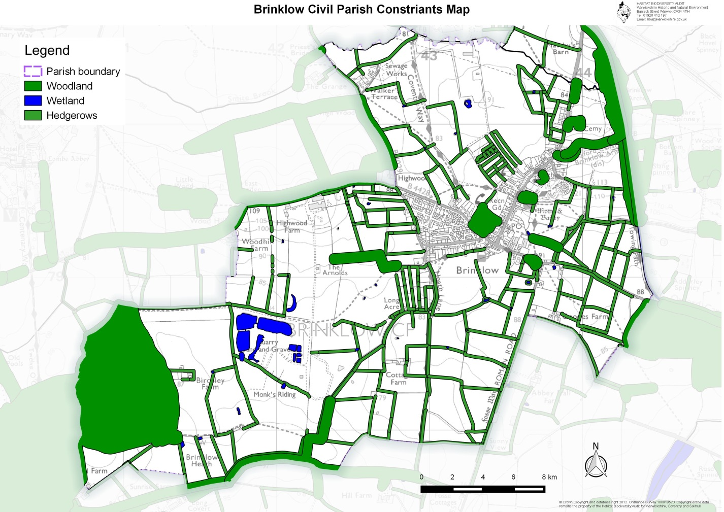
Figure 2 Constraints Map

Brinklow Parish Local Wildlife Sites

There are no statutory wildlife sites in the parish of Brinklow, but there are six local wildlife sites either within the parish or along the parish boundary. One site, Brinklow Castle is also a scheduled national monument, and is protected under the Ancient Monuments and Archaeological Areas Act 1979. The three designated woodland sites are all recorded in the Natural England Ancient Wood Inventory (AWI).

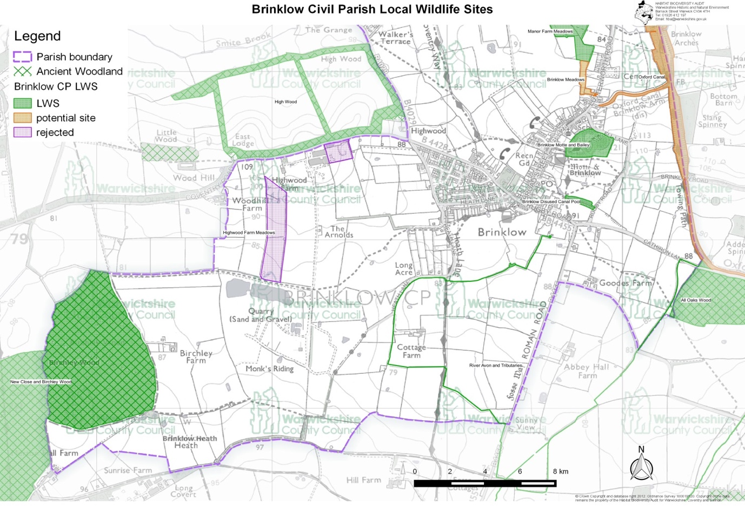

Brinklow Castle LWS

Brinklow Castle was first surveyed as a local wildlife site in August 2017 (Bowley, 2018) and was designated in February 2018.The site is an exceptionally well-preserved Motte-and-Bailey castle (scheduled as an Ancient Monument since 1925) containing areas of species-rich semi-improved grassland on the banks and marsh in the ditches, as well as scrub mosaics. It is likely that the site has been under permanent pasture for 800 years.
There is a good diversity of habitats present within the castle site, with semi-improved neutral to moderately calcareous grassland being the most important. The best areas are found on the steeper slopes as on the motte and on the banks within the bailey. The ditches hold areas of marsh and some semi-permanent pools, while scrub and secondary woodland is present on the outer bank of the bailey. A hedge with mature trees forms the north boundary of the motte and continues around to enclose a small meadow at the eastern end of the site
Despite its relatively small size the site includes a wide range of habitats and sub-habitats, ranging from semi-improved neutral grassland, through tall herb and Bramble brakes, to hedges and both open and closed scrub mosaics and mature semi-natural deciduous woodland. There are also areas of marsh occupying the ditch bottoms, dry ditches, steep slopes and localised areas of open water. Together these habitats support a wide range of vascular plants, with 150 species recorded during the survey. The grasslands occupying the thinner soils of the steep banks are particularly rich in species, particularly those characteristic of the MG5 pasture communities, such as Agrimony, Common Knapweed, Lady’s Bedstraw, Meadow Barley, Meadow Vetchling, Common Birds-foot-trefoil, Lesser Burnet-saxifrage, Creeping Cinquefoil, Red Clover and Yellow Oat-grass. The scrub areas attract a good range of birds.

Brinklow Disused Canal Pool LWS

Brinklow Disused Canal Pool was first surveyed for local wildlife site status in 2017 and designated in 2018 (Bowley, 2018). The site consists of two moderately species-rich water bodies situated within an area of cattle pastures, which are remnants of one of the original meanders of the Oxford Canal, cut off in the early part of the nineteenth century.
The western end of the site is located just 150m to the east of Broad Street, Brinklow and extends eastwards to Rugby Road. It is surrounded by medium sized cattle pastures, enclosed by a variety of often well-timbered hedgerows. The farm stockyard is situated immediately south of the site, with the northern entrance to the farm dividing the main pool from the much smaller pool to the west. The nearest LWS to the site is Brinklow Castle situated about 300m to the north across the fields, where there is another linear water feature in the southern moat. The present course of the Oxford Canal pLWS is a major wildlife corridor located 500m to the east beyond Rugby Road.
There is quite a high diversity of plants for the small size of the site, with 101 species of vascular plants recorded. Most of these are typical of either waterside habitats, such as Reed Sweet-grass, Common Marsh-bedstraw, Yellow Iris, Gipsywort, Water Mint, Common Watercress and Common Skullcap; or of well-established hedgerows, such as False Brome, Herb Robert and two species of violet. The site also includes Glyceria swamp, lily pads, wet sallow scrub, areas of cattle-poached mud and rough grassy marginal ground.

New Close and Birchley Woods LWS

New Close and Birchley Woods LWS (Bowley & Shuttleworth, 2009) consist of two large contiguous ancient semi-natural woodlands situated within the parishes of Binley and Brinklow, The LWS also includes a small woodland appendix and the site of some medieval fish ponds on the north side of New Close Wood in the parish of Combe Fields.

The woods were formerly part of the Coombe Abbey estate, with Birchley Wood likely to be very ancient and possibly pre-conquest wood pasture in origin – it was certainly mentioned as woodland in documents by about 1400.

The two woodlands are both ancient semi-natural sites with a high level of biodiversity. At least ten plant ancient woodland indicator species are present (Wood Anemone, Pendulous and Remote Sedges, Hazel, Woodruff, Yellow Archangel, Hairy Wood-rush, Wood Millet, Wood-sorrel and Small-leaved Lime) and others are thought to be present. There is a very wide variety of sub habitats present including streams, rides, ponds, wet grassland, scrub and both wet and dry woodland, with much decaying wood throughout the woodlands. The populations of birds, invertebrates and fungi are thought likely to be important at a county level. Blue bells, wild primroses and foxgloves are also present in our ancient woods.

Ancient semi-natural deciduous woodland is a nationally important habitat and one which has declined steadily in Warwickshire since the last world war. Several species of plant such as Hairy Wood-rush and Heath-grass are threatened at a county level and are now considered to be scarce. Marsh Tit is on the Red List of the national Birds of Conservation Concern.

High Wood LWS

High Wood LWS (Bowley J. , 2009) consists of a narrow belt of semi-natural deciduous woodland framing two large square arable fields, set in open agricultural land in the south-eastern corner of the parish of Combe Fields adjacent to the western outskirts of Brinklow village. It is bounded by large arable fields on the north and west sides, and by the B4027 and B4029 on the south and east sides beyond which are a patchwork of smaller grass fields.

The site is an ancient semi-natural woodland with a very diverse list of vascular plants, of which at least eight (Wood Anemone, Hazel, Woodruff, Yellow Archangel, Hairy Wood-rush, Crab Apple, Wood Millet and Wood-sorrel) are characteristic of ancient woodland within Warwickshire. Despite the destruction of most of the wood, there is still a reasonable range of sub-habitats, including wet areas, steep dry banks, water-filled ditches, decaying timber, small areas of tall herb in the clearings and along the Coventry Road, and areas of dense shrub layer. The wood holds a reasonable population of woodland birds and mammals, and probably supports a good variety of invertebrates, mosses and fungi.

Manor Farm Meadows SINC

Manor Farm Meadows SINC (Cole, 2004) comprises three semi-improved neutral grasslands located to the north of the village of Brinklow. Smite Brook flows along the northern boundary of the site. Two of fields are treated as hay meadows with a cut taken about mid-July, but with the exception of some occasional grazing from sheep that escape from an adjacent field, are not aftermath grazed. The third field is a small horse grazed pasture over prominent ridge and furrow. This field lacks the diversity seen in the other fields but is included within the SINC boundary due to rarity of this type of grassland, and because of its link with the richer semi-improved grassland fields.

The site is diverse in habitat with areas of species rich semi-improved dry grassland, wet grassland, boundary hedgerows and ditches, and a small pond surrounded by swamp vegetation. The grassland areas are herb rich and contain several species indicative of unimproved or species rich semi-improved grassland including Black Knapweed, Yellow Rattle, Great Burnet, Meadowsweet, Field Wood-rush, and Greater Bird’s-foot-trefoil.

In terms of rarity, species rich neutral grassland is rare in the County and is a nationally important habitat. The high nature conservation value of the site depends on continued traditional management

To the south of Manor Farm Meadows are two small fields identified as potential local wildlife sites called Brinklow Meadows.

The River Avon LWS

There are a number of tributaries of the River Avon that run through the parish and these form part of the River Avon LWS.

Oxford Canal Potential Local Wildlife Site

The Oxford Canal on the eastern edge of the parish, includes the Brinklow arm of the canal, is an important wildlife habitat and corridor. There are no plans at present to survey the canal.

Protected Species in Warwickshire (Warwickshire Wildlife Trust, 2012)

European Protected Species (EPS) are protected under the Conservation (Natural Habitats &c.) Regulations 1994 found in Warwickshire include:
- All species of bat
- Great crested newt
- Otter
- Dormouse
- White-clawed crayfish
- Other species that are protected under the Wildlife and Countryside Act 1981 (as mended) and the Protection of Badgers Act 1982 relevant to Warwickshire include:
- Water Vole
- Barn owl
- Grass snake
- Slow worm
- Common lizard
- Badger
Warwickshire, Coventry and Solihull Local Biodiversity Action Plan (LBAP)

The Warwickshire, Coventry and Solihull Local Biodiversity Action Plan (LBAP) provide a local response to the UK Government’s National Action Plans for threatened habitats and species. The LBAP contributes to national targets wherever these are relevant to the Warwickshire sub-region but also sets local targets. The LBAP action plans for all local habitats can be found on the Warwickshire Wildlife Trust site:
http://www.warwickshirewildlifetrust.org.uk/LBAP
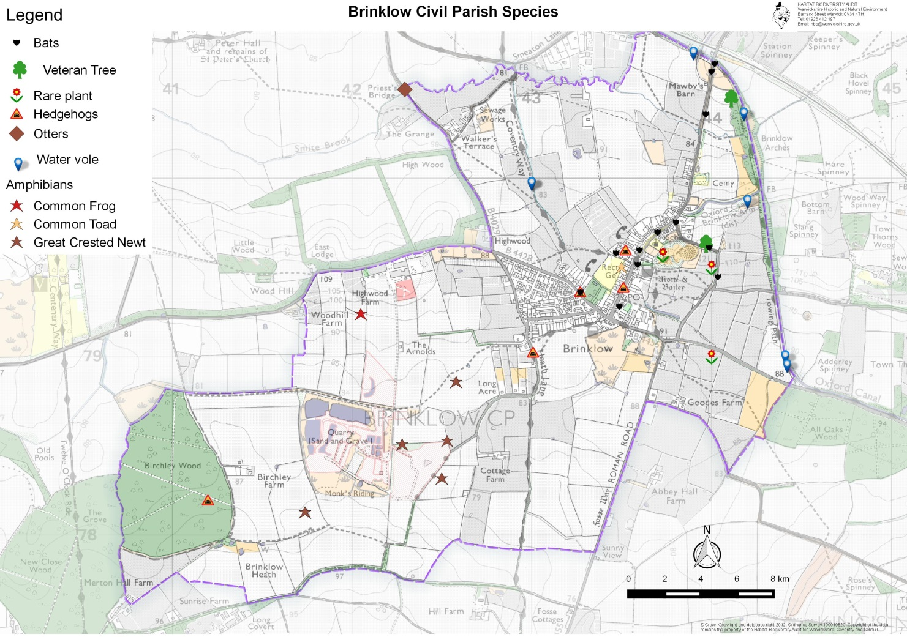
Figure 8 Species map

MAP OF EXISTING RIGHTS OF WAY

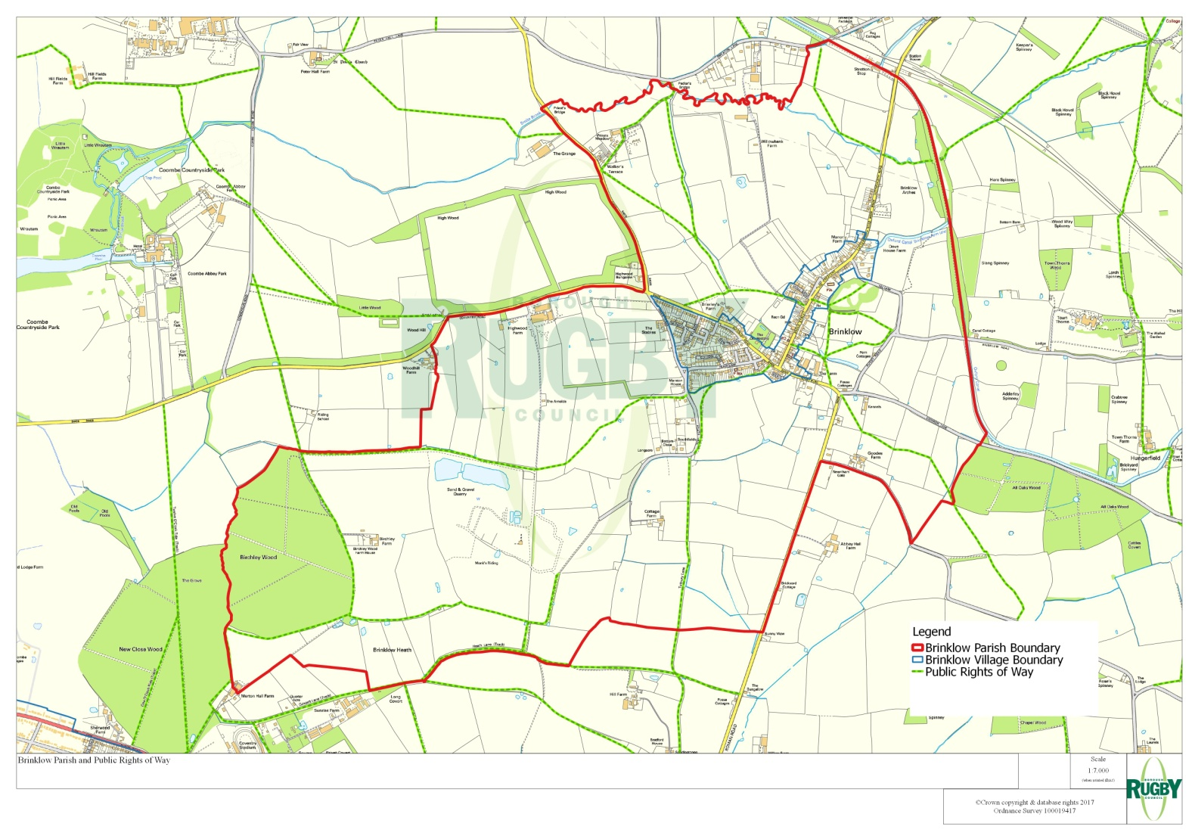

Policy - E1 – Public Rights of Way
This Policy seeks to extend the public rights of way network in an appropriate manner, in line with national policy. The development, improvement and extension of the footpath and open space network in Brinklow, in order to provide better pedestrian access to the countryside and to wildlife or nature conservation sites, will be supported.

Policy - E2 Protecting and Enhancing Green Open Spaces
Green open spaces will be protected and improved to ensure that space is available for the recreation of villagers of and visitors to the Neighbourhood Plan area.
Explanation:
    - The minimum ratio of green space to population, as defined in Natural England’s Greenspace Standard Recommendations, should be applied to all new developments in the Neighbourhood Plan Area.
    - In accordance with paragraph 76 of the National Planning Policy Framework local communities through their neighbourhood plans can identify for special protection green areas of particular importance, ruling out new development except in exceptional circumstances.
    - The green areas identified in the photographs and text below are important spaces within the plan area which need protection.
    - Paragraph 99 of the NPPF also requires that existing open space, sports and recreational buildings and land, including playing fields, should not be built on unless specific conditions are met.
In accordance with paragraph 101 of the National Planning Policy Framework local communities through their neighbourhood plans can identify for special protection green areas of particular importance, ruling out new development except in exceptional circumstances.

Paragraph 102 of the NPPF sets out the criteria that green space must meet to be designated as Local Green Space:

The Local Green Space designation should only be used where the green space is:
- in reasonably close proximity to the community it serves;
- demonstrably special to a local community and holds a particular local significance, for example because of its beauty, historic significance, recreational value (including as a playing field), tranquillity or richness of its wildlife; and
- local in character and is not an extensive tract of land.

These criteria have been applied to seven green open spaces within the Parish identified as:
    - Five of the sites below meet all three of these criteria:
- The War Memorial, because of its association to the members of the village who gave their lives in several conflicts
- The cemetery: This was opened in 1884 as there was no space left in the churchyard for burials and is of personal and historic importance to the inhabitants of Brinklow.
- The playing field, which is an important recreational space for the junior football team and is also used for the Brinklow Scarecrow festival.
- The allotments, which are of recreational value to members of the village. Allotments are an important community facility. They make a valuable contribution to biodiversity and healthy lifestyles, represent years of public and individual investment, and are worthy of protection.The members of the allotment society voted unanimously at their AGM for the allotments to be included as a Local Green Space.
- The Crescent, which is the site of Brinklow’s medieval market, and as such historically important.

    - The other sites are without any particular history but are important to the village as recreational spaces:

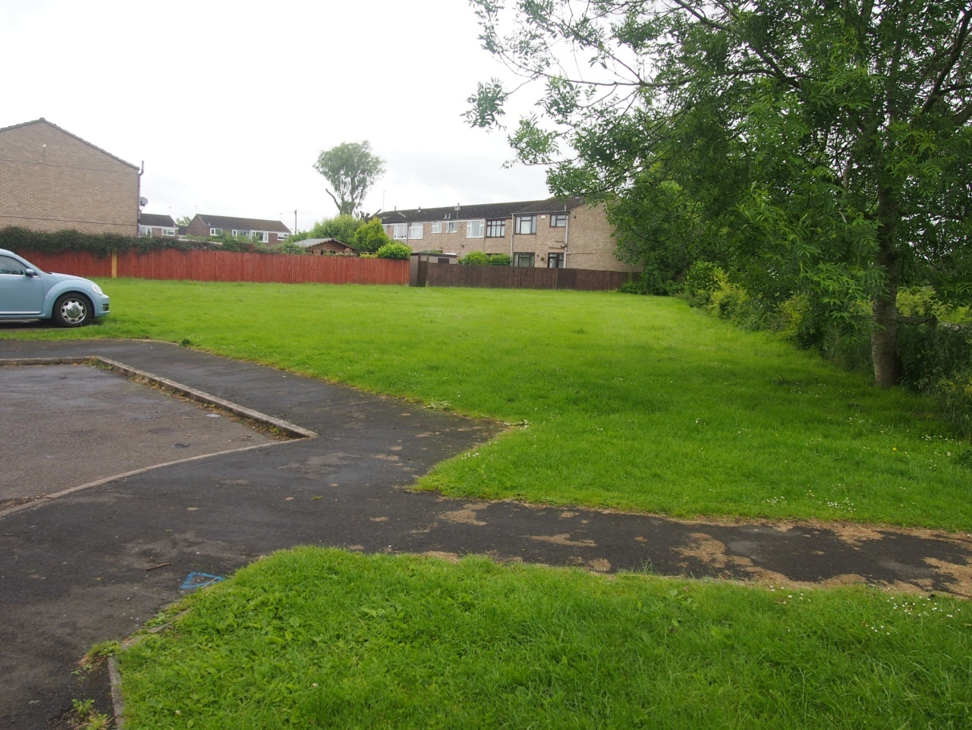
Photo 1: Green space at side of Green Lane 52.411083, -1.370718
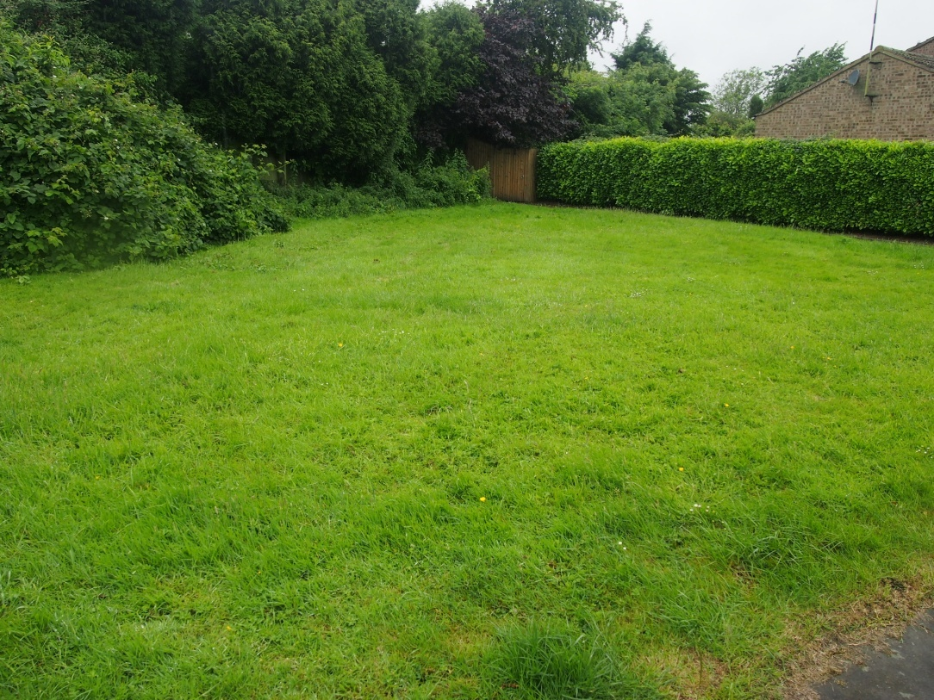
Photo 2: Green space behind Great Balance 52.410556, -1.370170

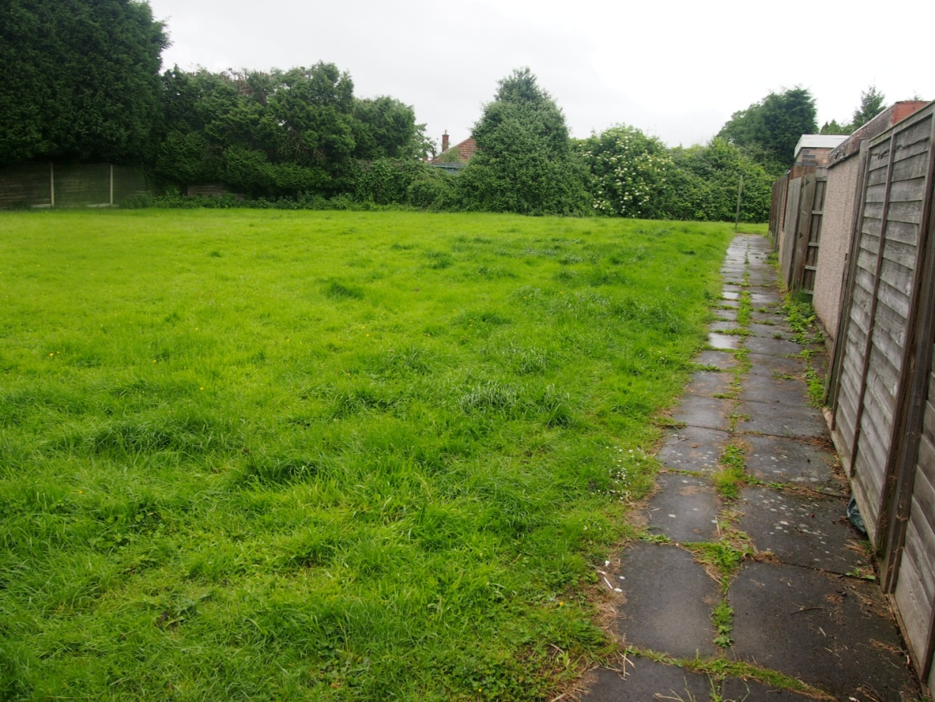
Photo 3: Green Space off George Birch Close 52.410323, -1.368814
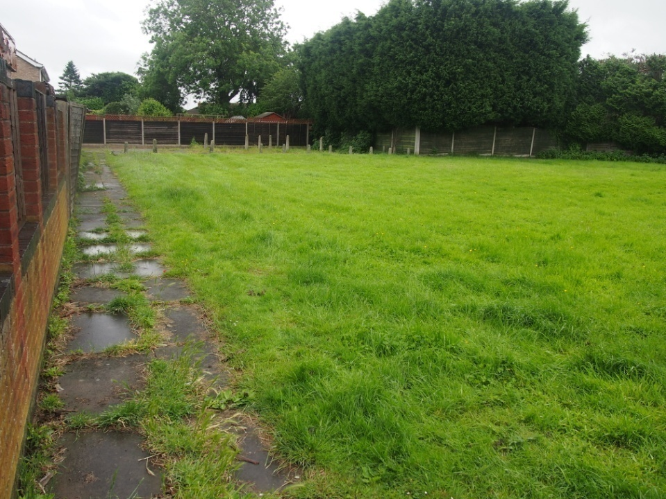
Photo 4: Other view Green Space off George Birch Close 52.410323, -1.368814

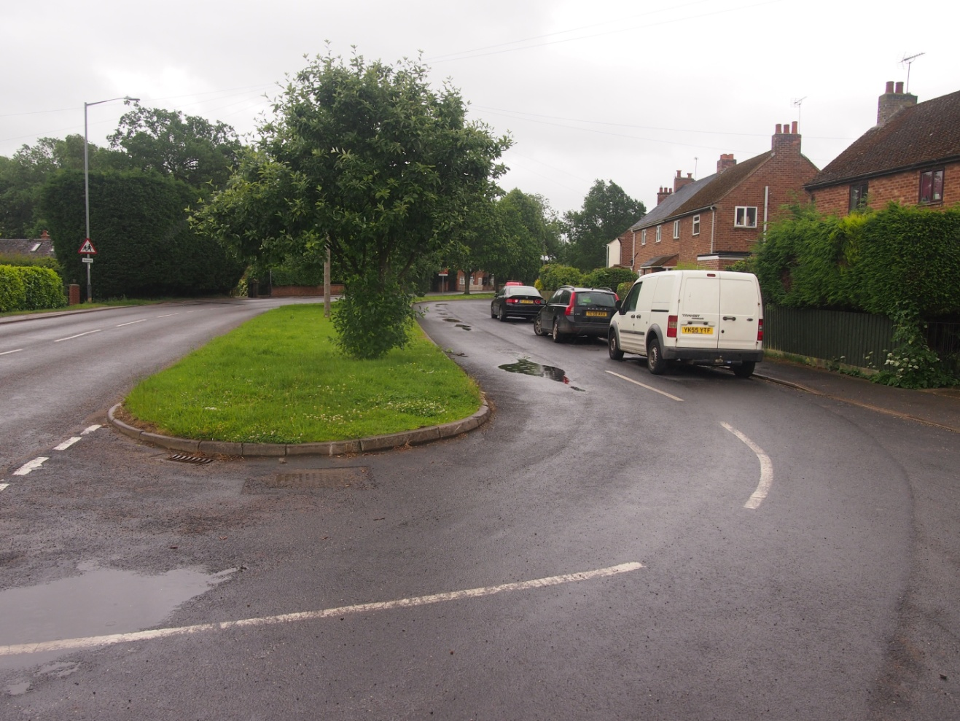
Photo 5: Green space off Coventry Road towards Yew Tree Hill 52.411222, -1.366808
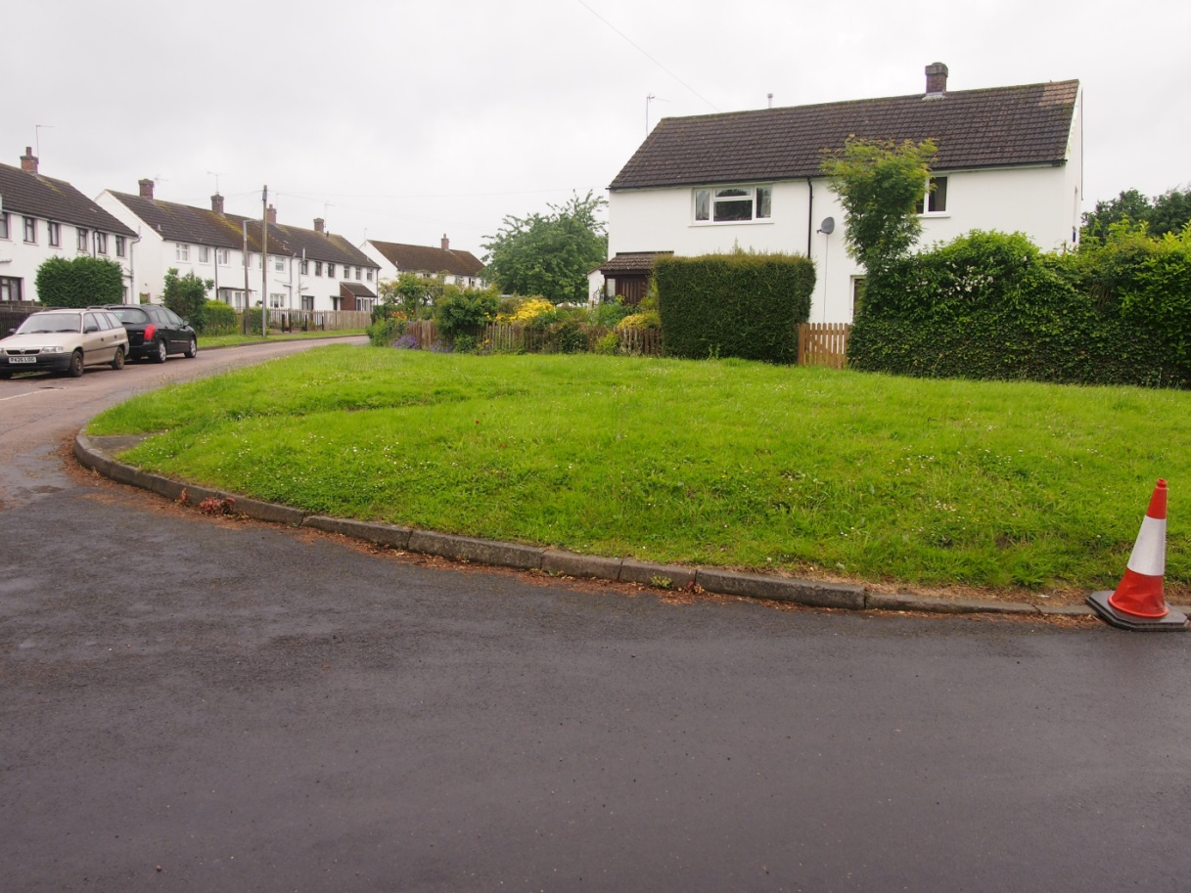
Photo 6: Corner of Yew Tree Hill 52.410607, -1.365583

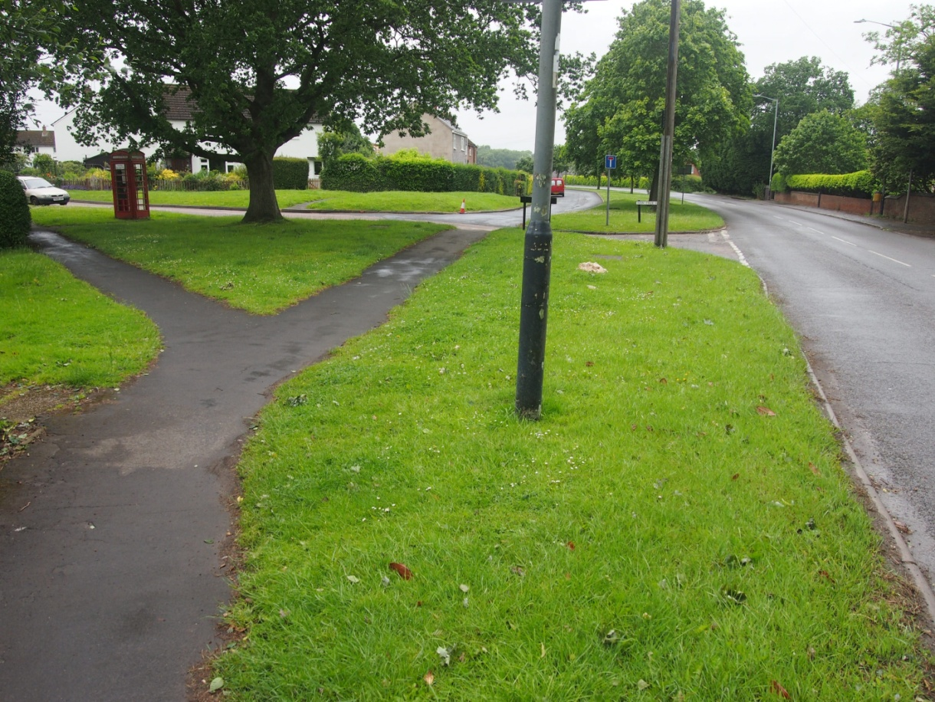
Photo 7: Coventry Road and other side of Yew Tree Hill 52.410496, -1.365463
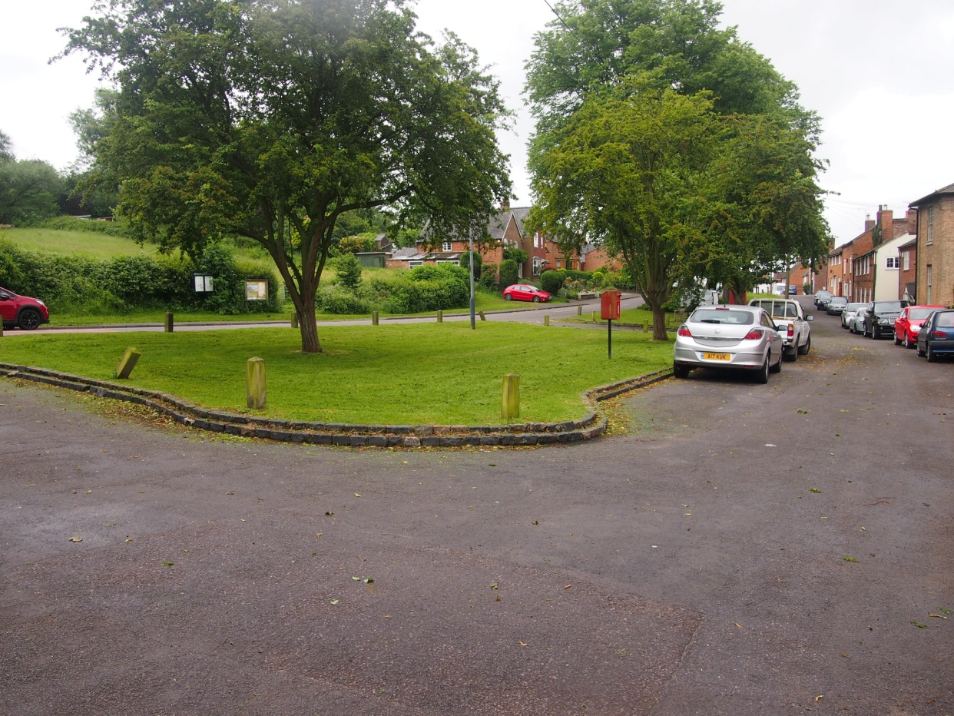
Photo 8: The Crescent, opposite the Tump 52.412858, -1.360028
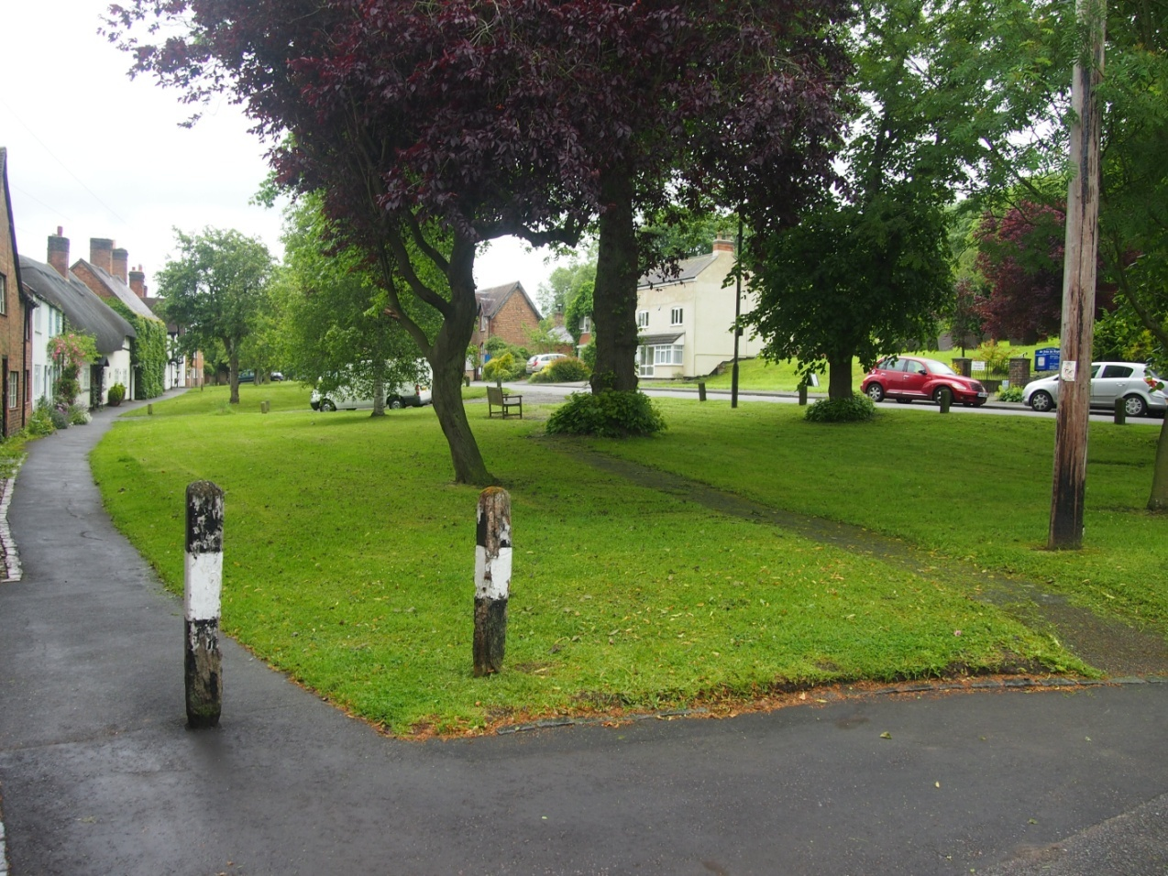
Photo 9: The Crescent, opposite the Church 52.413071, -1.359807

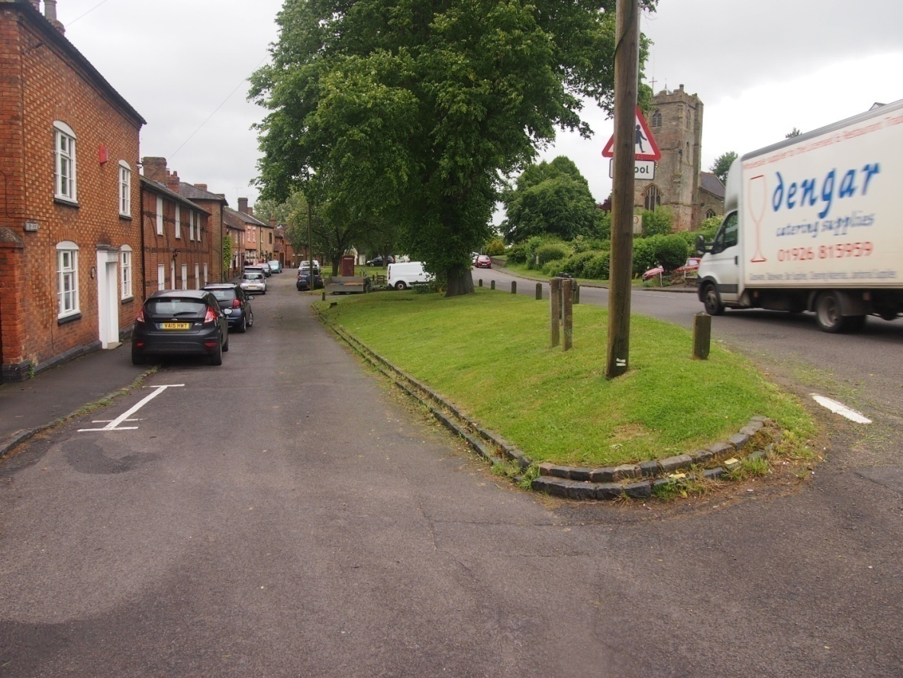
Photo 10: The Crescent, off Broad Street 52.412562, -1.360359

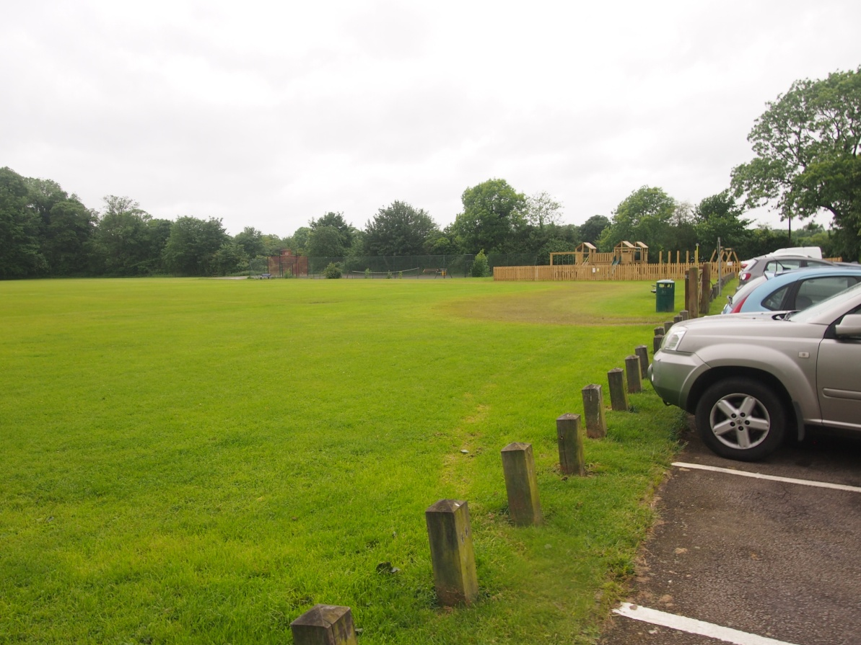
Photo 11: Playing Field Barr Lane 52.412240, -1.362199

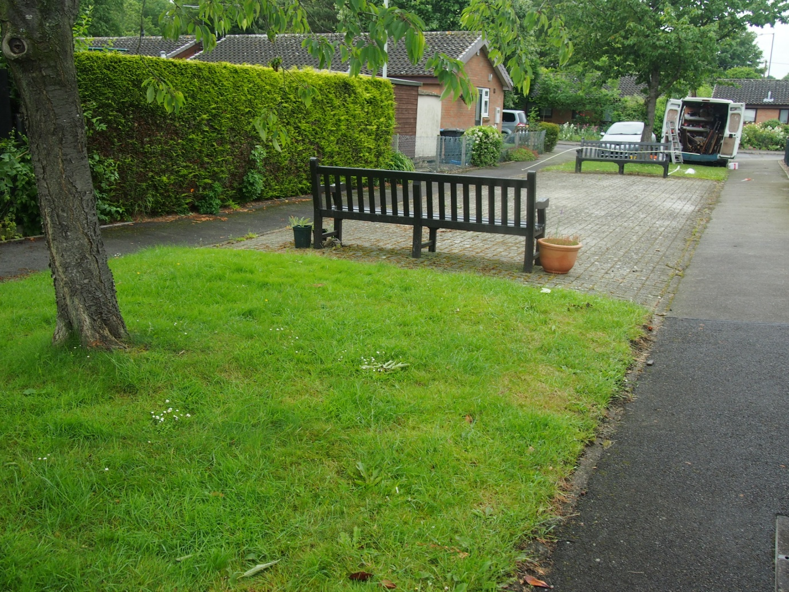
Photo 12: Potters Close 52.409851, -1.365727

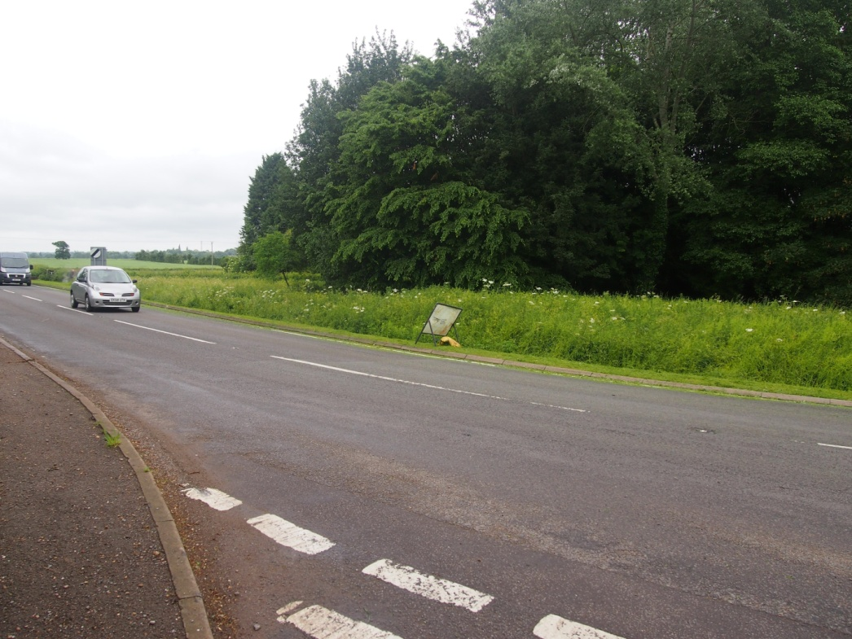
Photo 13: Green space corner of Fosse Way 52.407999, -1.358749
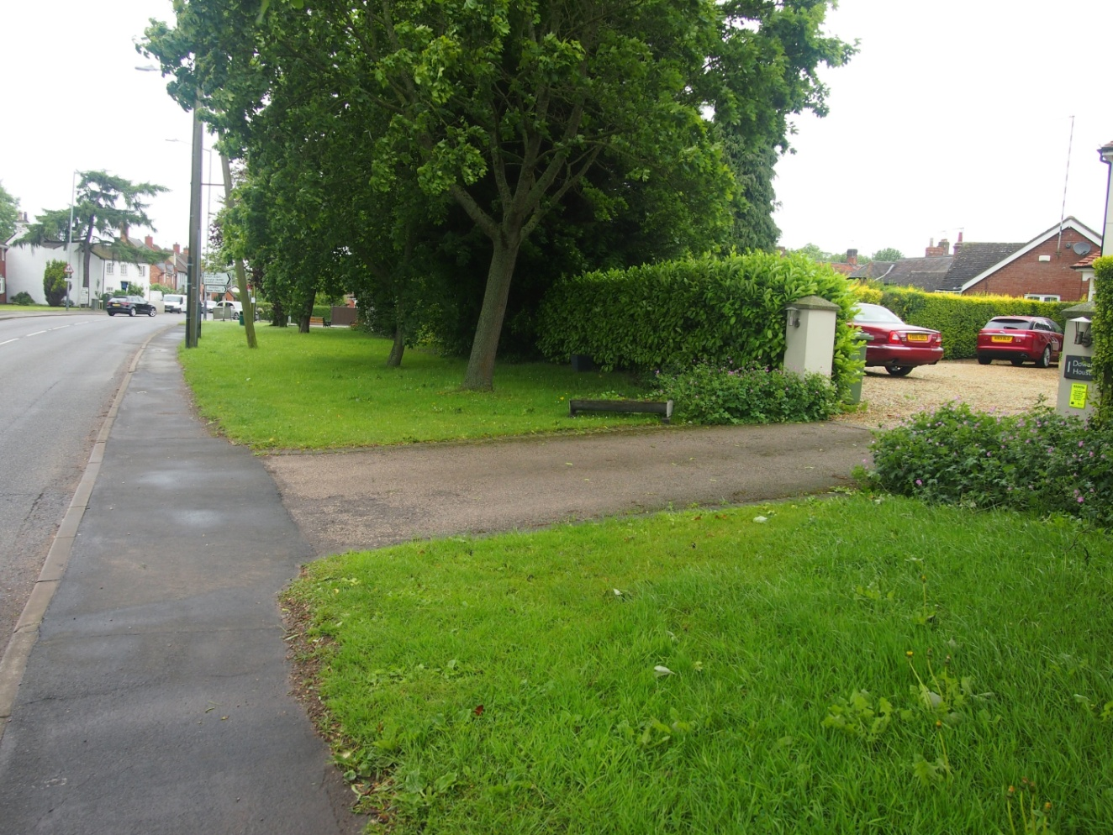
Photo 14: Green space on B4455 52.409068, -1.362066

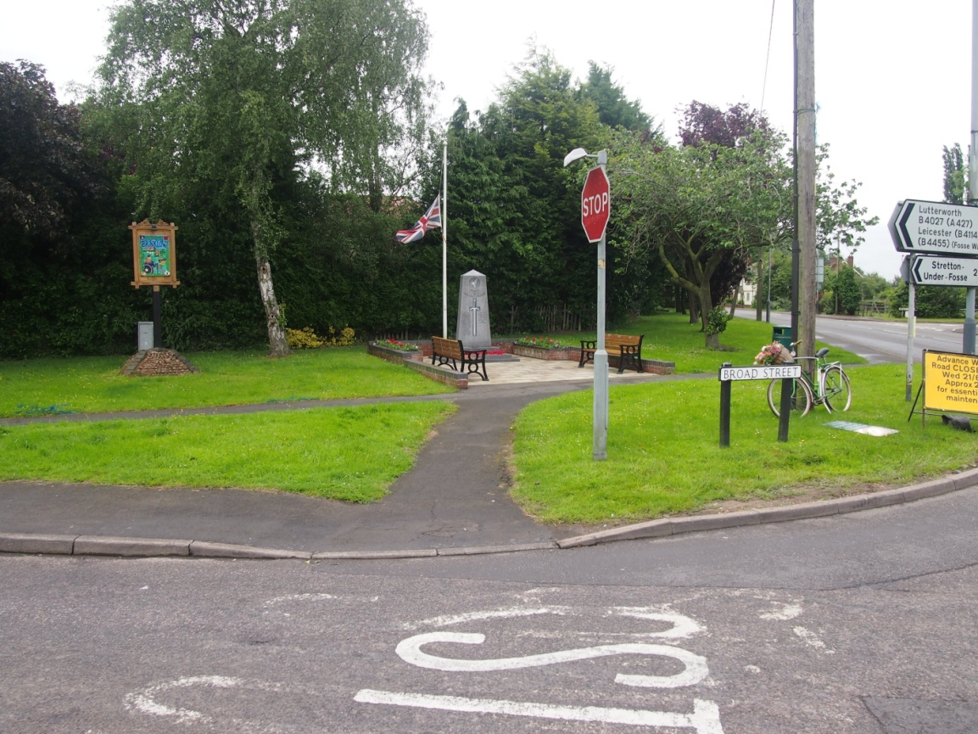
Photo 15: Green space by War Memorial 52.409263, -1.362651
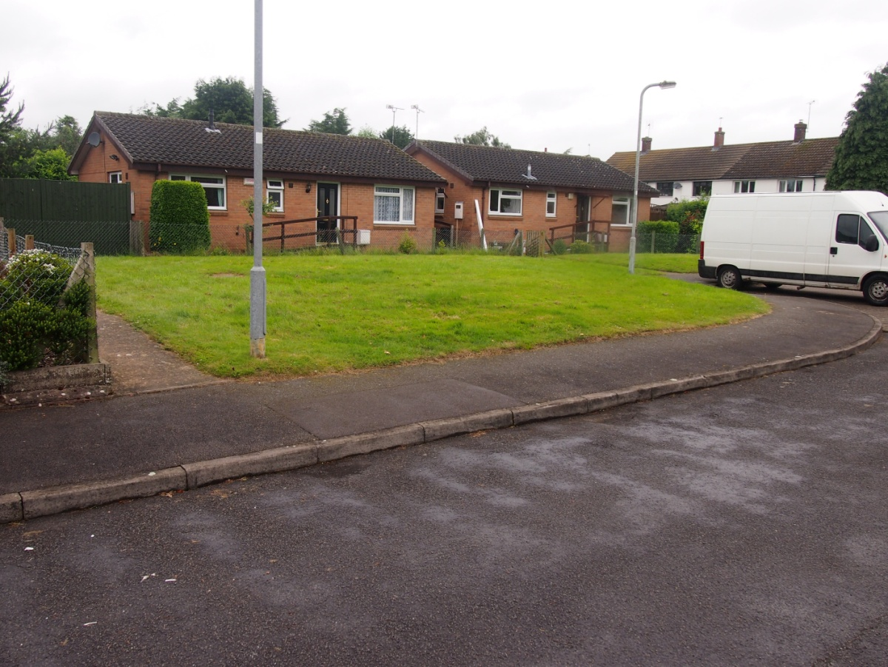
Photo 16: Large green verges off Heath Lane 52.409432, -1.366583
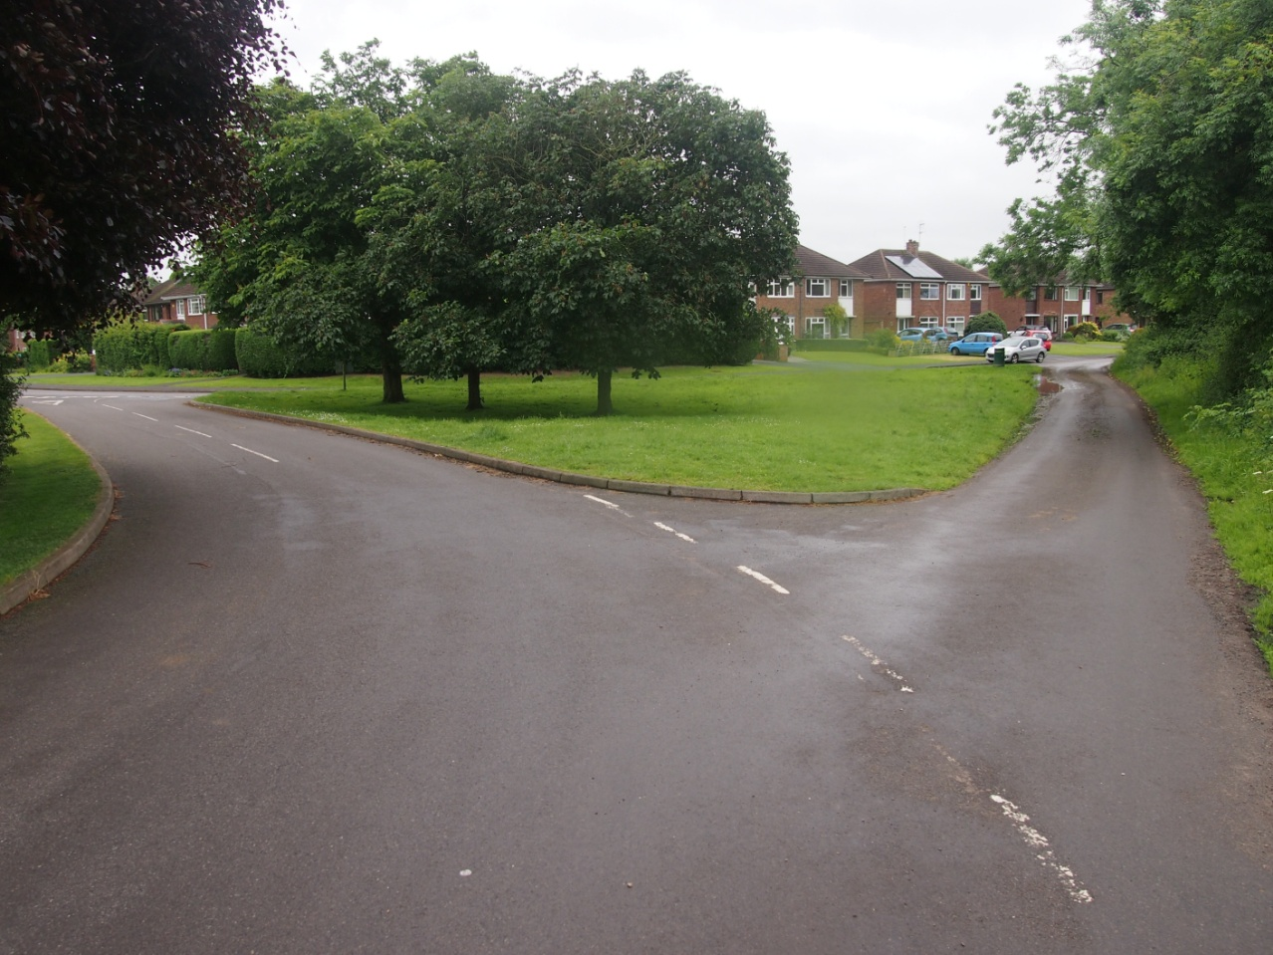
Photo 17: The triangle on Green Lane 52.409127, -1.369728
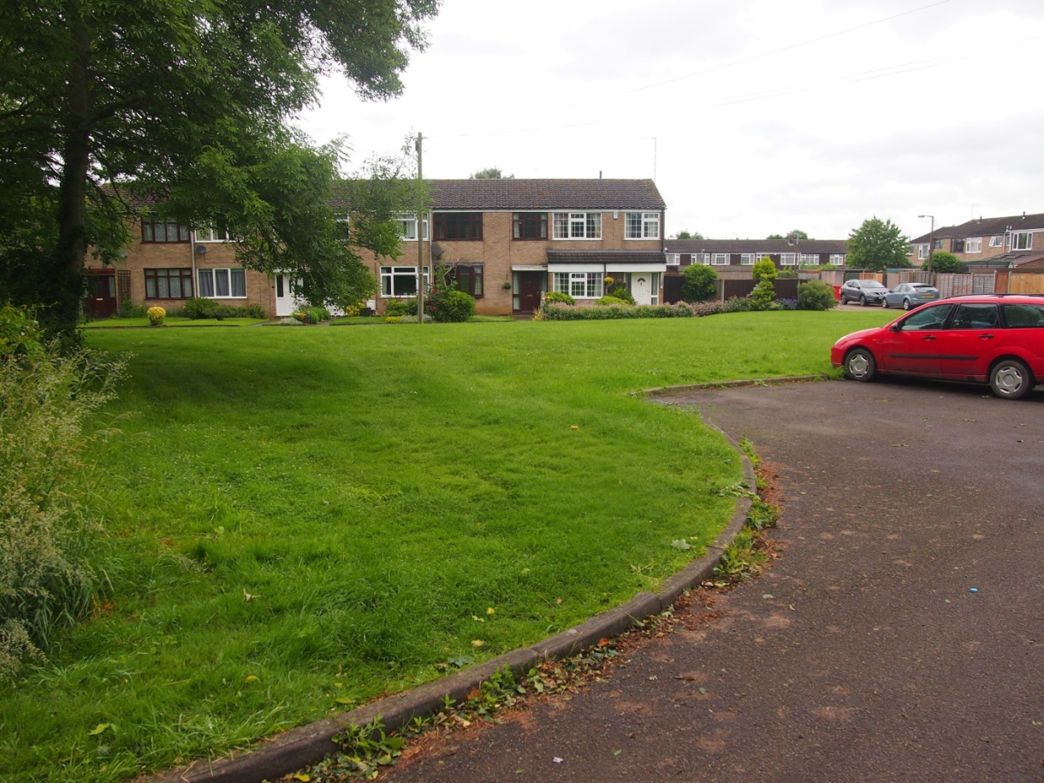
Photo 18: Large green off Great Balance 52.410471, -1.370304
Rugby Borough Council’s Green Infrastructure Study in June 2009 recommended under the section on Biodiversity that land for allotments should be retained and their use promoted. We are designating this allotment land as Local Green Space.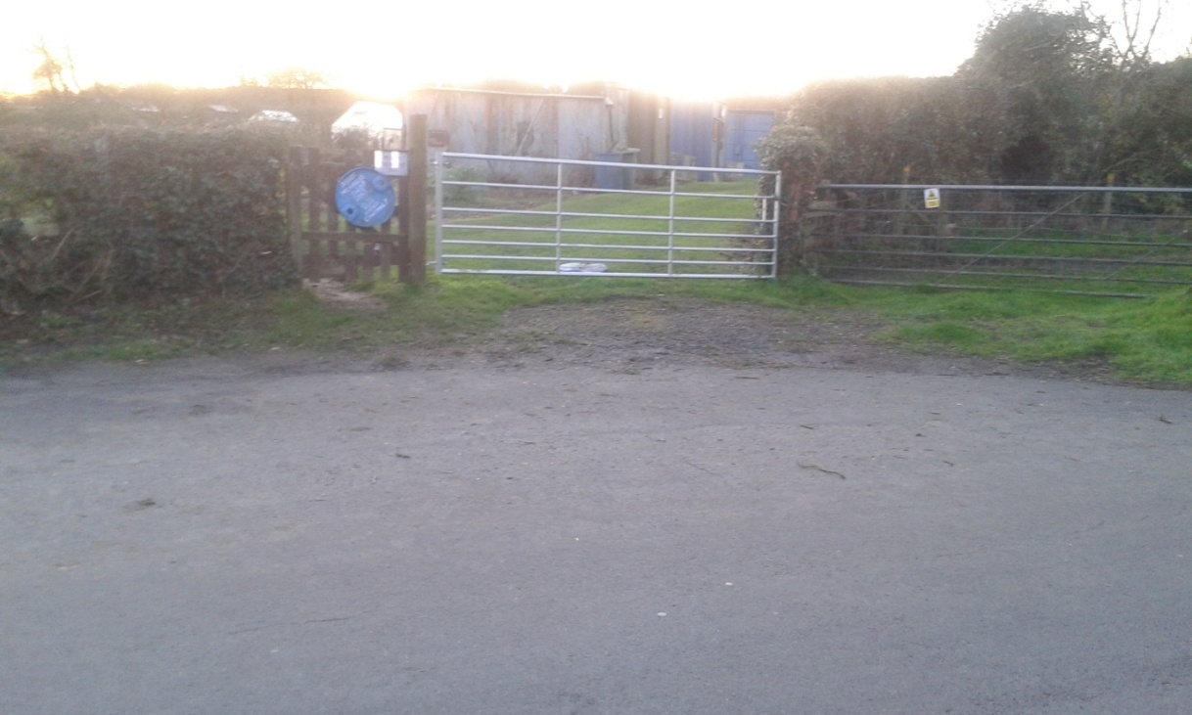
Photo 19: Brinklow Allotments Green Lane 52.412086, -1.371955 1.37195512086, -1412086, -1.371955
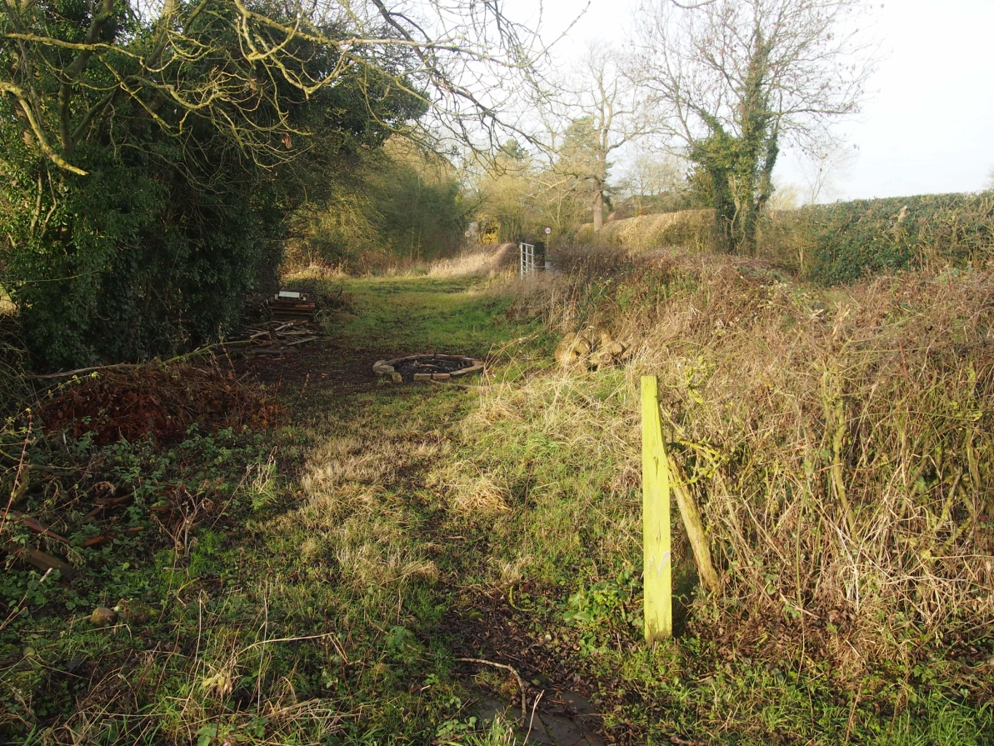
Photo 20 Green Space Ell Lane 52.412785, -1.355473

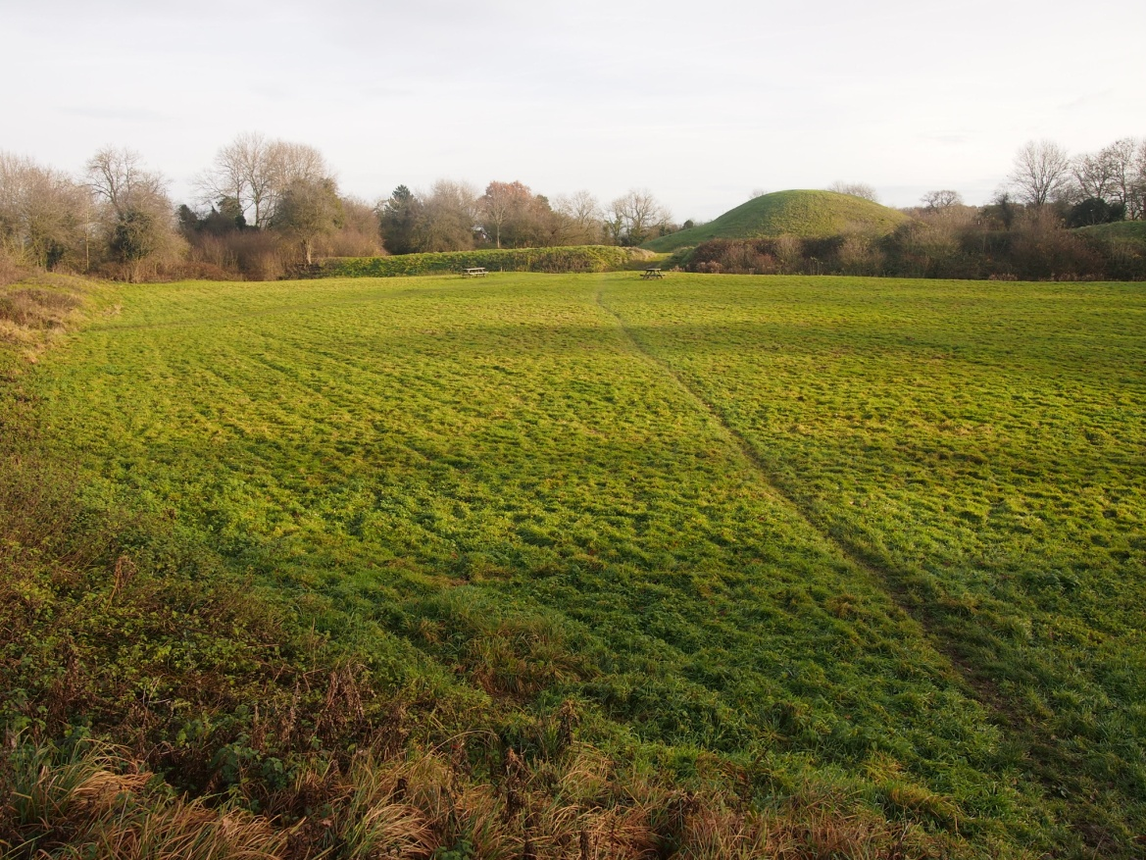
Photo 21 Field adjacent to the Tump 52.412918, -1.359619
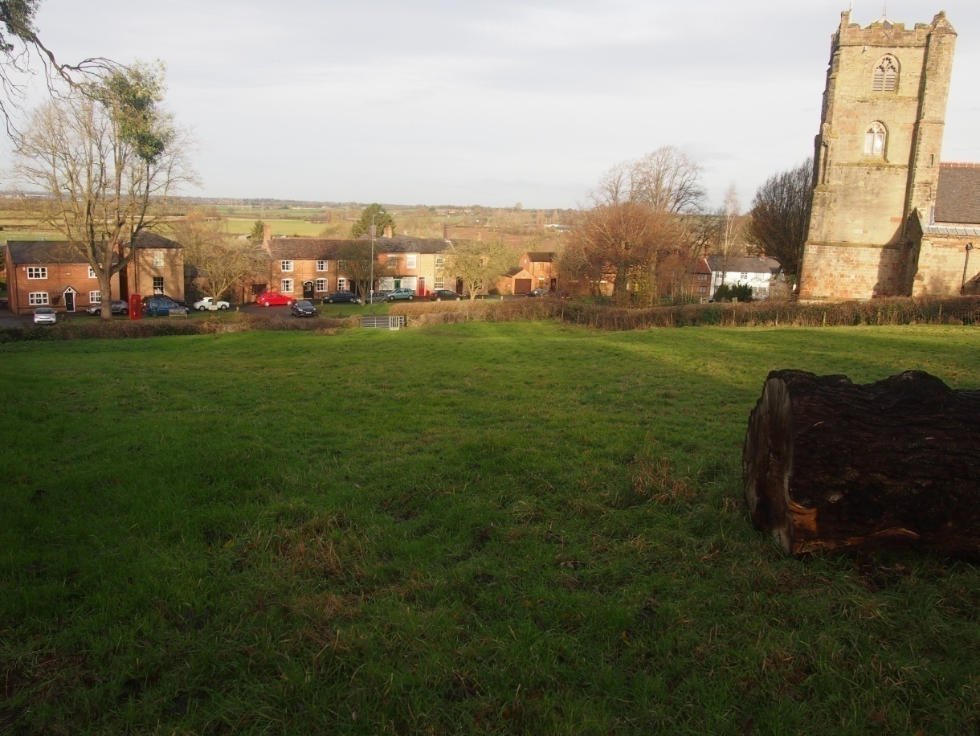
Photo 22 Church Field 52.412459, -1.359168

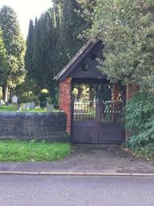
Photo 23 Brinklow Cemetery 52.416324, -1.355420

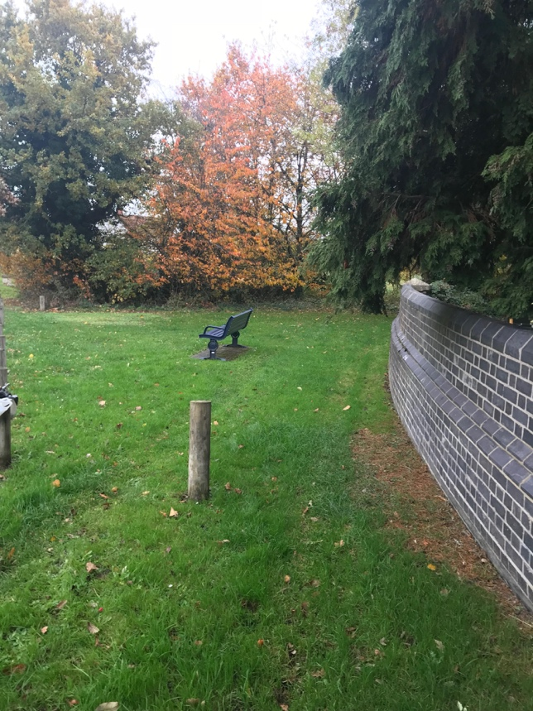
Photo 24 Triangle of land next to Brinklow Cemetery 52.416476, -1.355795

Policy - E3 – Agricultural Land
Agricultural land is an essential part of the landscape of Brinklow as well as providing local employment and food security for the nation. In addition the beauty of the landscape around Brinklow consists of the combination of hills and agricultural land. In many fields adjoining the settlement, the ancient pattern of ridge and furrow is well preserved. This historic landscape feature is greatly valued and should be protected.
Development of the best and most versatile agricultural land (defined as land in grades 1, 2 and 3a of the Agricultural Land Classification) will normally be resisted unless it can be demonstrated that significant development of agricultural land is necessary and no other land of a poorer agricultural quality is available.

Policy - E4 – Landscapes, Vistas and Skylines
Development proposals must ensure that key features of the views identified on the plan titled ‘Valued Landscapes’ can continue to be enjoyed including distinct buildings, heritage assets, areas of landscape and the juxtaposition of village edges and the open countryside. Large scale proposals should submit a landscape and visual assessment to help demonstrate this.
Communication masts, pylons, wind turbines, or other structures such as solar panel farms which are highly visible will not be encouraged if they would have an adverse impact on the character of the landscape and the built environment of the settlement. Highly visible skyline building of houses will not be encouraged.
Important aspects of the Brinklow landscape can be seen from the Motte and Bailey historic monument and are a valued local asset.
The green areas of land within the settlement and on the edge of the settlement boundary, are important features of Brinklow and characterise the village. These pieces of open land bring the countryside close, and afford views across fields.They should enable an excellent system of paths to give residents and visitors easy access to the countryside. They act as wildlife habitats and wildlife corridors.

Policy - E5– Minimising Pollution
Paragraph 120 of the NPPF clearly sets out, in broad terms, that pollution is a material planning consideration. Pollution can and does have detrimental impacts on the environment and human health. In the absence of a robust plan policy, both the quality of life of local residents and the ecology of the area would be compromised.
Development proposals which would give, or potentially give, rise to pollution because of its type or its location will only be supported if they are accompanied by evidence that demonstrates any harmful impacts particularly arising from noise, light or traffic generation, including details of any measures to be taken to deal with the anticipated impacts of the proposal, are satisfactory.
Proposals which would give rise to unacceptable levels of air, light, noise or water pollution will be resisted. This Neighbourhood Development Plan is particularly concerned with light pollution and the impact of development on the tranquillity of the Neighbourhood Area. The Neighbourhood Development Plan will follow the recommendations of the Council for the Preservation of Rural England (CPRE) to minimise noise generation. The CPRE has stated “The tranquillity of the English countryside is one of its most important qualities. Tranquillity is important for our mental and physical well-being. It improves our quality of life. It is also critical to rural economies because it’s one of the main reasons why people head out of towns and cities to ‘get away from it all’. But getting away from it all is becoming harder and harder to do. Aircraft, cars, roads and building developments are all eroding the tranquillity that means so much to all of us.” The roads through the centre of Brinklow produce significant noise and air pollution, and new developments should not generate significant additional traffic.

Policy - E6: Renewable Energy
Development proposals relating to the production of renewable energy will be supported providing they can they can be satisfactorily integrated into the character and environs of the parish. Proposals which fail to preserve or enhance the established character and appearance of the local area will be resisted. The benefits of renewable energy generation through processes such as biomass, ground source and air source heat pumps, hydroelectric, wind and thermal capture are all well-documented. This Neighbourhood Development Plan seeks to encourage rather than stifle opportunities to establish the generation of renewal energy in appropriate locations where the benefits of such projects clearly outweigh any harm. Proposals that will have an impact on woodlands, hedges and trees should incorporate measures to protect their contribution to landscape character, public amenity and biodiversity. The loss of those trees which are of high public amenity value will be resisted and such trees will be protected by the use of Tree Preservation Orders. Where possible, removal of hedgerows will be resisted.

Policy - E7: Biodiversity and Habitats
Development proposals impacting on biodiversity will be required to demonstrate how any potential impact on local wildlife sites, habitats and species networks has been taken into account. This will require appropriate measures being put into place to protect wildlife and habitats and enhance biodiversity.
Woodlands, trees, hedges, ponds and watercourses, unimproved/semi-improved grassland, heathland and other habitats should be retained wherever possible. This includes national and local designated sites. If development is permitted, any consequent loss of biodiversity must be minimised and mitigated by the creation of new habitats or the enhancement of existing habitats.

Policy - E8: Hedgehog protection
Hedgehogs have much declined in recent years, notably in more rural areas such as this, and are now a priority concern for nature conservation as defined in the Warwickshire, Coventry and Solihull Local Biodiversity Action Plan. The Wildlife Trust and British Hedgehog Preservation Society have designated ‘Hedgehog Improvement Areas’ to help conserve this iconic species. The local community values the presence of hedgehogs and other wildlife within the neighbourhood and is keen to ensure that they are protected.”
The Neighbourhood Plan Area is situated within a Hedgehog Improvement Area and sightings of hedgehogs have been reported, particularly in Brinklow village. Development plans will be supported when features to help the species are incorporated into new developments. Boundaries and barriers should be made permeable, for example through the use of fence panels with 13x13cm hedgehog holes at the base. Connectivity and shelter for ground-dwelling wildlife should be encouraged in the Neighbourhood Area, through features such as native species hedgerows and grassy margins.

References

Document Name | Author/ partners | Date
Landscape Sensitivity Study | WCC | August 2016
www………………………………….

Document Name | Author/ partners | Date
Green_Infrastructure_Study | Entec | June 2009
www………………………………….

Document Name | Author/ partners | Date
WCS_Sub_Reg_GI_Strategy | Warwickshire Museum and Natural Environment | 2014
www………………………………….

Document Name | Author/ partners | Date
Brinklow Parish Ecological Report | Habitat Biodiversity Audit Partnership for Warwickshire, Coventry and Solihull Warwickshire Wildlife Trust Ecological Services Warwickshire County Council | February 2018
www………………………………….

Document Name | Author/ partners | Date
Brinklow Allotment Association AGM Minutes | Jason Huddlestone | February 2018
www………………………………….

Document Name | Author/ partners | Date
Village Design Statement | Brinklow Villagers | 2005
www………………………………….

