# Brinklow Parish Local Wildlife Sites

There are no statutory wildlife sites in the parish of Brinklow, but there are six local wildlife sites either within the parish or along the parish boundary. One site, Brinklow Castle is also a scheduled national monument, and is protected under the Ancient Monuments and Archaeological Areas Act 1979. The three designated woodland sites are all recorded in the Natural England Ancient Wood Inventory (AWI).

**Brinklow Castle LWS**

Brinklow Castle was first surveyed as a local wildlife site in August 2017 (Bowley, 2018) and was designated in February 2018.The site is an exceptionally well-preserved Motte-and-Bailey castle (scheduled as an Ancient Monument since 1925) containing areas of species-rich semi-improved grassland on the banks and marsh in the ditches, as well as scrub mosaics. It is likely that the site has been under permanent pasture for 800 years.

There is a good diversity of habitats present within the castle site, with semi-improved neutral to moderately calcareous grassland being the most important. The best areas are found on the steeper slopes as on the motte and on the banks within the bailey. The ditches hold areas of marsh and some semi-permanent pools, while scrub and secondary woodland is present on the outer bank of the bailey. A hedge with mature trees forms the north boundary of the motte and continues around to enclose a small meadow at the eastern end of the site

Despite its relatively small size the site includes a wide range of habitats and sub-habitats, ranging from semi-improved neutral grassland, through tall herb and Bramble brakes, to hedges and both open and closed scrub mosaics and mature semi-natural deciduous woodland. There are also areas of marsh occupying the ditch bottoms, dry ditches, steep slopes and localised areas of open water. Together these habitats support a wide range of vascular plants, with 150 species recorded during the survey. The grasslands occupying the thinner soils of the steep banks are particularly rich in species, particularly those characteristic of the MG5 pasture communities, such as Agrimony, Common Knapweed, Lady’s Bedstraw, Meadow Barley, Meadow Vetchling, Common Birds-foot-trefoil, Lesser Burnet-saxifrage, Creeping Cinquefoil, Red Clover and Yellow Oat-grass. The scrub areas attract a good range of birds.

**Brinklow Disused Canal Pool LWS**

Brinklow Disused Canal Pool was first surveyed for local wildlife site status in 2017 and designated in 2018 (Bowley, 2018). The site consists of two moderately species-rich water bodies situated within an area of cattle pastures, which are remnants of one of the original meanders of the Oxford Canal, cut off in the early part of the nineteenth century.

The western end of the site is located just 150m to the east of Broad Street, Brinklow and extends eastwards to Rugby Road. It is surrounded by medium sized cattle pastures, enclosed by a variety of often well-timbered hedgerows. The farm stockyard is situated immediately south of the site, with the northern entrance to the farm dividing the main pool from the much smaller pool to the west. The nearest LWS to the site is Brinklow Castle situated about 300m to the north across the fields, where there is another linear water feature in the southern moat. The present course of the Oxford Canal pLWS is a major wildlife corridor located 500m to the east beyond Rugby Road.

There is quite a high diversity of plants for the small size of the site, with 101 species of vascular plants recorded. Most of these are typical of either waterside habitats, such as Reed Sweet-grass, Common Marsh-bedstraw, Yellow Iris, Gipsywort, Water Mint, Common Watercress and Common Skullcap; or of well-established hedgerows, such as False Brome, Herb Robert and two species of violet. The site also includes Glyceria swamp, lily pads, wet sallow scrub, areas of cattle-poached mud and rough grassy marginal ground.

**New Close and Birchley Woods LWS**

New Close and Birchley Woods LWS (Bowley & Shuttleworth, 2009) consist of two large contiguous ancient semi-natural woodlands situated within the parishes of Binley and Brinklow, The LWS also includes a small woodland appendix and the site of some medieval fish ponds on the north side of New Close Wood in the parish of Combe Fields.

The woods were formerly part of the Coombe Abbey estate, with Birchley Wood likely to be very ancient and possibly pre-conquest wood pasture in origin – it was certainly mentioned as woodland in documents by about 1400.

The two woodlands are both ancient semi-natural sites with a high level of biodiversity. At least ten plant ancient woodland indicator species are present (Wood Anemone, Pendulous and Remote Sedges, Hazel, Woodruff, Yellow Archangel, Hairy Wood-rush, Wood Millet, Wood-sorrel and Small-leaved Lime) and others are thought to be present. There is a very wide variety of sub habitats present including streams, rides, ponds, wet grassland, scrub and both wet and dry woodland, with much decaying wood throughout the woodlands. The populations of birds, invertebrates and fungi are thought likely to be important at a county level.

Ancient semi-natural deciduous woodland is a nationally important habitat and one which has declined steadily in Warwickshire since the last world war. Several species of plant such as Hairy Wood-rush and Heath-grass are threatened at a county level and are now considered to be scarce. Marsh Tit is on the Red List of the national Birds of Conservation Concern.

**High Wood LWS**

High Wood LWS (Bowley J. , 2009) consists of a narrow belt of semi-natural deciduous woodland framing two large square arable fields, set in open agricultural land in the south-eastern corner of the parish of Combe Fields adjacent to the western outskirts of Brinklow village. It is bounded by large arable fields on the north and west sides, and by the B4027 and B4029 on the south and east sides beyond which are a patchwork of smaller grass fields.

The site is an ancient semi-natural woodland with a very diverse list of vascular plants, of which at least eight (Wood Anemone, Hazel, Woodruff, Yellow Archangel, Hairy Wood-rush, Crab Apple, Wood Millet and Wood-sorrel) are characteristic of ancient woodland within Warwickshire. Despite the destruction of most of the wood, there is still a reasonable range of sub-habitats, including wet areas, steep dry banks, water-filled ditches, decaying timber, small areas of tall herb in the clearings and along the Coventry Road, and areas of dense shrub layer. The wood holds a reasonable population of woodland birds and mammals, and probably supports a good variety of invertebrates, mosses and fungi.

**Manor Farm Meadows SINC**

Manor Farm Meadows SINC (Cole, 2004) comprises three semi-improved neutral grasslands located to the north of the village of Brinklow. Smite Brook flows along the northern boundary of the site. Two of fields are treated as hay meadows with a cut taken about mid-July, but with the exception of some occasional grazing from sheep that escape from an adjacent field, are not aftermath grazed. The third field is a small horse grazed pasture over prominent ridge and furrow. This field lacks the diversity seen in the other fields but is included within the SINC boundary due to rarity of this type of grassland, and because of its link with the richer semi-improved grassland fields.

The site is diverse in habitat with areas of species rich semi-improved dry grassland, wet grassland, boundary hedgerows and ditches, and a small pond surrounded by swamp vegetation. The grassland areas are herb rich and contain several species indicative of unimproved or species rich semi-improved grassland including Black Knapweed, Yellow Rattle, Great Burnet, Meadowsweet, Field Wood-rush, and Greater Bird’s-foot-trefoil.

In terms of rarity, species rich neutral grassland is rare in the County and is a nationally important habitat. The high nature conservation value of the site depends on continued traditional management

To the south of Manor Farm Meadows are two small fields identified as potential local wildlife sites called Brinklow Meadows.

**The River Avon LWS**

There are a number of tributaries of the River Avon that run through the parish and these form part of the River Avon LWS.

**Highwood Farm Meadows - rejected**

The site consists of three small rectangular grass fields situated on Highwood Farm on the western side of Brinklow parish, just to the south of the B4027 Brinklow-Coventry Road. The smallest field lies adjacent to this road about 300m west of Brinklow, while the other two are situated about 900m to the south-west of the village. The surrounding land consists’ mainly of medium-large regular shaped enclosure fields and are generally now under arable crops. The site is close to several important ancient woodlands, including High Wood LWS on the north side of the B4027 and Birchley/New Close Woods LWS 1km to the south-west.(Bowley J. J., 2009)

All three fields are much neglected and no longer grazed, and this has led to a steep decline in biodiversity. The northern-most field by the road is used as a storage yard.

**Oxford Canal Potential Local Wildlife Site**

The Oxford Canal on the eastern edge of the parish, includes the Brinklow arm of the canal, is an important wildlife habitat and corridor. There are no plans at present to survey the canal.

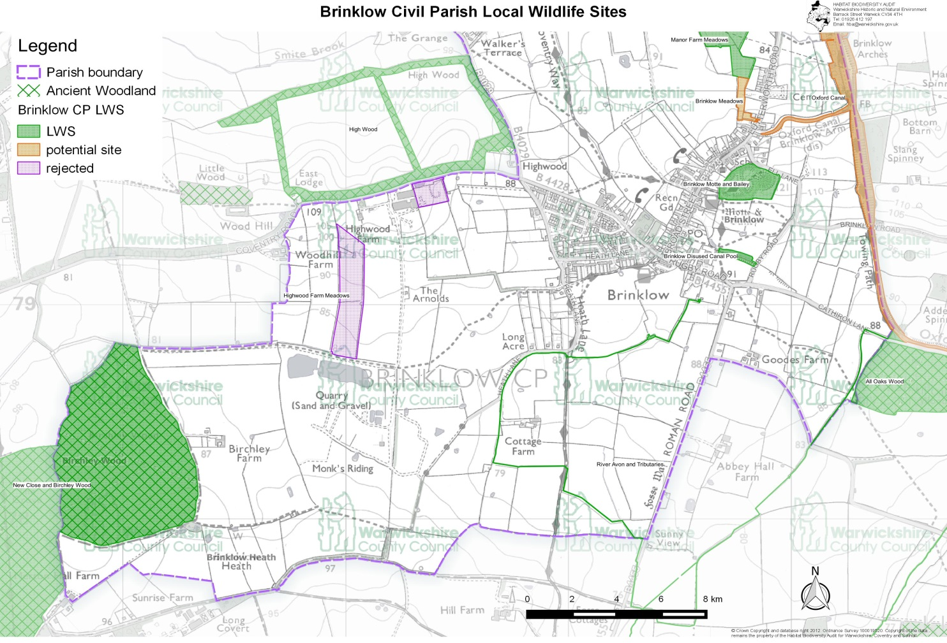

Figure 3 Local Wildlife Sites map