Representation Form for Local Plans
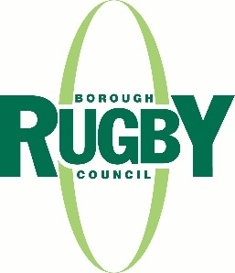 | Local Plan  Publication Stage Representation Form |  |  |  |  |  |  |  | Ref:  (For official use only)
Name of the Local Plan to which this representation relates: |  |  |  | Rugby Borough Council Proposed Submission Local Plan
Please return to Rugby Borough Council by 5:00pm Friday 13th March 2026
By email to: localplan@rugby.gov.uk with Proposed Submission Consultation in the subject line, OR by post to: Development Strategy, Town Hall, Evreux Way, Rugby, CV21 2RR.
This form has two parts –
Part A – Personal Details: need only be completed once.
Part B – Your representation(s). Please fill in a separate sheet for each representation you wish to make.

Part A
1. Personal Details* |  |  |  |  |  |  |  | 2. Agent’s Details (if applicable)
*If an agent is appointed, please complete only the Title, Name and Organisation boxes below (if applicable) but complete the full contact details of the agent in 2.

Title |  | Mr
First Name |  | John
Last Name |  | Reid
Job Title |  | Chairman
(where relevant)
Organisation |  | Brinklow Parish Council
(where relevant)
Address Line 1 |  | c/o Debbie Lloyd
Line 2 |  | Parish Clerk
Line 3 |  | 66 Coventry Road
Line 4 |  | Brinklow
Post Code |  | CV23 OLS
Telephone Number
E-mail Address |  | clerk@brinklowparish.gov.uk
(where relevant)

Part B – Please use a separate sheet for each policy or site you wish to comment on

Name or Organisation: Brinklow Parish Council

3. To which part of the Local Plan does this representation relate?
Paragraph |  | Policy |  |  |  | Policies Map
Site ID | 337
4. Do you consider the Local Plan:
(1) is Legally compliant  (2) is Sound |  |  |  |  |  |  |  |  |  | no
 |  |  |  |  |  |  |  |  |  | no
(3) complies with the
no

Duty to co-operate

. Please give details of why you consider the Local Plan is not legally compliant or is unsound or fails to comply with the duty to co-operate. Please be as precise as possible.
If you wish to support the legal compliance or soundness of the Local Plan or its compliance with the duty to co-operate, please also use this box to set out your comments.

In the view of the Parih Council, the plan has not been positively prepared, nor in our view justified with robust and credible evidence. Suitable alternatives have not been fully considered, and this is borne out by our experience of lack of engagement by RBC to discuss the many sites that could be considered in and around the village, which may have less impact. The following goes into detail about the concerns that support this position.

With reference to the Rugby Consultation 18 documents here is a list of the NPPF paragraphs which apply to that proposal and our list of objections, many of which we refer to in the text.
This will cover the reasons why we consider the plan is not sound.

NPPF Paragraphs to cite in objections to sites in Brinklow

Paragraph 8(c)
Text from NPPF | An environmental objective – to protect and enhance our natural, built and historic environment; including making effective use of land, improving biodiversity, minimising waste and pollution.
Relevance to Brinklow | Sites 315 and 337 do not enhance the historic environment – the scale of expansion in Brinklow will cause irreversible harm to the landscape setting, village character and settlement identity.
Theme relevance | Scale, heritage, environment

Paragraph 11 (a)
Text from NPPF | all plans should promote a sustainable pattern of development that seeks to: meet the development needs of their area; align growth and infrastructure; improve the environment.
Relevance to Brinklow | The village relies on car travel, lacks access to schools, has healthcare at capacity. Nor do the plans align with assessed need identified in Brinklow’s Neighbourhood Plan
Theme relevance | Scale

Paragraph 22
Text from NPPF | Strategic policies should look ahead over a minimum 15-year period. Where larger scale developments such as new settlements or significant extensions to existing villages and towns form part of the strategy for the area, policies that look further ahead.
Relevance to Brinklow | A 70% increase in the size of the village should be considered to be a significant extension, but no 30-year plan for how essential services and infrastructure will be provided. The plan has failed to justify why growth of this magnitude is appropriate.it is completely disproportionate and not seen at this scale anywhere else in such a rural location in the plan area. The local plan has no regard to the evidence gathered in the preparation of the neighbourhood plan. The reason for this is that the neighbourhood plan has to align with the local plan, but there is no evidence to suggest that there is the need for this level of growth.
Theme relevance | Scale

Paragraph 77
Text from NPPF | Working with the support of their communities, authorities should identify suitable locations with other authorities if appropriate, strategic policy-making authorities should identify suitable locations for such development where this can help to meet identified needs in a sustainable way. In doing so, they should:  a) ensure that their size and location will support a sustainable community, with sufficient access to services and employment opportunities.  b) set clear expectations for the quality of the places to be created and how this can be maintained to secure a variety of well-designed homes to meet the needs of different groups in the community;  c) make a realistic assessment of likely rates of delivery, and identify opportunities for locally-led development 38; and  d) consider whether it is appropriate to be established in the Green Belt
Relevance to Brinklow | Issues with design of sites 337 and 315 both accesses being on to Coventry Road. No planned infrastructure and significant infrastructure constraints at Bretford, Green Lane, Heath Lane, Junction with Broad Street. 50% of village residents responding to S18 consultation opposing the plans.
Theme relevance | Scale, travel

Paragraph 83
Text from NPPF | To promote sustainable development in rural areas, housing should be located where it will enhance or maintain the vitality of rural communities. Planning policies should identify opportunities for villages to grow and thrive, especially where this will support local services.
Relevance to Brinklow | An 70% expansion risks overwhelming local services rather than supporting them — especially where growth far exceeds local need.
Theme relevance | Heath, Schools, Scale

Paragraph 100
Text from NPPF | It is important that a sufficient choice of early years, school and post-16 places are available. Local planning authorities should take a proactive, positive and collaborative approach to meeting this requirement, and to development that will widen choice in education. They should:  a) work with early years, school and post-16 promoters, delivery partners and statutory bodies to identify and resolve key planning issues before applications are submitted
Relevance to Brinklow | There is only a reception class in Brinklow which means that every child will have to access education by car, or their nearest school via publicly funded school transport. This limits choice, particularly for families who don’t have the luxury of driving their children to school.
Theme relevance | Schools

Paragraph 110
Text from NPPF | The planning system should actively manage patterns of growth in support of these objectives. Significant development should be focused on locations which are sustainable, and offering a genuine choice of transport modes. This should be taken into account in both plan-making and decision-making
Relevance to Brinklow | Car ownership is essential in Brinklow due to the rural locality and limited public transport choice; there are no active travel options in the village. All surrounding roads are unlit with very few, if any pavements. The location can’t be made more sustainable due to the over 2-mile distance to the next nearest village.
Theme relevance | Travel

Paragraph 145
Text from NPPF | Green Belt boundaries should only be altered where exceptional circumstances are fully evidenced and justified through Strategic policies Where a need for changes to Green Belt boundaries has been established through strategic policies, detailed amendments to those boundaries may be made through policies, including neighbourhood plans.
Relevance to Brinklow | Exceptional circumstances have not been fully evidenced and justified. Following the S18 consultation and a reduced house supply being required and additional brownfield sites identified in Rugby, RBC didn’t take out all of the Green Belt sites, instead it made unjustified and unevidenced choices to remove sites in non-Green Belt locations. These decisions do not result in a justification for building on Green Belt land. This issue should be fully explored through the examination process of the plan.
Theme relevance | Landscape, Green Belt, Scale

Paragraph 187
Text from NPPF | Planning policies and decisions should contribute to and enhance the natural and local environment by:  a) protecting and enhancing valued landscapes.  b) recognising the intrinsic character and beauty of the countryside – including the benefits of the best agricultural land, trees and woodland;  c) minimising impacts on and providing net gains for bio-diversity including establishing coherent ecological networks that are more resilient to current and future pressures and incorporating features which support threatened species.  d). Development should, wherever possible, help to improve local environmental conditions such as air and water quality, taking into river basin management plans; and  e) remediating degraded, derelict, contaminated and unstable land.
Relevance to Brinklow | Sites 337 and 315 will destroy landscapes from Brinklow’s conservation area and scheduled monument. Scheduled monument are important heritage assets and must have significant regard. Furthermore, views in and out of the conservation area are critical components of its character, which is key to maintaining the special historic interest of Brinklow.  Site 315 is food-productive agricultural land which will be permanently removed from our food chain  Site 315 the site promoter’s ecology assessment has been ignored by the promoter in order to create a secondary access to the site on to a single-track lane. This has not been challenged by RBC either.
Theme relevance | Landscape, environment

Paragraph 203
Text from NPPF | Plans should set out a positive strategy for the conservation and enjoyment of the historic environment, including heritage assets. This strategy should take into account:  d) the enhancing the significance of heritage assets, and putting them to viable uses.  e) the wider social, cultural, economic and environmental the historic environment can bring;  f) the desirability of new development making a positive contribution to local character and on the contribution made by the historic environment to the character of a place
Relevance to Brinklow | Heritage assets at risk from increased traffic using Ell Lane as a rat run around the village.  Landscapes from heritage asset and conservation area will be permanently harmed.  Cultural heritage of the village at risk by being overwhelmed by an 70% increase in dwellings  Key cultural events will not be able to go ahead any more as land used in the events e.g. Brinklow’s Scarecrow Festival will not be available.
Theme relevance | Scale, heritage, landscapes, travel

Abbreviations
RBC…..Rugby Borough Council
BPC……Brinklow Parish Council __________________________________________________

Health Care Provision
The Revel Surgery situated in Barr Lane already draws its patients from outside its formal area. below is their statement in regard to the additional numbers which the development will generate.
Access to the surgery and pharmacy are restricted because Barr Lane is a single-track road, with no pavements. The car parking spaces are at capacity and general access has pedestrians and vehicles in conflict. There is no possibility of providing land for either car park or surgery expansion.

----------------------------------------------------------------------------------------------------------------------


Barr Lane
Brinklow
Rugby
Warwickshire
CV23 0LU
01788 834830

16 February 2026

To whom it may concern;

Thank you for asking us for our opinion regarding the proposed housing development, and the impact this would have on the surgery.

We will not comment on any impact on the infrastructure, roads, schools etc as this is not in our remit.
400 houses would equate to the potential for a further 800-1600 patients. This would push our practice number from circa 8000 to 9000-9500 patients.

While we have sufficient GP’s to manage extra patients (based on the RCGP recommendations of GP’s per patient), our current building has insufficient space to accommodate an increase in numbers of this magnitude. The car parking in inadequate for the current demand as it is. With the lack of available estate funding through NHS England/ICB to build a new building with larger parking area, we cannot foresee a change in this regard and so we would not support a large-scale development in Brinklow.

Kind regards
Dr Hannah Collier and Dr Linda Perry
GP Partners
Revel Surgery

__________________________

The proposal under the RBC local plan to add 325 residential dwellings to Brinklow, an increase of over 70%, is considered unsound from a transport and highways perspective and in contradiction of paragraphs 77, 110 and 203 of the National Planning Policy Framework (NPPF).
Background
Brinklow is a small rural village of only 464 dwellings (RBC Rural Sustainability Study), situated at a junction converging the B4455 (Fosse Way) and B4428 (Coventry Road / Lutterworth Road (Broad Street). Main roads are already heavily congested at peak times through a combination of motor vehicle / HGV (Magna Park) and agricultural traffic.
Traffic Survey
Some of the information to prepare a sound local plan is still missing. For Brinklow, which is already submerged in an excessive flow of traffic, the Local Highway Authority’s Strategic Transport Assessment (STA) would have been critical in allocating new sites. Brinklow Parish Council has been verbally assured by RBC that transport assessments have been completed but these have never been provided. Accordingly, Brinklow Parish Council undertook its own assessment in May 2025.
Concerning the subject proposal are extra traffic effects from sites 315 and 337 that access Coventry Road and Rugby Road would result in excessive queues and severe delays. Furthermore, the effects of extra traffic at secondary access points to Heath Lane and Green Lane put pedestrians at risk and could result in more accidents. This is because Green Lane is a single-track road with no footpath or street lighting.
From the surveys undertaken, the peak traffic location in Brinklow is Rugby Road, which takes up to 900 movements per hour. Both of the proposed development sites will egress at this location and will be directly opposite each other. The current road network will struggle to cope at peak time. Brinklow is an increasingly business thoroughfare with close proximity to Magna Park and also the proposed Fraser Group HQ at Ansty, which this survey does not account.
Based on current data from (www.gov.uk) the average number of cars per household is 1.21. The subject proposal can reasonably be assumed to increase the number of resident cars from 561 (464 x 1.21) to 978 (789 x 1.21), an unsustainable increase of >70%. The significant increase in cars will contribute significantly to additional highway congestion.
In the local plan there is reference to RBC having cleared highway concerns with Warwickshire County Council (WCC). This is incorrect with WCC advising further surveys are required to gain comfort from the proposal.

Bretford Bridge
The B4455 (Fosse way) is a key highway route through Warwickshire, connecting Rugby to Coventry and key infrastructure such as the M6 and Coventry and Warwickshire Hospital. A significant risk however is the road crossing the River Avon at The Bretford Bridge, being a Grade II listed single carriageway bridge. There is already significant congestion at this bridge, with traffic regularly backing up along the Fosse.
This risk increases as the volume of cars increases, as proposed by the housing proposal for Brinklow, Long Lawford and Wolvey, as well as the already consented HQ development for the Fraser Group at Ansty.
Due to the construction of the bridge from sandstone, ashlar and brick patching there is a regular need for closure for maintenance as demonstrated in 2025 when the bridge was closed for multiple months creating significant disruption.
Village Highways
As a small village of only 464 dwellings Brinklow village highway infrastructure is immature and undeveloped. Most residential dwellings are located on the lanes of Heath Lane, Green Lane and off Broad Street and Great Balance.
Whilst site 337 feeds directly onto Coventry Road, Site 315 is proposed to have access/egress off Coventry Road and Green Lane. Green Lane is a very narrow single-track road unsuitable for significant development. More extensive highway use has not been surveyed and approved by WCC. The lane has residential dwellings directly abutting the highway, so it is not broadly capable of improvement.
Similar challenges exist in respect of the village surgery, which is accessed Barr Lane, which has no pavement, is a single-track lane and has limited lighting. During GP opening hours Barr Lane is excessively congested (see photo) and dangerous with car movements blocking access and regress.
This matter was raised with RBC during the Regulation 18 consultation but dismissed with rhetoric, people will not drive to the GP but will walk. This stance is entirely non practical due to:

- ill and infirm people and those elderly and juvenile will not walk to a doctor but will rely on transport.
- ii) Highway access is dangerous for greater use whether vehicle or pedestrian.
Car Reliance
Under the NPPF there is reference to ensuring developments mitigate reliance on personal motor transport. In Brinklow there is effectively 100% reliance on personal transport due to limited public transport infrastructure, with the village limited to three bus routes. Personal transport is therefore essential for work/commute/social and leisure/education. The proposal for building a significant number of additional homes with absolute reliance on personal transport is therefore contrary to policy.

Active Travel
Under the NPPF, development is recommended in locations where there is less dependency on personal transport and there are options for active travel. Around Brinklow there are no cycle ways, safe pedestrian footpaths or bridal ways the suitably connect the village to other villages, towns or cities without reliance on cars. Local primary schools are over 5km away from Brinklow. Roads are unlit and pavements do not cover full distance. Roads are busy and traffic speeds (as per Brinklow’s traffic survey) are regularly excessive. Walking to primary school is therefore not feasible. Equally secondary schools are almost 10km away from Brinklow. Similar challenges exist and are exceeded with the distance not been practical or appropriate. Options and opportunities for active travel are therefore considered limited and impractical, meaning reliance remains with motor vehicles and personal means of transport.
Conclusion
In summary, from a highways and traffic perspective it is recommended the proposal is unsound and conflicts with numerous paragraphs of the NPPF.
Brinklow already experiences challenging highways and traffic infrastructure being a rural village with effective 100% reliance on personal transportation. The scale of the proposal is considered disproportionate to the village with no risk mitigations proposed through investment in infrastructure improvements.

---------------------------------------------------------
Environment and Heritage

The proposal under the RBC local plan to add 325 residential dwellings to Brinklow, an increase of over 70%, is considered unsound from an environmental and heritage perspective and in direct contradiction of RBC policy #55, to preserve and protect the countryside and the National Planning Policy Framework (NPPF).
Background
Brinklow is a small rural village of only 464 dwellings (RBC Rural Sustainability Study), situated at a junction converging the B4455 (Fosse Way) and B4428 (Coventry Road / Lutterworth Road (Broad Street). The village is located in the middle of Green Belt land between Rugby and Coventry.
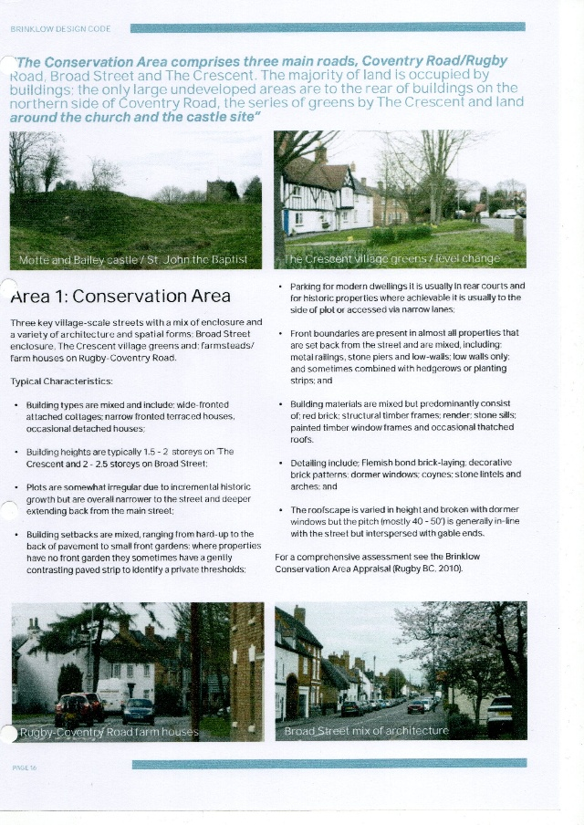

Green Belt
The proposal to construct 325 new dwellings in Brinklow, in the heart of greenbelt land, is a direct contradiction to policy to protect and preserve green belt and is also at odds with the NPPF.
The draft local plan seeks to allocate over 1500 new dwellings to green belt land. This does not protect the green belt. There are development options outside of green belt land that should be focused on, including a greater volume in Rugby Town. The subject proposal increases Rugby dwellings by 2% compared to a village like Brinklow at 70%. This is unreasonable and unjustified.
Ridge and Furrow
The proposal, especially site 315, proposes to dissect a field of heritage importance with ridge and furrow landscape. Conservation and landscape policy is to protect such sites, but this proposal proposes an access road and new dwellings over historically sensitive landscape that will destroy such landscape.
Conservation Area
Site 337 is within the Brinklow conservation area with site 315 directly opposite. Development of these sites with the proposed intensity of residential dwellings will negatively impact on the historical importance and heritage of the sensitive and protected area.
National Monument
Brinklow Castle (The Tump) is a designated National Monument and protected under the Ancient Monuments and Archaeological Areas Act 1979. The proposal of site 315 and 337 interferes with views to and from the monument and site 337 directly abuts the monument. Site 315 has been historically declined for planning development with reference to the aesthetics of the monument part of direct feedback for planning refusal by RBC.

Listed Buildings
Site 337 directly abuts listed residential properties. Development of this site will adversely impact these properties and derogate their historical importance in contradiction with conservation and heritage policy.

Flooding
In recent years the village has been subject to flooding events (as shown in attached photos). Site 337 has been particularly susceptible to flooding as have the surrounding roads of Heath Lane and Green Lane, as well as properties on Coventry Road. Removing grass fields, hedgerows and trees, and replacing them with concrete will exasperate the risk of further flooding.
Surface water flooding has also been caused by inadequate and historically dated sewer and drainage systems. Not only has overflow of such systems increased the intensity of flood risks but also of sewer overflow. Raw sewage overflow has occurred on numerous occasions alongside flood events on Barr Lane, Heath Lane and Green Lane. Pictures 1&2 show the aftermath of a manhole on the playing field lifted off its foundations by pressure of foul water following a heavy rain storm, and the garden flooding caused when rainwater exceeded the drainage capacity and surface water from the Coventry Road built up and was within an inch of causing internal flooding.
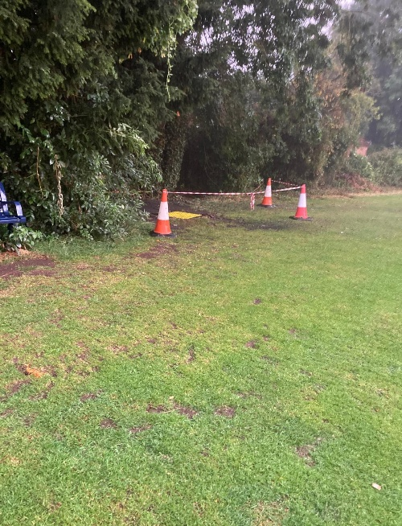
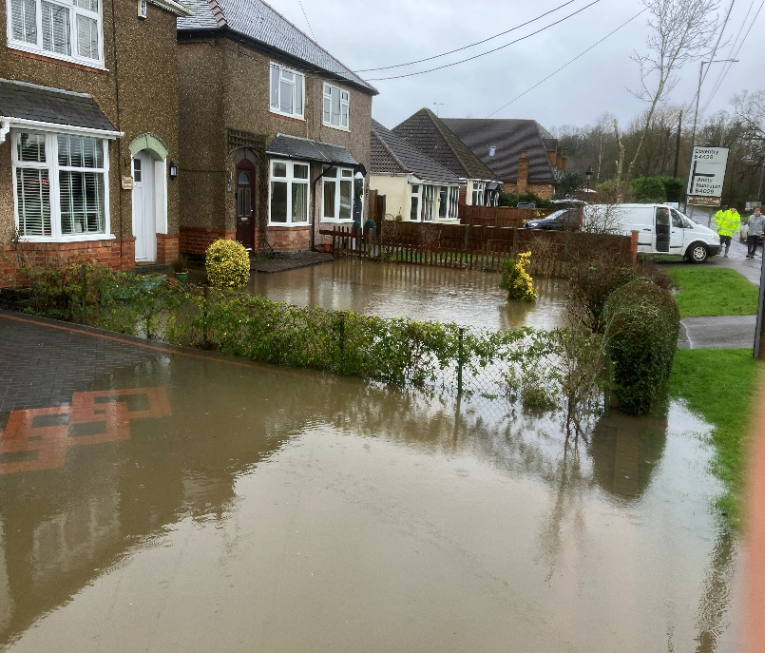

The kennels in Cathiron Lane unfortunately suffered internal flooding during both of these occasions. An increase in the amount of surface water due to 315 houses can only make this situation worse.
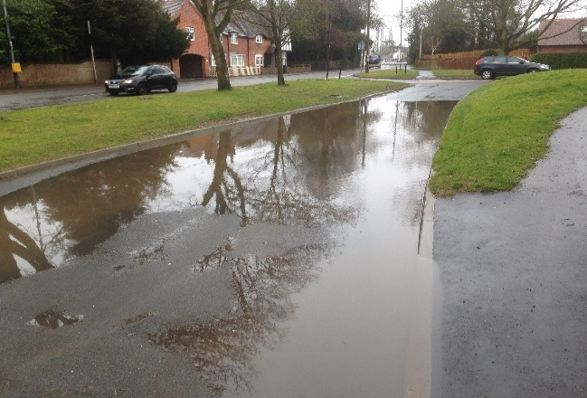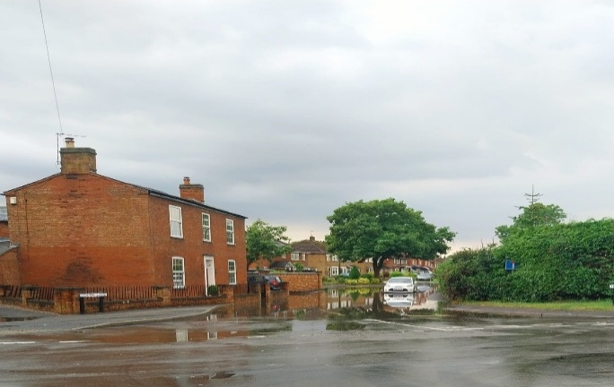

Conclusion
In summary, from an environment and heritage perspective it is recommended the proposal is unsound and conflicts with environmental, conservation and heritage policy and numerous paragraphs of the NPPF.
Most critically Brinklow is situated proudly in protected greenbelt, which is also valuable and productive farmland that should be maintained for generations to come. This land is essential to protect boundaries between towns and to protect and conserve landscape, wildlife and flora and fauna
Brinklow has a known flooding risk, particularly at the Heath Lane /Coventry Road junction, and at the Green Lane/Coventry Road junction. Internal flooding of domestic properties has only just been avoided in the last few years; no actions have been taken to ensure the under-capacity is remedied.
The statement made by Severn Trent only confirms our position on the very edge of the flood plain.
Brinklow is a comparatively small Village, but as a Main Rural Settlement is has been unfairly selected to take a far greater proportion of the new housing allocation than other Villages.

The people of Brinklow value the Heritage which is embedded within the Village, where 36 listed building can be found, adjacent to the 12th century SSSI Brinklow Castle. English Heritage place emphasis on the views to and from the castle, and recognise that it’s a central part of Brinklow’s environment.

(Continue on a separate sheet /expand box if necessary)
6. Please set out the modification(s) you consider necessary to make the Local Plan legally compliant and sound, in respect of any legal compliance or soundness matters you have identified at 5 above. (Please note that non-compliance with the duty to co-operate is incapable of modification at examination). You will need to say why each modification will make the Local Plan legally compliant or sound. It will be helpful if you are able to put forward your suggested revised wording of any policy or text. Please be as precise as possible.
An alternative View:
We carried out an overall view of the housing requirement for the Village and are now able to offer as alternative sites the following. Some have been previously researched by Planners like AECOM and others have come forward since the last Local Plan. Our planning advisor suggests that a density of 32.5 units per hectare is appropriate.
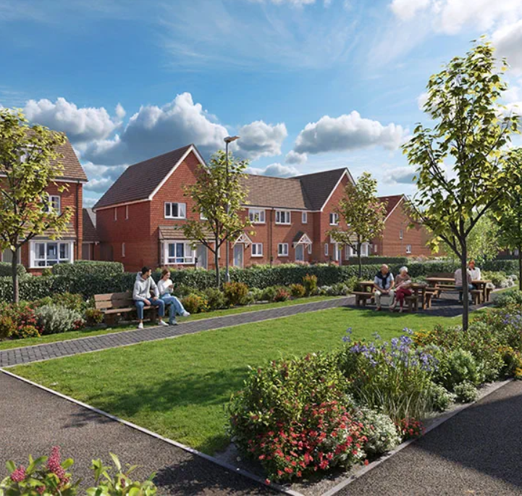

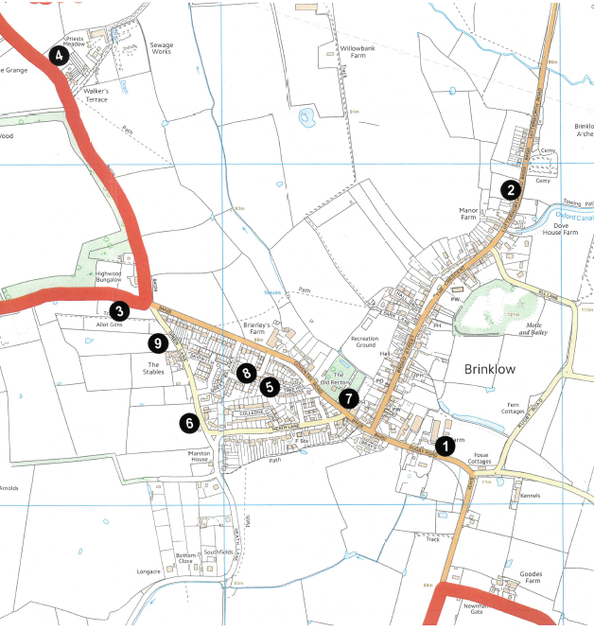

Site 1. West Farm. (Area 1.82 Hectares)
This site was originally proposed by RBC and it is now a joint plan with its neighbouring farm Home Farm. That proposition hasn’t been properly resolved because it takes both farms out of active farming because of the loss of storage. There are a number of listed buildings involved, and it is our proposal to develop only the West Farm segment. That allows Home Farm to continue in business, but gives enough Brown Field site to accomplish the building of a properly planned development of “specialist over 55yrs accommodation” RBC’s words. With sensitive treatment the listed buildings on the site could be re-purposed as Village amenities. Home Farm could continue farming as it has done for the last 200 years. The Listed farm house would remain intact. This reduction in size would take into account the views of Heritage England in regard to the view towards the SSI known as Brinklow Castle and would not interfere with the flooded canal arms left after re-working in 19th century, a fishing and unusual nature centre. Specialist advice taken suggests that the number of units should be reduced from 75 to 40/45.

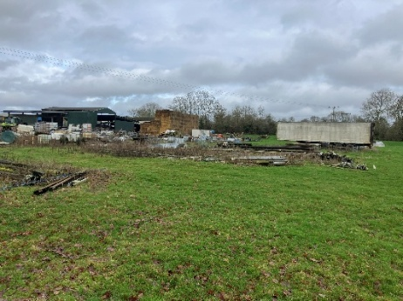
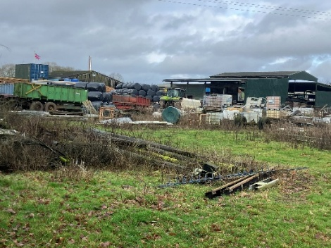

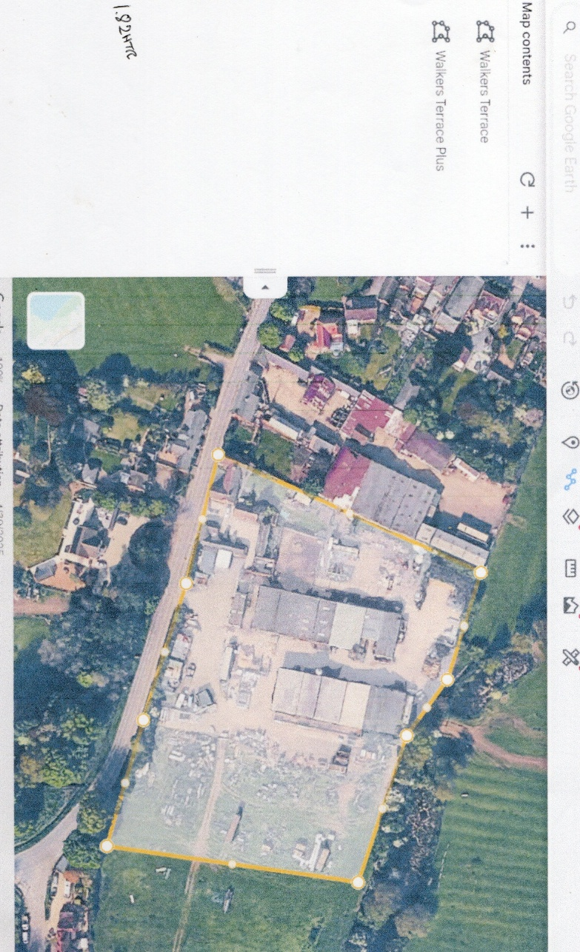
--------------------------------------------

Site 2. Land to west of Lutterworth Road: Negotiations are at an advanced stage to build 19 properties, a mix of affordable units and units suitable for retirement or for the disabled. A builder is already looking at the second stage of planning with RBC and it is expected that planning permission will be sought by April 2026 and that the site will commence building at the end of 2026.
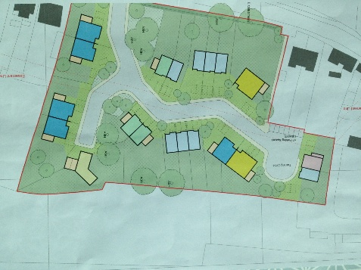

-------------------------------------------

Site 3 Field off Green Lane
BPC have been proactive in introducing the owner of this site to a suitable building contractor and provisional meetings indicate that the site will provide land for between 40 and 50 units. Negotiations continue between the parties, the owner and his siblings have co-operated fully in the process and are keen to proceed. BPC continue to monitor the process to prevent it stalling.

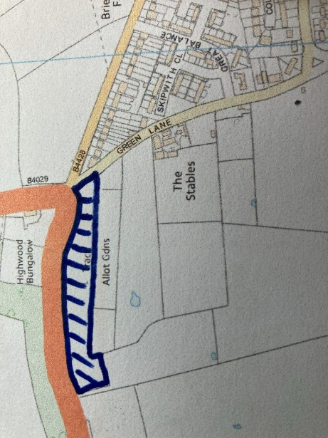

--------------------------------------

Site 4. Land at Walkers Terrace
(Area 0.24 Hectares)
BPC have been approached by the landowners who have indicated that they want the land to come back into use. An approach has also been made to join in an adjacent piece of land. BPC will introduce them to a local specialist builder who has indicated that the combined site would fit 8-9 units.

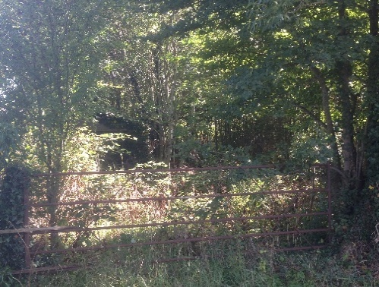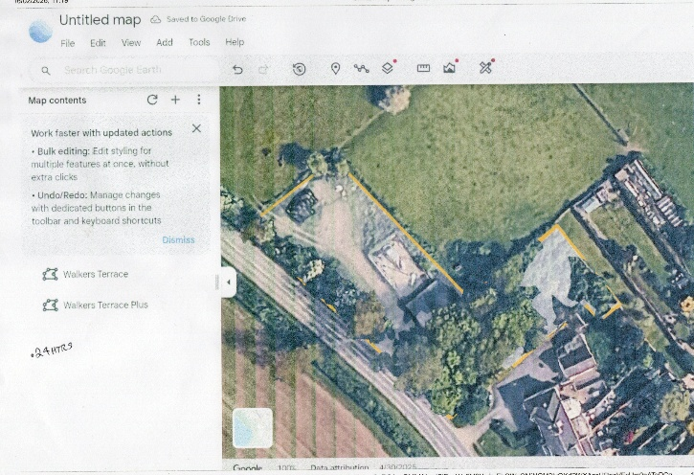

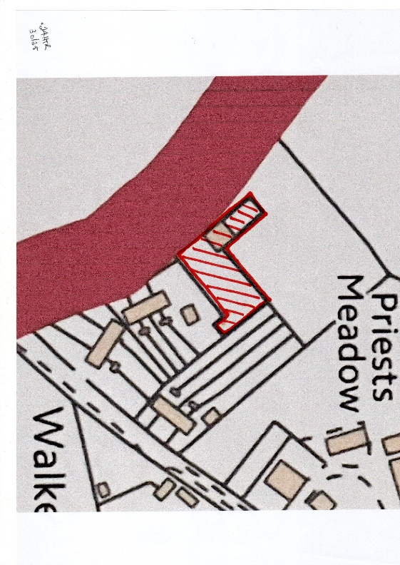

----------------------------------------------

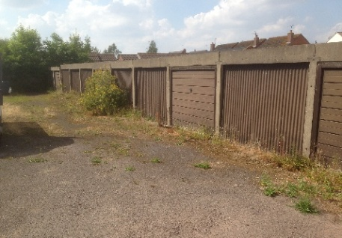
Site 5. RBC disused garages at Yew Tree Hill. (0.25 Hectares)
This site has been put forward before, but now RBC have sold the site by auction. We are disappointed that this site was not developed by RBC because they could have set it up as properly affordable housing, there was nominally no land costs. The site sold for £139500 before specialist clearance costs, and it is therefore only suitable for “Market Value” houses. When the new owner is known BPC will actively work with them to develop the ¾ units already proposed by AECOM in the 2022 Neighbourhood Plan.

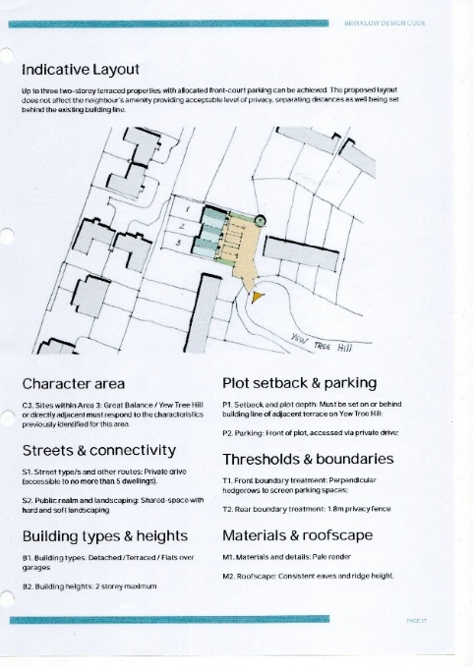

---------------------------------------------------

Site 6. Land at Heath Lane Green Lane junction.
(Whole site area 4.49 hectares)
This site is known as Humber Fields, and in collaboration with BPC the owner has stated that ribbon development can be proposed within the Plan time scale. Initial roadside ribbon development might provide 10+ units.

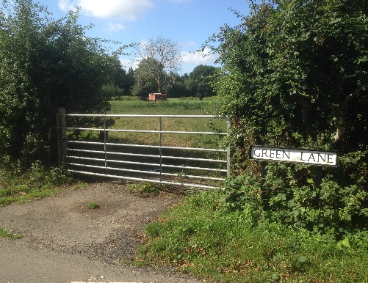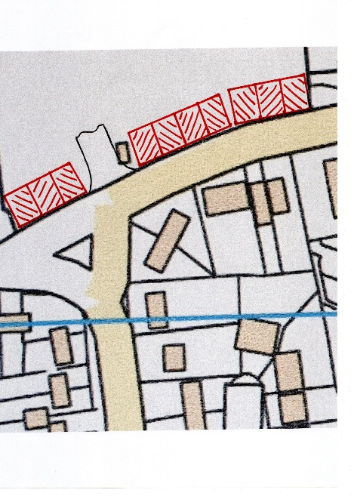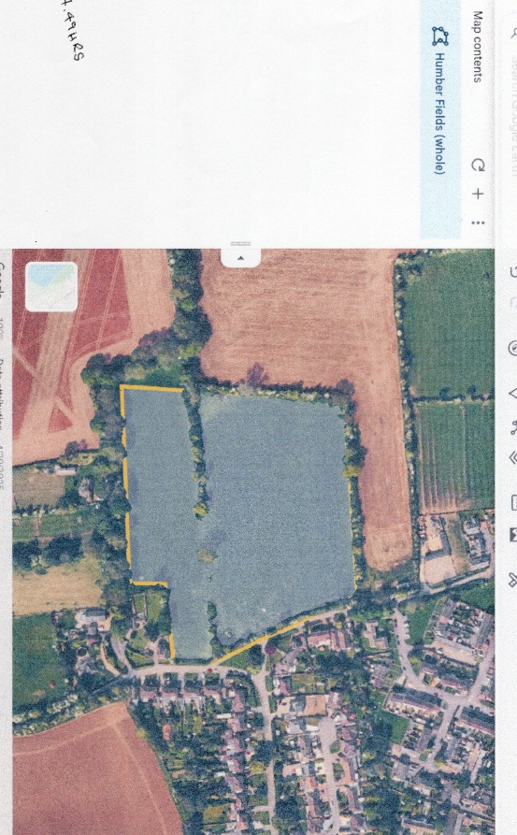

---------------------------------------------------

Site 7. The Spinney
Still under negotiation with the owner, it’s a proposal to utilise an overgrown and neglected area within easy walking distance of the Village Centre. The trees on the site and the undergrowth have not received any attention since 2 condemned cottages were demolished in the 1960’s. In 2020 AECOM designed circa 17 retirement units and flats on the site, but this is thought to be over ambitious due to the tree canopy spread. The proposal now shows terrace houses on the footprint of the old cottages facing the road. Capacity 3-4.

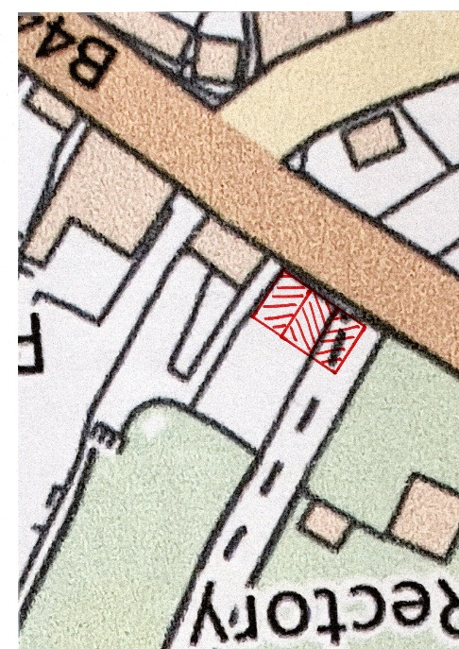
----------------------------------------------

Site 8. George Birch Close Garages (1-20)
(Area 0.8 Hectares)
RBC informed us that these garages are about to go to auction, the same as site 5. AECOM designed 5 units for this site (see plan).

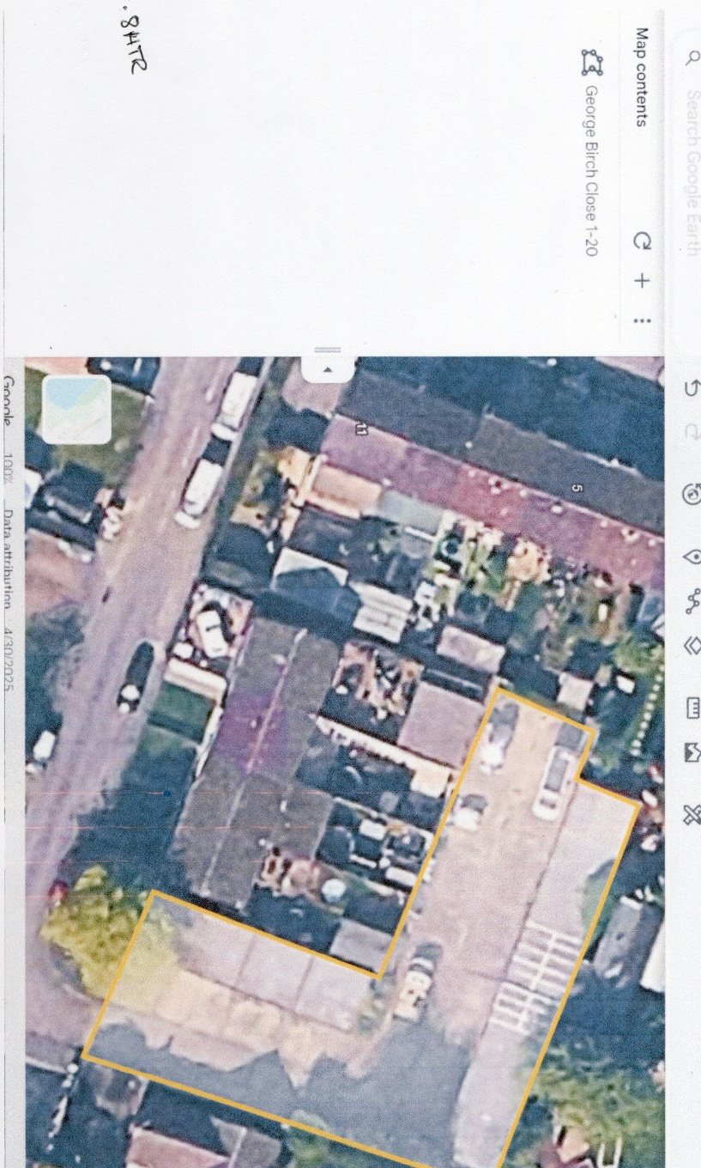
For full details of the AECOM DESIGN CODES see:

https://brinklowparish.gov.uk/wp-content/uploads/2026/02/DR-10398_Final-BrinklowReport_v1-2.pdf

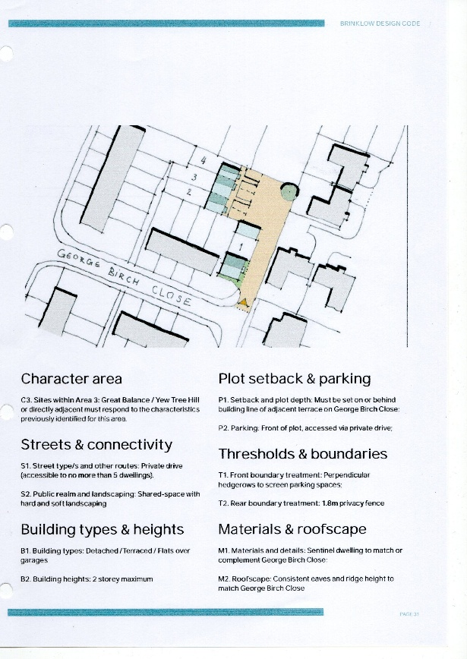

Site 9 Extension to Percy Close.
A small development by a local villager/landowner as an extension to units he built around 5/6 years ago. In the period of the plan an additional 6/10 units.

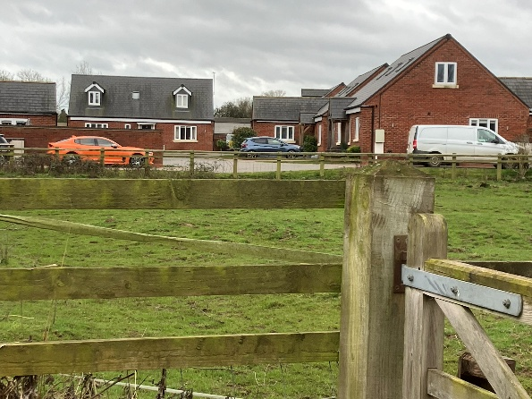
-------------------------------------
Whilst RBC adopt a fairly robust attitude to defend these sites, BPC comments about the alternatives should be allowed to be heard. That’s why we have put so much work into this document, so that the Planning Inspector can see our approach and he can make a reasoned judgement about our propositions.

The Alternative Numbers:

Site 1 | West Farm | 45
Site 2 | Field to West of Lutterworth Road | 19
Site 3 | Field off Green Lane | 40
Site 4 | Land at Walkers Terrace | 9
Site 5 | Yew Tree Hill Garages | 3
Site 6 | Land at Heath Lane Green Lane Junction | 10
Site 7 | The Spinney | 4
Site 8 | George Birch Close | 5
Site 9 | Percy Close | 10
Total |  | 145

BPC would hope that at least some of suggestions could form an acceptable resolve to a grossly unfair number of dwellings being proposed within this Heritage village.

(Continue on a separate sheet /expand box if necessary)
Please note: In your representation you should provide succinctly all the evidence and supporting information necessary to support your representation and your suggested modification(s). You should not assume that you will have a further opportunity to make submissions.
After this stage, further submissions may only be made if invited by the Inspector, based on the matters and issues he or she identifies for examination.

7. If your representation is seeking a modification to the plan, do you consider it necessary to participate in examination hearing session(s)?
 |  | No, I do not wish to  participate in  hearing session(s) | Yes |  | Yes, I wish to participate in  hearing session(s)
Please note that while this will provide an initial indication of your wish to participate in hearing session(s), you may be asked at a later point to confirm your request to participate.

8. If you wish to participate in the hearing session(s), please outline why you consider this to be necessary:
We want to speak on behalf of Brinklow Parish Council because we feel that we have been allocated an unfair proportion of the new housing requirement.
See above….70%
RBC have not listened to our statement that this number of houses in this location is unsuitable, our services are unable to service this increase. We have proposed a number of alternatives which deserve to be considered.
We also consider that RBC have not engaged with us as a Parish Council that understands the need for growth, but to be done in a proportionate way over the plan period, subject to the correct level of infrastructure being provided.

Please note the Inspector will determine the most appropriate procedure to adopt to hear those who have indicated that they wish to participate in
hearing session(s). You may be asked to confirm your wish to participate when the Inspector has identified the matters and issues for examination.

All representations received will be submitted to the Planning Inspectorate alongside the Proposed Submission Local Plan and published on the council’s website. Personal addresses and email addresses (as distinct from businesses addresses), but not names, will be redacted before representations are published.

The Rugby Borough Council Privacy Notice for Development Strategy is available here: https://www.rugby.gov.uk/w/privacy#development-strategy
The Planning Inspectorate’s privacy notice can be accessed here: https://www.gov.uk/government/publications/planning-inspectorate-privacy-notices

